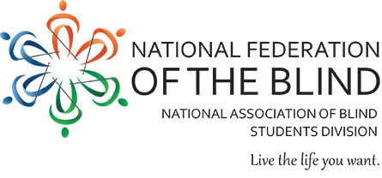
The 2018 NFB Southeast Regional Seminar

An opportunity to sharpen self-advocacy, confidence, and social networking skills for blind students.
Eligibility: Blind High School and college students in the southeast states. Other interested students are welcomed to attend.
Activities Include: Engaging workshops with Federation mentors, interactive confidence-building opportunities, and chances to apply NFB philosophy to real world situations.
- When: August 10-12, 2018
- Where: National Federation of the Blind
The Jernigan institute
200 East Wells St.
Baltimore, MD 21230
To register, please contact Naim abu El-Hawa, Vice President, Virginia Association of Blind Students at 202.848.8932.
Registration opens on May 15, 2018 and closes on July 15, 2018. For any questions about this event, please contact Robert Parsons at 804.801.7674. Students that are members of the Virginia Association of Blind Students are eligible to receive a $25 subsidy to assist with travel expenses to the event.

