

Independence is our Vision

Columbia Lighthouse for the Blind Can Provide Orientation and Mobility Services for Visually Impaired and Blind Residents of Northern Virginia

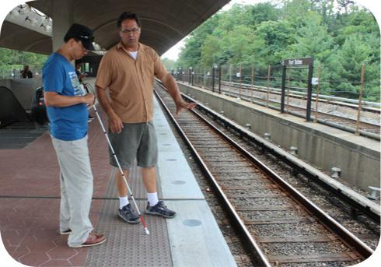
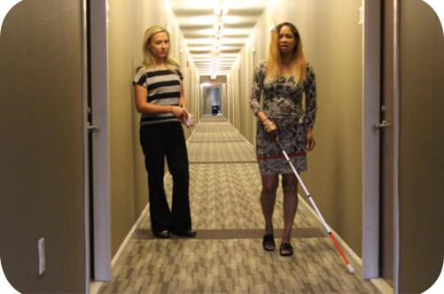
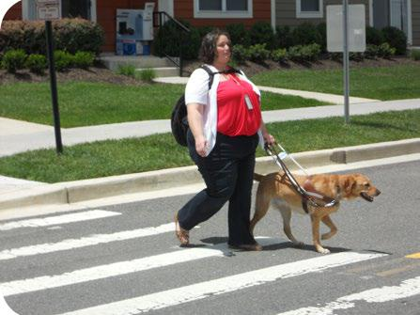

CLB’s O&M Training Services Include:
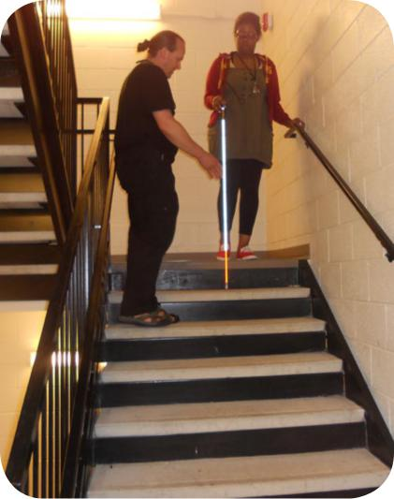

• Evaluation of O&M needs or skills • Working with a human guide
• Indoor/outdoor cane training • How to use landmarks and
• How to cross streets and intersections clues
• Orientation to find your place of employment • How to use compass
or school campus directions
• How to use public transportation including, • Map reading skills
taxis, buses, and Metro trains
•Route planning & travel

E-mail or Call Olivia Norman at onorman@clb.org; 240-737-5170

1825 K Street, NW Suite 1103 | 8757 Georgia Avenue, Suite 805
Washington, DC 20006 | Silver Spring, MD 20910
202-454-6400 | 301-589-0894

