Resilience | Independence | Self-Advocacy | Employment

R E S I L I E N C E
Blind students ages 14-21 throughout the entire state of
Virginia will have the chance to interact with and form lasting relationships with young successful blind
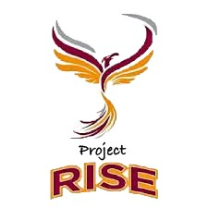
professionals, who have overcome many of the obstacles placed before blind students and now are eager to teach their younger peers how to conquer life.

N D E P E N D E N C E
The statewide program will meet four times throughout
2018-2019. Students will have the opportunity to further develop skills such as travel, home management, and technology through interactive and hands on workshops and community activities.

S E L F - A D V O C A C Y
Through mentorship and a positive environment, students of all ages will learn how to communicate effectively with teachers and employers to ensure they receive the tools they need to succeed in school, and the work place.

EMPLOYMENT
Students will share their educational and career goals and
Project RISE will help them reach those goals through, resume and interview workshops, and placement in summer internships or jobs that interest them.
Join us in this journey toward independence, confidence, and success! Blindness will never hold you back.
For any questions or to secure your spot
Email: nfbprojectrise@gmail.com
Visit: rise.nfbv.org
Call: (203) 273-8463

