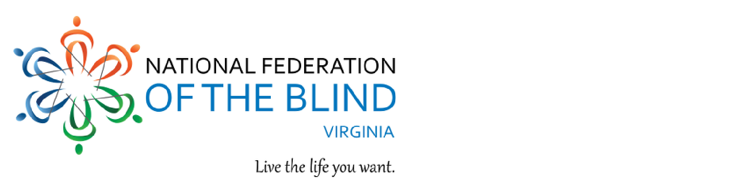
National Federation of the Blind of Virginia
State Convention | Fredericksburg VA
| November 9-11, 2018
Student Professional Development Seminar – Students will rotate to various round-tables to learn more about resumes and cover letters, interviewing skills, professional attire, and opportunities to talk with potential employers.
Networking – The power of human interaction is so vital in professional development. Our student and young professional networking events will equip all students with the confidence in making brief, intentional, and meaningful conversation with key personnel.
Student Panel – Successful blind role models will engage in conversations surrounding effective communication and, extracurricular activities, challenges of college life, challenges of student employment, self-advocacy, accommodations, social pressures of campus life, and more!
Act before October 26 to pre-register to receive reduced convention registration and meal fees. To preregister, go to
www.nfbv.org/convention/

To access our negotiated hotel rates, call the Hospitality House directly at (540) 208-4746 for our $79 per night room rate plus tax. For other questions or information, email Kathryn Webster at nabs.president@gmail.com; phone or text 203-373-8463.

