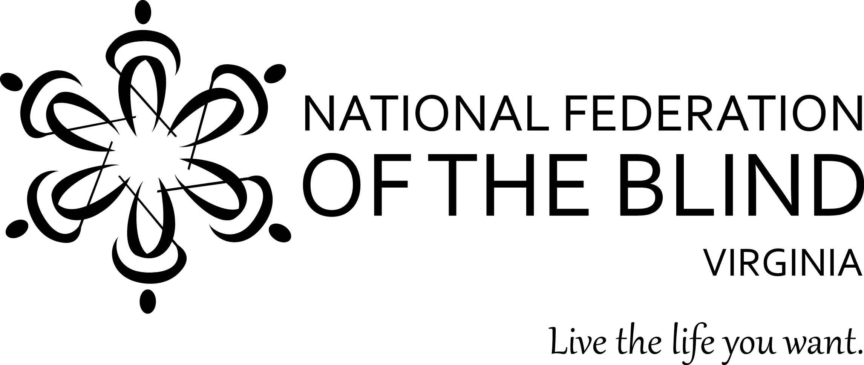

Onward and Upward
Blind Professionals Striving for More!

Is your low vision or blindness getting in the way of the next step in your professional development?

The 2018 convention of the National Federation of the Blind of Virginia welcomes you. Join us in Fredericksburg at the Hospitality House Hotel from November 9-11, 2018. You will have opportunities to:
- Enhance your network with professionals following similar career paths
- Share and discover alternative techniques to perform at your absolute best on the job and in daily life
- Take control of the practical skills you need to get the job you want from seasoned professionals

Act before October 26 to pre-register to receive reduced convention registration and meal fees. To preregister, go to www.nfbv.org/convention/
To access our negotiated hotel rates, call the Hospitality House directly at (540) 208-4746 for our $79 per night room rate plus tax. For other questions or information, email Sandy Halverson at sjh300@outlook.com; phone or text 703-400-6890.

