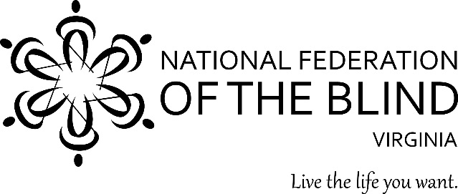

If your low vision makes simple daily tasks difficult or impossible, you are not alone.

Come join us on Saturday, November 10, 2018 for our Seniors Empowerment Program presented by the National Federation of the Blind at our 2018 convention in Fredericksburg, Virginia.

You will learn to take charge of your life by:
being active through volunteering in your community;
improving your independence; reducing isolation; and overcoming challenges with the help of experts.

To learn alternative techniques to live the life you want, join us in Fredericksburg. The 2018 NFB of Virginia convention will be held November 9 -11 at the Fredericksburg Hospitality House, 2801 Plank Road, Fredericksburg, VA 22401. All details on the convention can be found at: www.nfbv.org/convention/

To make hotel reservations, please call the hotel directly at (800) 682-1049 or (540) 786-8321. The room rate is $79 per night plus tax. To guarantee this rate, reservations must be made prior to October 26, 2018.

For additional information, please call Nancy Yeager (703)283-2524 or email to nancyyeager542@comcast.net

