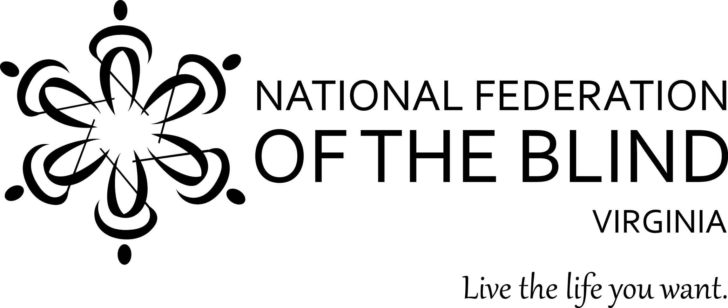
Tracy Soforenko, President
1511 North Jackson Street
Arlington, VA 22201
202-285-4595
tracy.soforenko@gmail.com

2019 LEGISLATIVE PRIORITIES OF THE BLIND OF VIRGINIA

Priority #1: Enable blind people to get back to work faster.

Action: Support the Governor’s budget proposal for increased funds for DBVI.

Issue: The Department for the Blind and Vision Impaired (“DBVI”) provides vocational rehabilitation services leading to employment of Virginians who are blind, deaf/blind, and vision impaired. DBVI provides training in the alternative techniques used by blind people to work and live independently. For example, Virginia students with significant vision disabilities receive pre-employment transition services that assist them in acquiring the skills and credentials to enter the Virginia workforce. Funding for DBVI has not increased for 20 years and the waitlist for vocational rehabilitation services has grown to 150 adults and 400 underserved students. Individuals on the waitlist typically wait for nearly 9 months. Blind Virginians want to work and live independently.

Solution: Support the Governor’s budget to increase DBVI funding. The Governor’s budget proposal is an incremental step toward ensuring the availability of sufficient funds needed to serve blind Virginians. Increased funding ($625,000) would reduce the waiting list by 50 people, fund ($176,000) reasonable accommodations for DBVI’s blind employees who need drivers to perform their job functions, and fund services ($218,000) for deaf/blind Virginians. Without this funding, many Virginians will not receive services which lead them to self-sufficiency and the opportunity to lead productive and comfortable lives.

Priority #2: Support access to online banking by the blind.

Action: Oppose SB1302 (Patron Barker)/HB2296 (Patron Leftwich) which does not fix the supposed problem but does dramatically weaken protections that ensure accessibility for blind people in Virginia.

Issue: Financial institutions expect their customers to use web-based online services to perform banking functions and manage their finances in an efficient and cost-effective manner. When financial institutions provide online services properly, blind people can use assistive technology to meet their professional and personal banking needs in an increasingly web-based world. When web services are inaccessible, blind people pay fees using a phone representative, spend more time to perform functions, receive less access to services versus other members of the general public, and must reveal private and sensitive financial information to other people to complete transactions.

Web-based banking services have dramatically improved the ability to bank independently for blind people. Access to these services is covered under the Americans with Disabilities Act (“ADA”). When accessibility problems arise as websites are updated, blind people typically inform their financial institution, and the problems are addressed because the institutions know they are expected to provide accessible services as a place of public accommodation under Title III of the ADA, which has been in effect for nearly 30 years. The bill (SB1304/HB 2296) would create confusion and not reduce so-called frivolous litigation because it only changes financial institutions’ obligations under state law, which they have not been sued under, but does not change their responsibilities under the ADA, the federal law that, when they are sued, they have always been sued under.

Solution: Oppose SB1302/HB2296 which does nothing to solve the problem raised by those in favor of the bill but which sets a dangerous precedent that the rights of people with disabilities in Virginia can be ignored until someone brings a lawsuit.

As previously stated, Virginia’s financial institutions have not been sued under state law, only under the ADA, a federal law. Thus, changing Virginia law will do nothing to reduce so-called frivolous lawsuits.

Moreover, this bill would put in place barriers for people with disabilities to enforce their rights, for example, by preventing people with disabilities from going forward with a lawsuit under state law until a financial institution that is breaking the law has been given a warning and 120 more days to stop violating the law. This would send a message to financial institutions that they should only follow Virginia law once they have been sued instead of following it all the time. Therefore, while this bill would not stop lawsuits against Virginia financial institutions under the ADA, it would set a dangerous precedent that would undermine the Commonwealth’s desire to ensure equal access for people with disabilities.

Even though this bill would not end the so-called frivolous lawsuits brought under federal law, it would introduce a number of technical and substantive issues into Virginia law. For example, many website accessibility cases end with a settlement or court order requiring entities to implement a system to prevent future violations of the law which are monitored for compliance by the courts. This bill would all-but eliminate such settlements or court orders if any cases were ever brought under Virginia law by giving financial institutions a big incentive to fix the immediate problem without fixing the underlying problems that led to the inaccessibility in the first place.

The ADA has been around for almost 30 years. The first version of the accessibility standards for websites identified in the bill, WCAG 1.0, has been around since 1999. Financial institutions that are currently breaking the law should not have to be told that they are in violation of a decades-old law when the guidance they wish to follow has already been around for 20 years.

In short, this bill harms the financial institutions it intends to protect by doing nothing to stop so-called frivolous lawsuits under the ADA and creating a culture of non-compliance with the law. This legislation merely offers the financial sector a false victory while simultaneously setting a precedent that the rights of people with disabilities can be ignored until they bring a lawsuit.

*****

ABOUT THE NATIONAL FEDERATION OF THE BLIND

The National Federation of the Blind is America’s largest and most active organization of the blind. With more than 50,000 members, we are not an “agency” claiming to speak for the blind; we are blind people speaking for ourselves. In Virginia, we are organized into 14 local chapters throughout the Commonwealth, and into various special interest divisions; including a parents’ division.

