NFB Membership Coin Pendant
The Virginia Affiliate of the National Federation of the Blind, Fund Raising Committee, will be selling a custom designed, stainless steel, hand polished, pendant to hold the NFB Membership Coin. This high quality stainless steel pendant can be worn as a necklace or used as a keychain holder.
The Virginia Affiliate is located in the exhibit hall at Table D2. Please stop by to purchase this custom made, fine piece of jewelry that proudly displays and protects your NFB Membership Coin, for $20.00.
The two attached photos display the pendant with the NFB Membership Coin. Please note how the coin is securely held within the pendant with none of the imagery or text obscured from view on either side of the coin.

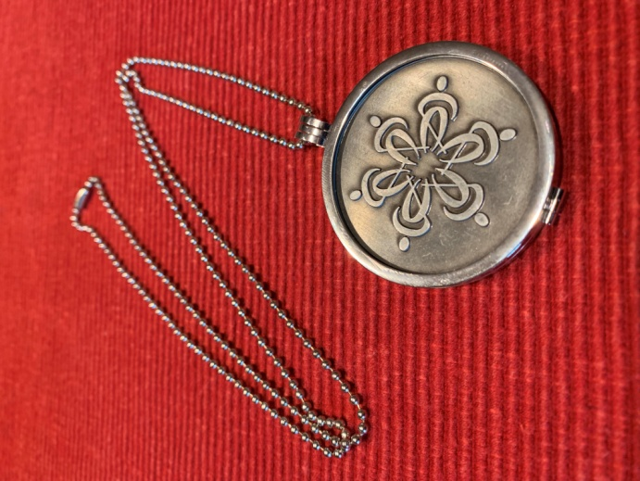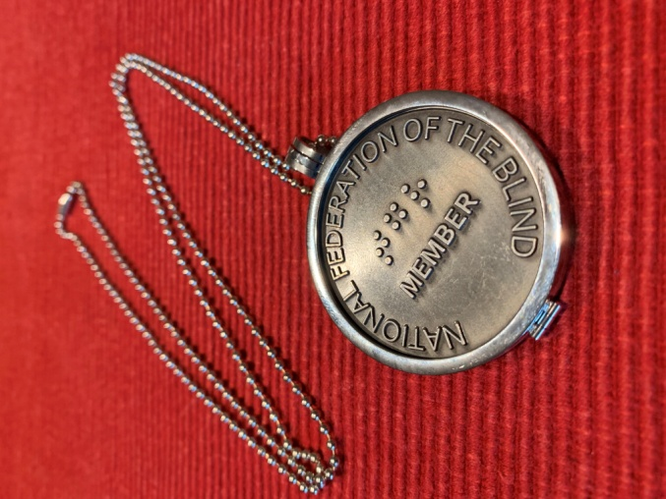

The Virginia Affiliate Fund Raising Committee will also be selling Our Famous Virginia Peanuts and other interesting and useful items.

