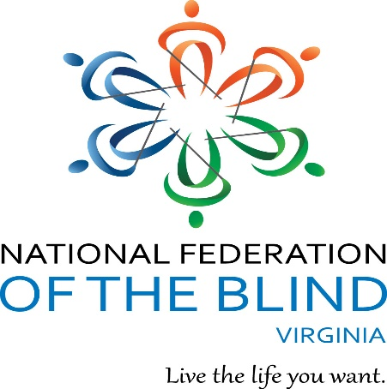

Virginia Association

of

Blind Students

are inviting you to

For more info contact: André Hill [andrehill6188@gmail.com](mailto:andrehill6188@gmail.com)

Dinner:

Golden Corral (Self-Pay)

**RSVP by September 29 at 4pm**

Raffle Tickets: 1 Ticket/$1 & 3 tickets/$5

To purchase tickets: paypal.me/aeh6188

You do not need to be present to win. Winners will be called or emailed.

**LAST** day to buy tickets online: Friday October 4th at 11:55pm

Pinboy’s At the Beach 1577 Laskin Rd, Virginia Beach, 23452

Saturday, October 5, 2019 from 1-3:30pm

Cost: $10/person (shoes & bowling)

Sign-up for bowling and tickets:

Transportation Questions:

NoVa: Naim- 202-848-8932

Richmond: Gerald- 804-2433980

Bowl with the Blind!