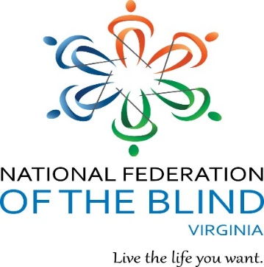The

Virginia Association

of

Blind Students

are inviting you to

Bowl with the Blind!

**Pinboy’s At the Beach** 1577 Laskin Rd, Virginia Beach, 23452

Saturday, October 5, 2019 from 1:00-4:00pm

**Cost**: $10/person (shoes & bowling)

**Sign-up for bowling and tickets**: <https://forms.gle/GDmhvTKnBmM4qbBz6> (ONE submission form per person. Please do NOT put two people's name on one submission form.)

**Raffling:** 3 gift cards $25 each as a bundle and 2 $25 Visa gift cards individually

**Cost of Raffle Tickets**: 1 Ticket/$1 & 3 tickets/$5

**To purchase tickets**: paypal.me/aeh6188

**LAST day to buy tickets online:** October 4th at 11:55pm

Winners will be called or emailed.

**Transportation Areas**:

NoVa: Naim- 202-848-8932 or Richmond: Gerald- 804-2433980

**Dinner**: Golden Corral (Self-Pay)

**RSVP to dinner by:** September 29 at 4pm

For more info contact: André Hill [andrehill6188@gmail.com](mailto:andrehill6188@gmail.com)