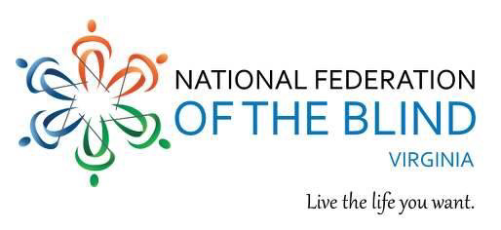
NATIONAL FEDERATION OF THE BLIND OF VIRGINIA PRESENTS
POSSIBILITIES FAIR FOR SENIORS

Have you stopped reading the newspaper or books, writing checks or other correspondence, or completing other tasks that require vision? If the answer is yes to any of the above, join us to learn about low- or no-cost solutions to these and other aspects of your daily life.
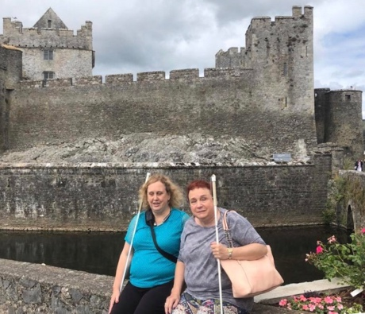
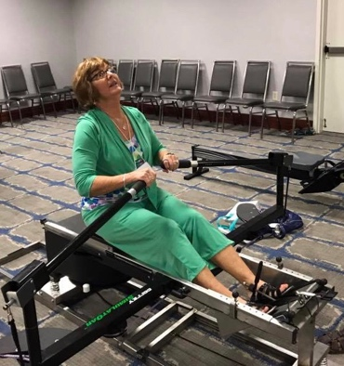
WHEN: Friday, November 1, 2019

WHERE: Renaissance-Norfolk Hotel located at 425 Water Street, Portsmouth, VA 23704.

TIME: 2:00 to 4:00 p.m.

For additional information and to RSVP, email Nancy Yeager at nancyyeager542@comcast.net or call (703) 283-2524; this number accepts voice and text messages.

