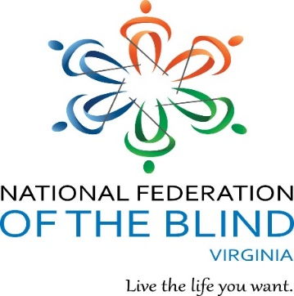
The
Virginia Association
of
Blind Students
is hosting
Bowl with the Blind!

Pinboy’s At the Beach 1577 Laskin Rd, Virginia Beach, 23452
Saturday, October 5, 2019 from 1:00-4:00pm
Cost: $10/person (3 games and shoe rental)

Raffling:
As a bundle*- $25 Starbucks, $25 Target, $25 Amazon
Individually: (2) $25 Visa Gift Card

Cost of Raffle Tickets: 1 Ticket/$2 & 3 tickets/$5
To purchase tickets: paypal.me/aeh6188
LAST day to buy tickets online: October 4th at 11:55pm
Winners will be called or emailed.

Dinner: Golden Corral (Self-Pay) 400 S. Independence Blvd.
For more info contact: André Hill andrehill6188@gmail.com

*If I get any more gift cards, I will add them to the bundle
Everyone is invited to this event

