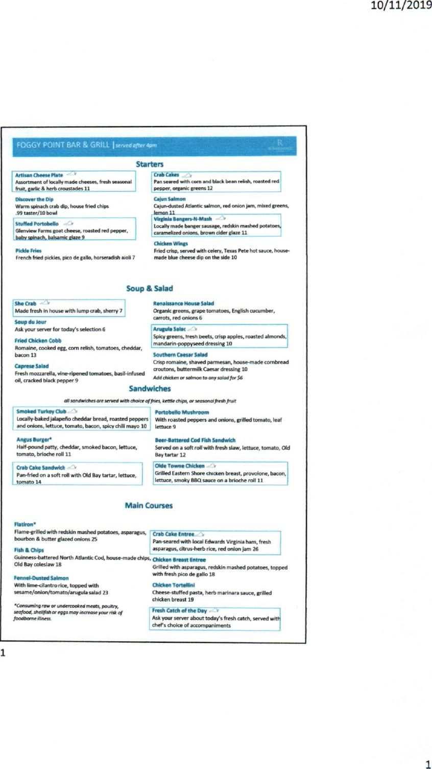

FOGGY POINT BAR & GRILL I *served after 4pm*

*MI

10/11/2019

1

1

**Starters**

**Artisan Cheese Plate —'**

**Assortment of locally made cheeses, fresh seasonal**

**fruit, garlic & herb croustades 11**

**Discover the Dip**

**Warm spinach crab** dip, house fried chips

**.99 taster/10 bowl**

**Stuffed Portobello**

**Glenview Farms goat cheese, roasted red pepper,**

**baby spinach, balsamic glaze 9**

**Pickle Fries**

**French fried pickles, pico de** gall, horseradish aioli 7

**Crab Cakes v**

**Pan sewed with corn and** black bean relish, roasted **red**

**pepper, organic greens 12**

**Cajun Salmon**

**Cajun-dusted Atlantic salmon, red onion lam, mixed greens,**

**_lemon 11**

**; Virginia liangers-N-Mosh**

**Locally made banger sausage, redskin mashed potatoes,**

**caramelized onions, brown cider glaze 11**

**Chicken Wings**

**Fried crisp, served with celery, Texas Pete hot sauce, house-**

**made blue cheese dip on the side 10**

**Soup & Salad**

**MOOS\***

**Made fresh in house with lump *crab,* sherry** *7*

**Soup du Jour**

**Ask your server for today's selection 6**

**Fried Chicken Cobb**

**Romaine, cooked egg, corn relish, tomatoes, cheddar,**

**bacon 13**

**Caprese Salad**

**Fresh mozzarella, vine-ripened tomatoes, basil-infused**

**oil, cracked black pepper 9**

**Renaissance House Salad**

**Organic greens, grape tomatoes, English cucumber,**

**carrots, red onions 6**

**Amok. Seim**

**Spicy greens, treut beets, crisp apples, roasted almonds,**

**mandarin-poppyseed dressing 10**

**Southern Caesar Wed**

**Crisp romaine, shaved parmesan, house-made cornbread**

**croutons, buttermilk Caesar dressing 10**

***Add chidcen or salmon to any salad foe $6***

**Sandwiches**

***aft sandwiches we served with choke offries, kettle chips, or seasonal fresh fruit***

**Smoked Turkey Club**

**locally-baked jalapello cheddar bread, roasted peppers**

**and onions, lettuce, tomato, bacon, spicy chili may° 10**

**Angus Burger\***

**Half-pound patty, cheddar, smoked bacon, lettuce,**

**tomato, brioche roll 11**

**Oneb Cat Sandwich**

**Pan-fried On a soft roll with Old Bay tartar, lettuce,**

**tomato 14**

**Portobello Mushroom**

**With roasted peppers and onions, gnlled tomato, leaf**

**lettuce 9**

**Beer-Battered Cod Fish Sandwich**

**Served on a soft roll with fresh slaw, lettuce, tomato,** Old

**Bay tartar 12**

**Old. Towne Chicken**

**Grilled Eastern Shore thicken breast, provolone, bacon,**

**; lettuce, smoky BBQ sauce one brioche roll** 11

**Main Courses**

**Flatiron'**

**Flame-grilled with redskin mashed potatoes, asparagus,**

**bourbon 8i butter glazed onions 25**

**Fish & Chips**

**Guinness-battered North Atlantic Cod, house-made chips,**

**Old Bay coleslaw 18**

**Fennel-Dusted Salmon**

**With lime-cilantro rice, topped with**

**sesame/onion/tomato/arugula salad 23**

**Crab Cake Entree. *`4***

**Pan-seared with local Edwards** Virginia ham, fresh

**asparagus, dtrus-herb** rice, red onion jam 26

**Chicken Breast Entree**

**Grilled with asparagus, redskin** mashed potatoes, topped

**with fresh pico de gallo 18**

**Chicken Tortellini**

**Cheese-stuffed pasta, herb** marinara sauce, grilled

**chicken breast 19**

***"Consuming row or* undercooked meats, *poultry,*** 
  
***seafood, shellfish or eggs may increase your risk of*** 
  
***foodborne***

**Fresh Catch of the Day -**

**Ask your server about today's fresh catch, served** with

**chef's choice of accompaniments**