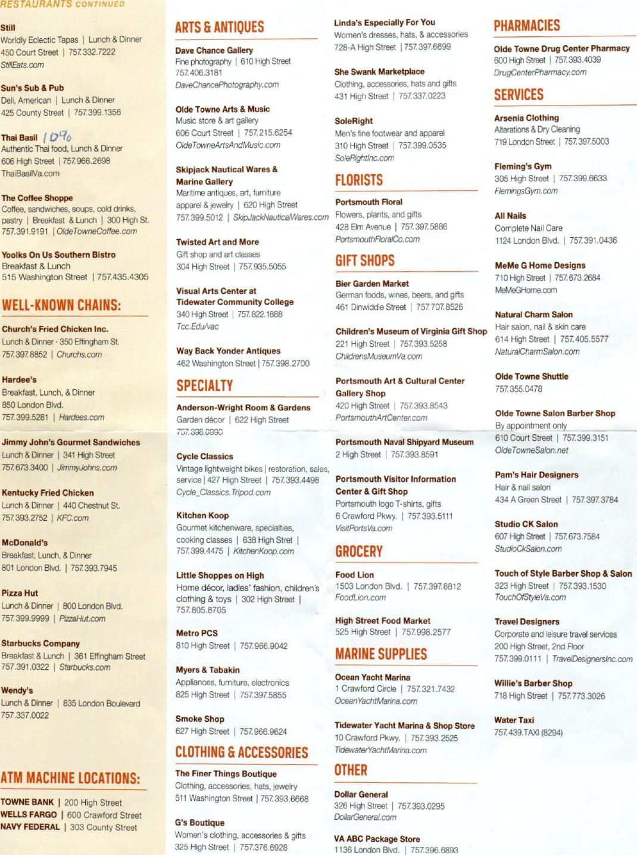
Tidewater Yacht Marina & Shop Store
10 Crawford Pkwy. I 757.393.2525
TidewaterYachtMarina.com
RESTAURANTS CONTINUED
Sthl
Worldly Eclectic Tapas 1 Lunch & Dinner
450 Court Street I 757.332.7222
StillEats.com
Sun's Sub & Pub
Deli, American I Lunch & Dinner
425 County Street I 757.399.1356
Thai Basil I 0¹⁻40
Authentic Thai food, Lunch & Dinner
606 High Street 1757.966.2698
ThaiBasilVa.com
The Coffee Shoppe
Coffee, sandwiches, soups, cold drinks,
pastry I Breakfast & Lunch I 300 High St.
757.391.9191 I OldeTowneCoffee.com
Yoolks On Us Southern Bistro
Breakfast & Lunch
515 Washington Street I 757.435.4305
WELL-KNOWN CHAINS:
Church's Fried Chicken Inc.
Lunch & Dinner • 350 Effingham St.
757.397.8852 I Churchs.com
Hardee's
Breakfast, Lunch, & Dinner
850 London Blvd.
757.399.5281 I Hardees.com
Jimmy John's Gourmet Sandwiches
Lunch & Dinner I 341 High Street
757 673.3400 I JimmyJohns.com
Kentucky Fried Chicken
Lunch & Dinner I 440 Chestnut St.
757 393.2752 I KFC.com
McDonald's
Breakfast, Lunch, & Dinner
801 London Blvd. I 757 393.7945
Pizza Hut
Lunch & Dinner I 800 London Blvd.
757 399.9999 I PizzaHut.com
Starbucks Company
Breakfast & Lunch I 361 Effingham Street
757.391.0322 I Starbucks.com
Wendy's
Lunch & Dinner 1 835 London Boulevard
757.337.0022
ATM MACHINE LOCATIONS:
TOWNE BANK I 200 High Street
WELLS FARGO I 600 Crawford Street
NAVY FEDERAL I 303 County Street
Olde Towne Arts & Music
Music store & art gallery
606 Court Street I 757.215.6254
OldeTowneArtsAndMusic.com
Skipjack Nautical Wares &
Marine Gallery
Maritime antiques, art, furniture
apparel & jewelry I 620 High Street
757.399.5012 I SkipJackNauticalVVares.com
Twisted Art and More
Gift shop and art classes
304 High Street I 757.935.5055
Visual Arts Center at
Tidewater Community College
340 High Street I 757.822.1888
Tcc.Edu/vac
Way Back Yonder Antiques
462 Washington Street I 757.398.2700
SPECIALTY
Anderson-Wright Room & Gardens
Garden decor I 622 High Street
757 398.0990
Cycle Classics
Vintage lightweight bikes I restoration, sales,
service I 427 High Street I 757.393.4498
Cycle_Classics.Tripodcorn
Kitchen Koop
Gourmet kitchenware, specialties,
cooking classes I 638 High Stret
757 399.4475 I KitchenKoop.com
Little Shoppes on High
Home decor, ladies' fashion, children's
clothing & toys I 302 High Street 1
757.805.8705
Metro PCS
810 High Street I 757 966.9042
Myers & Tabakin
Appliances, furniture, electronics
825 High Street I 757 397.5855
Smoke Shop
627 High Street I 757 966.9624
CLOTHING & ACCESSORIES
The Finer Things Boutique
Clothing, accessories, hats, jewelry
511 Washington Street I 757.393.6668
G's Boutique
Women's clothing, accessories & gifts
325 High Street I 757.376.6928
SoleRight
Men's fine footwear and apparel
310 High Street 757.399.0535
SoleRightInc.com
FLORISTS
Portsmouth Floral
Flowers, plants, and gifts
428 Elm Avenue I 757.397 5886
PortsmouthFloralCo.com
GIFT SHOPS
Bier Garden Market
German foods, wines, beers, and gifts
461 Dinwiddie Street I 757 707 8526
Children's Museum of Virginia Gift Sho
221 High Street I 757 393.5258
ChildrensMuseumVa.com
Portsmouth Art & Cultural Center
Gallery Shop
420 High Street I 757.393.8543
PortsmouthArtCenter.com
Portsmouth Naval Shipyard Museum
2 High Street I 757.393.8591
Portsmouth Visitor Information
Center & Gift Shop
Portsmouth logo T-shirts, gifts
6 Crawford Pkwy. I 757 393.5111
VisitPortsVa.com
GROCERY
Food Lion
1503 London Blvd. I 757.397.8812
FoodLion.com
High Street Food Market
525 High Street I 757.998.2577
MARINE SUPPLIES
Ocean Yacht Marina
1 Crawford Circle I 757.321.7432
OceanYachtMarina.com
OTHER
Dollar General
326 High Street I 757.393.0295
DollarGeneraLcom
VA ABC Package Store
1136 London Blvd. I 757.396.6893
Arsenia Clothing
Alterations & Dry Cleaning
719 London Street I 757 397.5003
Fleming's Gym
305 High Street I 757 399.6633
RemingsGym.com
All Nails
Complete Nail Care
1124 London Blvd. I 757 391.0436
MeMe G Home Designs
710 High Street I 757.673.2684
MeMeGHome.com
Natural Charm Salon
Hair salon, nail & skin care
614 High Street I 757.405.5577
NaturalCharmSalon.com
Olde Towne Shuttle
757 355.0478
Olde Towne Salon Barber Shop
By appointment only
610 Court Street I 757 399.3151
OldeTowneSalon.net
Pam's Hair Designers
Hair & nail salon
434 A Green Street I 757.397.3784
ARTS & ANTIQUES
Dave Chance Gallery
Fine photography 1 610 High Street
757.406.3181
DaveChancePhotography.com
Linda's Especially For You
Women's dresses, hats, & accessories
728-A High Street I 757.397.6699
She Swank Marketplace
Clothing, accessories, hats and gifts
431 High Street 757.337.0223
PHARMACIES
Olde Towne Drug Center Pharmacy
600 High Street I 757 393.4039
DrugCenterPharmacy.com
SERVICES
Studio CK Salon
607 High Street I 757 673.7584
StudioCkSalon.com
Touch of Style Barber Shop & Salon
323 High Street I 757 393.1530
TouchOfStyleVa.com
Travel Designers
Corporate and leisure travel services
200 High Street, 2nd Floor
757 399.0111 I TravelDesignersInc.com
Willie's Barber Shop
718 High Street I 757 773.3026
Water Taxi
757 439.TAXI (8294)

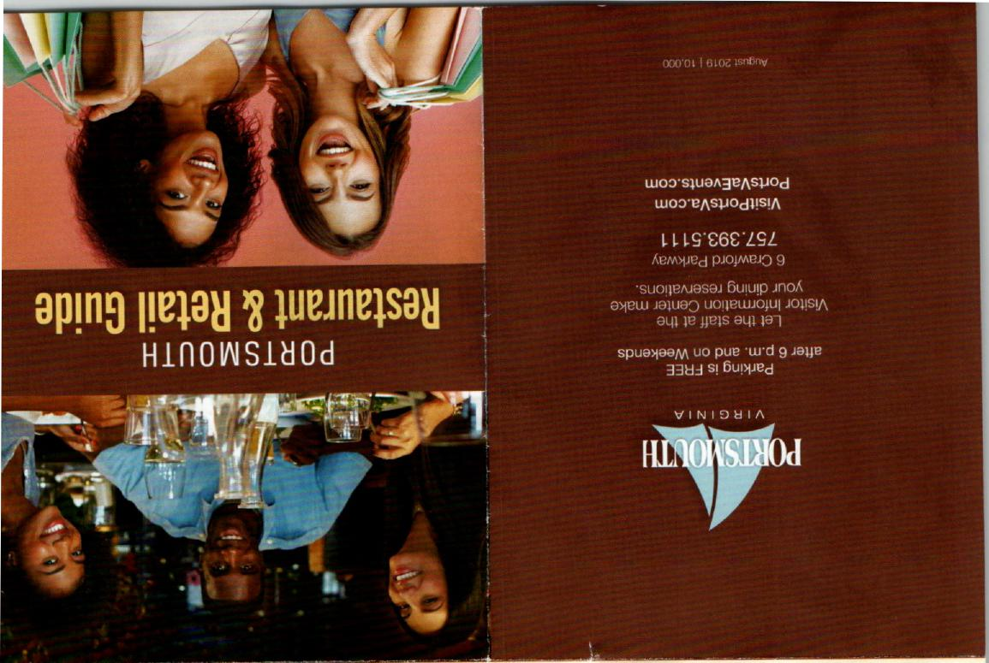
RESTAURANTS

619 Cantina
Gino's Pizzeria
Pizza, pasta & subs I 455 Court Street
757. 998.2040
Gosport Tavern t
Gastropub, Lunch, Dinner
Saturday & Sunday Brunch On
702 High Street 1 757.606.2666
GosportEats.com
Griff's Restaurant & Sports Lounge
Pub Fare & American, Lunch & Dinner
Saturday & Sunday Breakfast
509 High Street 1 757.606.3990
Guads at Olde Towne
Mexican • Lunch & Dinner
612 Court Street 1 757.399.6120
GuadsMexican.com
Humboldt Steel Corporation
Pizza by the slice, calzone & stromboli
Lunch & Dinner 1 501 High Street
757.606.2949 1 HumboltSteetcom
Legend Brewing Depot
Brew pub & Restaurant, Lunch & Dinner
1 High Street 757.998.6733 I
LegendBrewing.com
California style burritos, tacos, Lunch & Dinner
619 High Street I 757.967.9607
Baron's Pub & Restaurant
Pub fare, American, Lunch & Dinner
500 High Street I 757.399.4840
Bella Pizza
Pizza, pasta, & subs, Lunch & Dinner
1125 Port Centre Parkway I 757.399.4777
Beyond Vegan Cell Food
Vegan cafe, juice & smoothie bar, Lunch &
Dinner 1 615 High Street I 757.606.1307
BeyondVeganCellFood.com
Bier Garden ( ^{C)}/
Authentic German cuisine, Lunch & Dinner,
I 438 High Street I 757.393.6022 I
BierGarden.com

Café Europa
Mediterranean cuisine, Dinner
319 High Street 1 757.399.6652
TheCafeEuropa.com
Cancun Fiesta
Mexican cuisine Lunch & Dinner
506 Dinwiddie Street 1757.392.3465
CancunFiestaRestaurant com
Commodore Theatre
1945 Art Deco Style Motion Picture Theatre
Sandwiches, desserts, pizza, beer & wine
421 High Street 1 757.393.6962
CommodoteTheatre.com
District
American Southern Cuisine, Lunch & Dinner
448 Green Street 1 757.337.0337
Dock of the Bay
Seafood, Lunch & Dinner
103 Constitution Avenue 1 757.337.8604
DockotTheBayVa.com
Fish & Slips Marina Raw Bar & Grill
Lunch & dinner, weekend breakfast
10 Crawford Parkway 1 757.998.6631
FishnSlips.com
Five Boroughs
Pizza, subs & shawarma
814 High Street 1 757.967.9666
Five-Boroughs.MyCloverOnLine.com
Foggy Point Bar & Grill
Renaissance Portsmouth Hotel
American, seafood & steaks, breakfast,
Lunch, & Dinner
425 Water Street 1 757.673.3032
Lobscouser ) O^{LD}ID
American, steaks, & seafood
Lunch & Dinner 1 337 High Street
757 397 2728 1 Lobscousercom
Longboards Hawaiian Bar & Grill
Hawaiian & pub fare, Lunch & Dinner
440 High Street 1 757.399.4010
Longboardslounge.com
Olde Towne Public House American Bistro
Lunch & Dinner, Sunday breakfast
467 Court Street 1 757966.1229
OldeTownePublicHouse.com
Roger Brown's Restaurant & Sports Bar
American, seafood I Lunch & Dinner
316 High Street 1 757.399.5377
RogerBrowns.com ^{\-}6
Scoops!
Ice cream & café
221 High Street I 757.295.8369
Stellar Wine Company
Wine by the glass or bottle, tapas,
beer, desserts, Dinner
425 High Street 1 757 773.2672
StellarWineCo.com

CONTINUED

