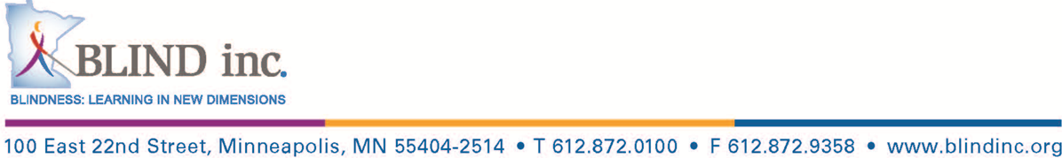

**Buddy Program Application 2022**

Date of Application:

GENERAL INFORMATION

Full Name:

Preferred Name:

Gender:

Date of Birth:

Age:

Height:

Address:

City, State, Zip Code:

Phone:

Email:

GUARDIAN INFORMATION

Guardian’s Name:

Relationship:

Address:

City, State, Zip Code:

Phone:

Email:

Preferred method of communication:

Guardian’s Name:

Relationship:

Address:

Phone:

Email:

Preferred method of communication:

EDUCATION BACKGROUND

Name of School:

Grade in School:

Name of Teacher of the Visually Impaired (TVI):

Phone:

Email:

Name of Orientation and Mobility (O&M) teacher:

Phone:

Email:

PREVIOUS BLINDNESS TRAINING

Please let us know if you have had training in any of the following types of blindness skills and what your current levels are in each area.

Orientation and Mobility (Cane Travel and/or Low Vision Training) YES or NO

If yes, please explain:

Home and Personal Management YES or NO

If yes, please explain:

Braille Reading and Writing YES or NO

If yes, please explain:

Typing/Keyboarding? YES or NO

Words Per Minute:

Degree of accuracy (100%, 80%, etc.):

Computers and Access Technology? YES or NO

Hardware and Software used:

Physical Fitness YES or NO

If yes, please explain:

HOBBIES/INTERESTS

What are some of your hobbies/interests:

MEDICAL HISTORY

Cause of blindness:

Degree of Vision with Correction: Right Eye Left Eye

Visual Field Limitations: Right Eye Left Eye

Do you have any allergies?

If yes, please explain:

Please describe any dietary restrictions.

Please describe any restrictions on activities.

Please describe any serious or potentially life-threatening medical conditions with treatment and/or medication (examples include asthma attacks, angina, and seizures):

Additional disabilities (hearing loss, learning disabilities, etc.)/Other things we should know:

MEDICATION INFORMATION

Do you take any medication on a regular basis? ____Yes ____No

(If yes, please provide details below.)

|  |  |  |  |  |
| --- | --- | --- | --- | --- |
| Name of Medication | **Dosage & Time Taken** | **Reason for Medication** | **Administer medication independently** | **Additional Comments** |
|  |  |  |  |  |
|  |  |  |  |  |
|  |  |  |  |  |
|  |  |  |  |  |

CURRENT HEALTH COVERAGE

Name of Insurance Provider:

Policy Number:

To the best of my knowledge the information listed above is complete and accurate. This will enable BLIND, Inc. staff to best meet the needs of the applicant.

Failure to provide complete or accurate information could result in denial or dismissal from the program.

**______________________________________________________________________________**

**Signature of Parent/Legal Guardian Date**

**______________________________________________________________________________**

**Name of Parent/Legal Guardian Date**

EMERGENCY CONTACT INFORMATION

Name:

Address:

City, State, Zip Code:

Phone Number:

Relationship:

Name:

Address:

City, State, Zip Code:

Phone Number:

Relationship:

**______________________________________________________________________________**

**Signature of Applicant Date**

**______________________________________________________________________________**

**Signature of Parent/Legal Guardian Date**

**Please return this application by scan and email it to** [mgip@blindinc.org](mailto:mgip@blindinc.org)**.**

*We invite you to take a tour of our facilities and learn more about our program. Please call (612) 872-0100, or our toll-free number 1-800-597-9558, to arrange a visit.*