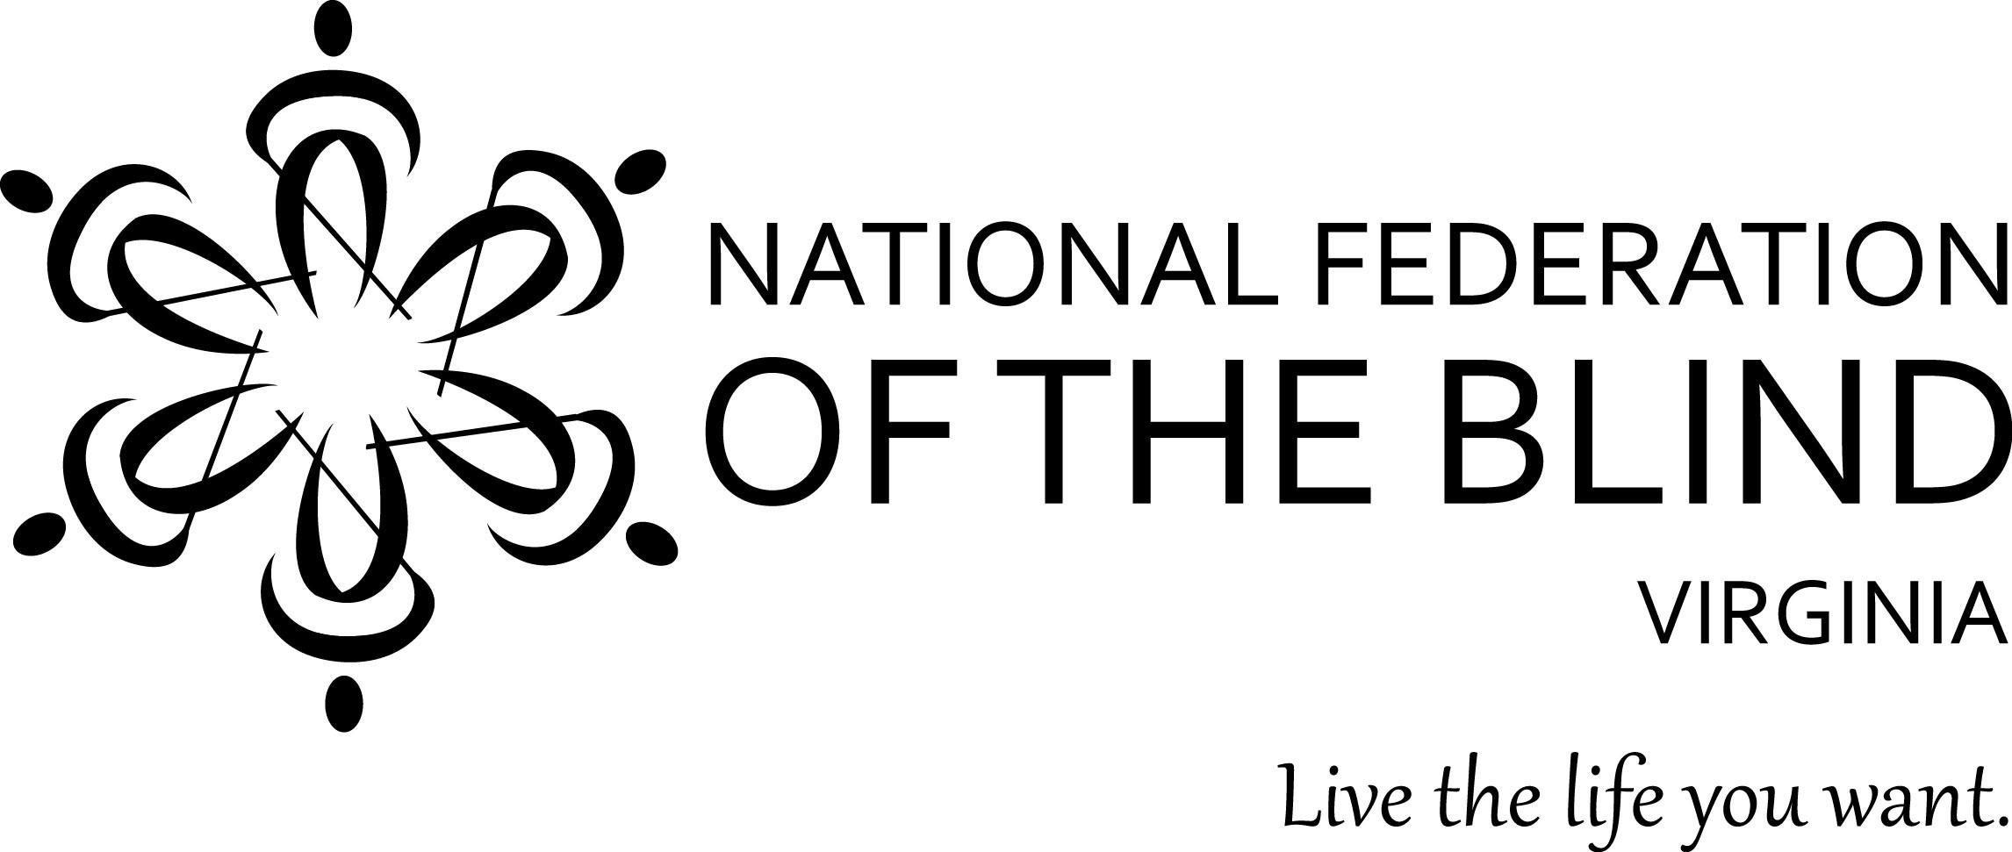

Tracy Soforenko, President

1511 North Jackson Street

Arlington, VA 22201

202-285-4595

tracy.soforenko@gmail.com

**2025 LEGISLATIVE PRIORITIES FROM THE BLIND OF VIRGINIA**

**Priority 1: Modernize governmental procurement of accessible technology**

**Action: Co-Sponsor H.B. 2541 (Del. Kathy Tran)**

**Issue**: Virginia governmental entities often use technology that is inaccessible to individuals with disabilities. This creates barriers for essential activities such as voting, accessing critical information during emergencies, interacting with public services, and even finding someone in the government to speak to about accessibility issues. While regulations under the Americans with Disabilities Act (ADA) require website accessibility, Virginia’s Information Technology Access Act (ITAA), passed in 1999, is woefully outdated and does not align with current ADA requirements.

In 2024, the General Assembly passed HB1355 in the House and referred it for further study by the Procurement Working Group. This study confirmed the need for updates and provided actionable recommendations to address accessibility gaps. The study recommended:

● Amending Chapter 35 of Title 2.2 to require compliance with Title II of the ADA for all covered entities, with timelines matching ADA standards.

● Expanding the definition of covered entities to include public schools.

● Prioritizing accessibility for systems and applications used by the public.

● Requiring agencies to publish contact information for reporting accessibility barriers.

**Solution**: HB 2541 incorporates these recommendations and modernizes the ITAA to align with federal laws, including the ADA, Section 504 of the Rehabilitation Act, and the Individuals with Disabilities Education Act. It equips Virginia governmental entities with the necessary tools to comply with these laws as they purchase new technology. It does not create additional legal burdens but provides practical guidance for compliance. Key improvements include:

● Extending protections to all disabilities, not just blindness or low vision.

● Including K-12 education to address the growing reliance on technology in schools.

● Providing a point of contact when an access barrier is identified.

**Priority 2: Website Access under the Virginians with Disabilities Act: Technical Amendment**

**Action: Co-Sponsor H.B. 1680(Del. Laura Jane Cohen)**

**Issue**: Websites and mobile applications are an essential part of modern living. Millions of individuals with disabilities rely on them for shopping, accessing services, and obtaining information. While the ADA regulations mandate accessibility, Virginia’s current Virginians with Disabilities Act does not include websites in its definition of "Place of Public Accommodation” making it inconsistent with federal law.

**Solution**: HB 1680 is a technical amendment that makes the Virginians with Disabilities Act consistent with the Americans with Disabilities Act by adding “websites” to the definition of place of Public Accommodation.

**ABOUT THE NATIONAL FEDERATION OF THE BLIND**

The National Federation of the Blind is America’s largest and most active organization of blind people. With tens of thousands of members nationwide, we are not an “agency” claiming to speak for the blind; we are blind people speaking for ourselves. In Virginia, we are organized into 12 local chapters throughout the Commonwealth, and into various special interest divisions.