National Federation of the Blind of the District of Columbia

Annual State Convention

presents the

Blind Professionals Networking Event

on
Friday, October 14, 2016 from 4-7 p.m.

at the
Embassy Suites Convention Center
900 10th St. NW·Washington, DC
Bar at Finn & Porter Restaurant

The purpose of the event is for blind and visually impaired professionals to network and share resources, ideas, and success stories. Be sure to bring your business cards! *CASH Bar*

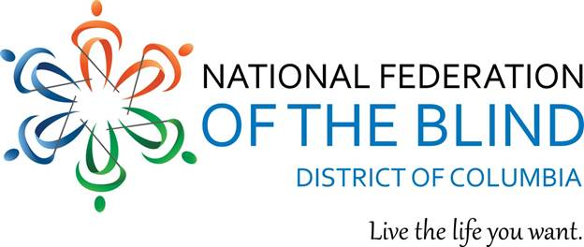
If you have questions, please contact Janice Forbes at janiceforbes2012@gmail.com

