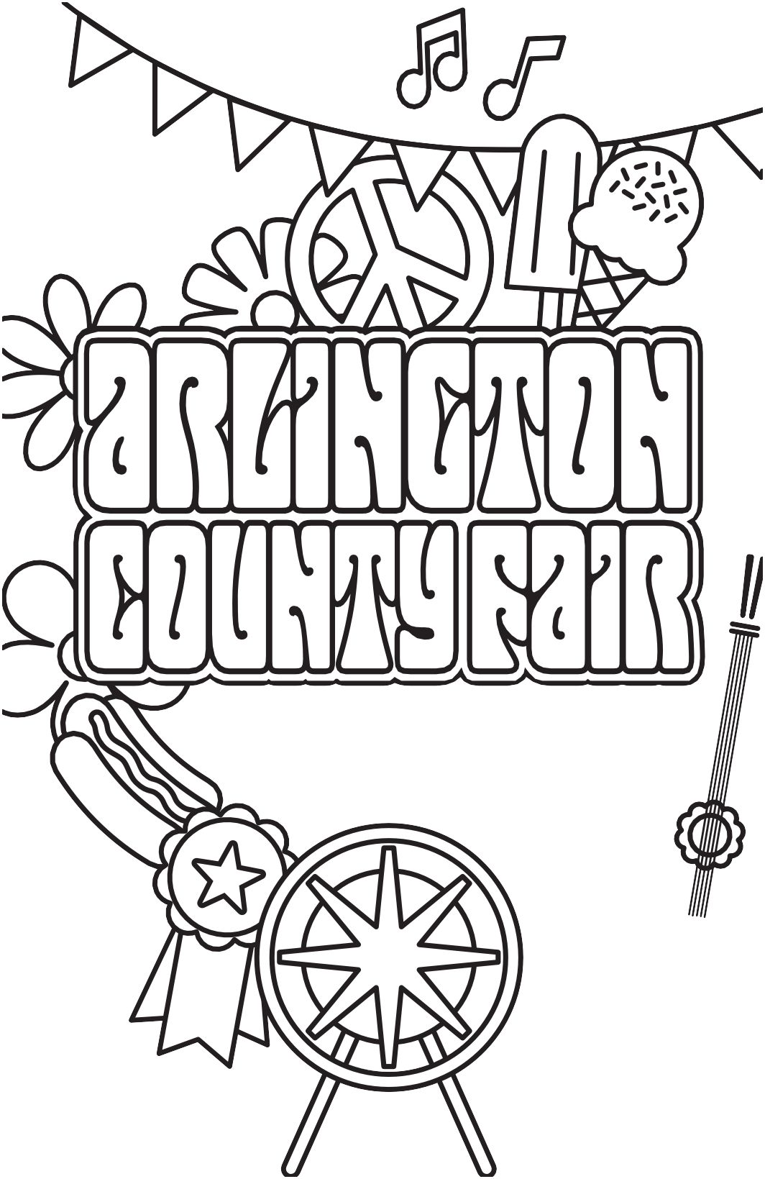

AUG 17-21, 2016

ArlingtonCountyFair.us

Board members:
René Gornall
Chairperson
Isabelle Kohler
Vice Chair
Jackie Abrams
Treasurer
Ray Herras
Secretary
Lisa Barrera Rachel Coates Kim Le
Lizbeth Melendez Michael Onuoha Kyle Thornhill
Katherine Garcia Jonathan Moya Justin Tran
Youth Representatives
Laura Barragan
County Liaison
August 17, 2016

Welcome to the Arlington County Fair!

We’re so excited for you to join us for our 40th year in Arlington! Our theme this year, “Groovy Since 1977,” not only celebrates our first Fair but every year since as we come together as a community to showcase the best of Arlington.

The 2016 Fair promises to be one of our best ever! We are welcoming back some fan favorites, as well as some far out, new fun. You’ll find something for everyone: pig races, pony rides, local performers, delicious food, rides and games! Check out all the new and returning fun on the activities schedule on page 4.

As always, our all-volunteer board has put together an incredible event for you to enjoy and we’re so grateful for all those who give their time to the Fair throughout the year and that special week in August. If you love the Fair as much as we do, we welcome your help and feedback. To join the board, volunteer or provide feedback, please email us at info@arlingtoncountyfair.us or find any of the board members on the fairgrounds.

The Arlington County Fair is a nonprofit organization and we are so grateful for the generous support of our sponsors and partners, who are vital to putting on this huge event each year. I would like to especially thank the Arlington County Government for their support and the Arlington Heights neighborhood who graciously allow
us make their home ours for a few days each year. Finally, I’d like to thank the Arlington County Fair Board of Directors. The talent and teamwork of this group is DY-NO-MITE and I’m proud to be part of such a great group of community leaders.

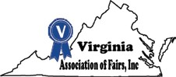
We hope you enjoy the groovy sights, sounds and tastes of the 40th Arlington County Fair!

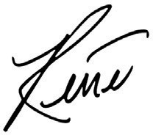
René Gornall, Chairperson
Arlington County Fair Board of Directors

Follow us on Twitter, Instagram & Snapchat: @arlingtoncofair or #arlingtoncofair
Like us on Facebook: facebook.com/arlingtoncofair
Visit our Website: arlingtoncountyfair.us

Cover illustration by Carolyn Sewell

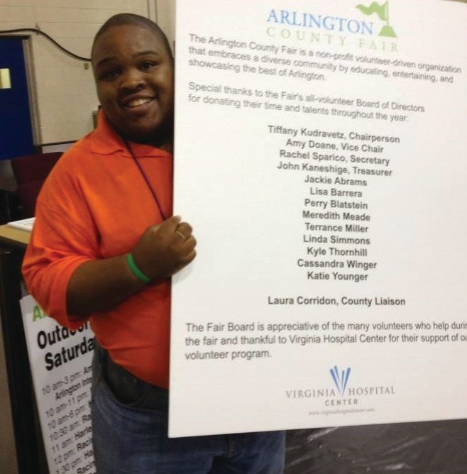
In MeMory oF
Terrance MILLer

ust weeks after our 2015 Arlington County Fair we lost a dear member of our Fair family, Terrance Miller, 28, a dedicated volunteer and two-term board member who passed away on August 18, 2015.
J

Terrance’s was one of the first faces people encountered as they arrived at the Fair. Throughout his tenure as a volunteer, Terrance served in almost every area of the Fair, and as with many board members, the Fair became a family effort and Terrance’s aunt, Janise Kyle, often joined him for volunteer shifts. Terrance loved the community nature of the fair and often spent time volunteering on our Turf Field and Kid's Court or enjoying performances on the Outdoor Stage and the carnival rides.

We dedicate the 2016 Arlington County Fair in Terrance’s memory. Wherever he went, Terrance brought so much joy to people’s lives and loved to share the fun of the Fair through his social media. We hope you will honor his legacy by joining us at our new photo booth in our Indoor Vendor area to make your own memories of the Fair, just as Terrance often did.

We know that we are not the only ones who will miss Terrance’s smiling face at the Fair this year. If you’d like to celebrate Terrance’s legacy to our community, contributions can be made to the Terrance James Miller ‘09 Memorial Scholarship at his alma mater Johnson & Wales University in Charlotte, NC. Donations can be sent to: Johnson & Wales University, Attn. Chris Plano / Terrance James Miller ‘09 Memorial Scholarship, 801 W Trade Street, Charlotte, NC 28202.

FAIR dAtes | IndooR HouRs | outdooR HouRs
Wednesday, August 17 | N/A | 5 pm – 10 pm
Thursday, August 18 | N/A | 5 pm – 10 pm
Friday, August 19 | 4 pm – 10 pm | 2 pm – 11 pm
Saturday, August 20 | 10 am – 9 pm | 10 am – 11 pm
Sunday, August 21 | 11 am – 7 pm | 11 am – 10 pm

Transportation to the Fair
2016 Dates and Times
Shuttles will run every 30 minutes each day during the Fair’s operating hours from the Ballston Metro, the Arlington Career Center, Pentagon City Metro and the I-66 parking garage. The last shuttle departs the Fair shuttle stop 10 minutes after the Fair closes. A $2 round-trip fee is charged for shuttle services and will be collected upon arrival at the Fair. Children 12 and under and seniors 65 and over ride for free. Onsite ADA parking is available at the Fair site in the parking lot located directly in front of the Thomas Jefferson Community Center.

There is no public parking at the Fair site and parking on nearby streets is restricted to neighborhood residents with temporary permits only.

We also offer free valet bike parking on our tennis courts through a partnership with BikeArlington and Two Wheel Valet. We encourage you to check out CarFreeDiet.com for information on other car-free transportation options.

neW for 2016! Find the Disco Ball contest
Since we have been groovy since 1977, we want to celebrate our 40th Fair and the decade of our birth by holding a contest. Once the indoor vendor area opens on Friday, August 19th, we will be hiding a disco
ball in a different vendor’s booth each day. The first person who spots the disco ball each day and notifies the Arlington County Fair staff at the registration desk will receive free ride tickets. Far out!

Official rules:
- No purchase necessary.
- Arlington County Fair Board of Directors and volunteers, food vendors and indoor vendors are not eligible.
- Indoor vendor hours are August 19 from 4pm to 10pm, August 20 from 10am to
9pm and August 21 from 11am to 7pm.
- One prize pack (two ride tickets, good for two full rides) will be given per day to the first person to find the disco ball. If no disco ball is found by the close of the indoor vendor area, no prizes will be awarded.
- To win, you must bring the disco ball to an Arlington County Fair board member (in green Fair polo shirts) at the indoor registration desk near the Indoor Stage. See the map on page 9 for details.
- Winners will be announced via the Arlington County Fair’s social media channel(s).
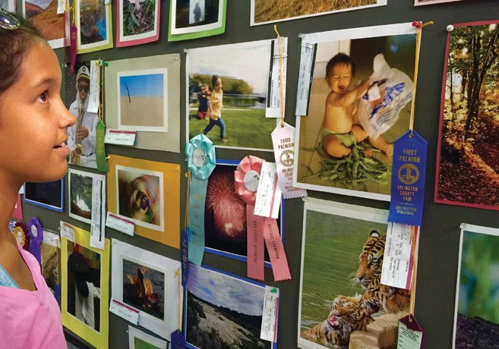

Photo of the Day contest
Get your camera out and have fun at the Fair! The Arlington County Fair invites you to submit your favorite photographs from this year’s Fair for our Photo of the Day contest. Each day, we will select one winner who will receive an official 2016 Fair t-shirt and four ride tickets. One grand prize will also be chosen to win a prize pack for the 2017 Fair, which includes two 2017 t-shirts and eight ride tickets.
You may also have your photograph featured on our website, Fair program, or competitive exhibits guide.

Please send your entries to marketing@ arlingtoncountyFair.us by 10:00am the following day, along with your name and your neighborhood. Photos will be judged on subject, creativity, composition, and how well they capture the spirit of the Arlington County Fair. Winners will be contacted directly by
e-mail with instructions on prize pick-up.

By submitting a photograph, you agree to the following:
- Materials that are obscene, vulgar, sexually- orientated, hateful, threatening, or otherwise violate any laws are strictly prohibited. If such photographs are received, proper action will be taken and you will be disqualified from the contest.
- No copyrighted images will be accepted. Each photograph must be your own and taken during the 2016 Arlington County Fair.
- You give the Arlington County Fair permission to use your photograph in future promotional materials and to have your first name and neighborhood shared along with your picture in our online photo album.
- Photographs must be attached in .jpg format.
- There is a limit of 5 photograph submissions per day; please send all submissions for a particular day in one email to marketing@arlingtoncountyFair. us by 10:00am the following day.
- Do not submit the same photograph on multiple days.
- No alternative prizes will be offered if the winner is not available to accept the prize offered. Prizes are not transferable.

To view photographs that have been submitted and see a list of winners, visit our photo album on Facebook at www.facebook.com/arlingtoncoFair. Good luck!

arlington county Fair Parade
Join us for the 40th Arlington County Fair and celebrate our community on Saturday, August 20, at 10:00am. Whether as a parade participant or
watching from the sidewalk, this is a must-attend for all Fair-goers!

Local Performers on Stage
The Arlington County Fair is proud to showcase the best of Arlington and our neighboring communities!
A variety of local music groups and solo performers are hosted on our Outdoor Stage. The stage is located on the baseball field. Seating is provided under a tent and Fair-goers are encouraged to grab some food for a picnic and cheer on the performers. All Fair-goers are invited to visit our Indoor Stage to watch some
of the area’s most talented groups perform. From singers to dancers to Bingo, a variety of entertainment will be showcased!

competitive exhibits
Competitive Exhibits are an integral and interactive part of the Arlington County Fair providing the
opportunity for community members to share their talents. We are so grateful to the Arlington Community Federal Credit Union for their support of this programming. All entries will be on display indoors starting on Friday, August 19th. All Fair-goers are also invited to the Awards Ceremony, which will take place at the Indoor Stage on Sunday, August 21, at 3:00pm.
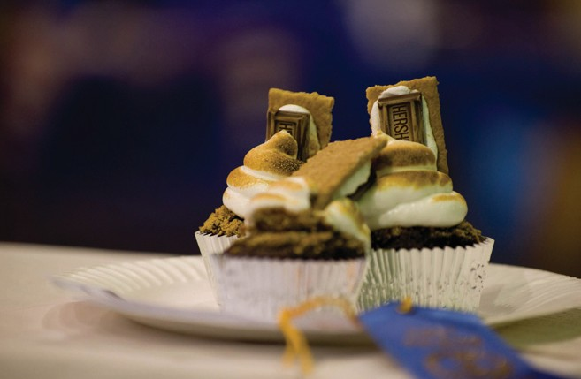

Kids’ court
Families are at the heart of the Arlington County Fair. Face painting, inflatables, the monster mural and other games and activities fill the Kids’ Court with fun for children. Be sure to visit the basketball court to experience the excitement of the Harlem Wizards! All activities on the Kids’ Court are free.

Senior Spotlight
In partnership with the Arlington County Senior Adult Program, we are pleased to bring a variety of
programming for Seniors to the Fair. Activities include Bingo, a performance by Ms. Senior Virginia America 2016 with the Cameo Jewels, and other performers on our Indoor Stage, a new Pickleball class on Thursday evening, and more!

Turf Field Programming
A visit to the turf field is a must for of all ages. Each day, the Fair will feature activities and demos from local youth and adult athletic leagues, dance groups and more! Most welcome audience participation, so check out the schedule for details.

ride Tickets
Cole Shows Amusement Company will return to the Arlington County Fair to provide amusement rides, midway games, and delicious food for Fair-goers of all ages. For more information, visit Cole Amusements online at www.colerides.com.

Schedule of all activities
*Welcomes audience participation

Wednesday, August 17
All day Pony Rides
5:00 pm True Health Kids Obstacle
Course* - Turf Field
5:30 pm Racing Piglets/Racing Goats 7:00 pm Racing Piglets/Racing Goats 9:00 pm Racing Piglets/Racing Goats

Thursday, August 18
All day Pony Rides
5:00 pm What is Pickleball?* Exhibition/ Class - Kids' Court
5:00 pm FIVES (Indie Rock/Pop) - Outdoor Stage 5:00 pm True Health Kids Obstacle
Course* - Turf Field
5:30 pm Racing Piglets/Racing Goats 6:15 pm Cymbalize (Singer-Songwriter/
Indie Pop) - Outdoor Stage 7:00 pm JOURNEYoga* - Turf Field 7:00 pm Racing Piglets/Racing Goats
7:30 pm Funkhouse (DJ set) - Outdoor Stage 9:00 pm Racing Piglets/Racing Goats

Friday, August 19
All day Pony Rides
2-7 pm ACFD Obstacle Course* - Tennis Courts 2:00 pm Ultimate Frisbee - Turf Field
3:00 pm Harlem Wizards* - Kids' Court 3:30 pm Dynamic Gymnastics - Turf Field 4:00 pm Creative Movers* - Kids' Court 4:00 pm Racing Piglets/Racing Goats 5:00 pm Senior Bingo* - Indoor Stage 5:00 pm Harlem Wizards* - Kids' Court 5:00 pm Zumba by Nataki* (Dance
Fitness) - Outdoor Stage 5:00 pm True Health Kids Obstacle
Course* - Turf Field
5:30 pm Racing Piglets/Racing Goats
6:00 pm Sultanas Troupe (Dance) - Indoor Stage 6:15 pm Jahnel Daliya (Singer-
Songwriter) - Outdoor Stage
7:00 pm Hypnotic Experience* - Indoor Stage 7:00 pm Racing Piglets/Racing Goats
7:30 pm 40 Miles Home (Bluegrass/
Indie) - Outdoor Stage
8:00 pm Potomac Harmony Chorus - Indoor Stage 8:30 pm Racing Piglets/Racing Goats
8:45 pm Sub Radio (Pop/Rock) - Outdoor Stage

Saturday, August 20
All day ACFD Obstacle Course* - Tennis Courts All day Pony Rides
10:00 am Parade
11:00 am Harlem Wizards* - Kids' Court 11:30 am YMCA Arlington* - Turf Field 12:00 pm Creative Story Hour by Encore
Stage - Kids' Court
12:00 pm Rhythm in Motion (Dance) - Indoor Stage 12:00 pm Darcy Dawn & Co (Rock) - Outdoor Stage 12:00 pm Racing Piglets/Racing Goats
1:00 pm The Arlingtones (Barbershop
Chorus) - Indoor Stage 1:00 pm YMCA Arlington* - Turf Field
1:15 pm The Capitol Heights (Coffee House Folk/Indie) - Outdoor Stage
1:30 pm Harlem Wizards* - Kids' Court 2:00 pm Cameo Jewels (Song/Dance/
Comedy) - Indoor Stage 2:00 pm Racing Piglets/Racing Goats
2:30 pm Creative Story Hour by Encore Stage - Kids' Court
2:30 pm Silver City (Americana) - Outdoor Stage 2:30 pm True Health Kids Obstacle
Course* - Turf Field
3:00 pm Calico Cloggers - Indoor Stage 3:45 pm A Thousand Rainy Days (The
Police tribute) - Outdoor Stage 4:00 pm Perfect Pointe Performance
Troupe (Dance) - Indoor Stage 4:00 pm Harlem Wizards* - Kids' Court 4:00 pm Evolve All (Martial Arts) - Turf Field 4:30 pm Racing Piglets/Racing Goats
5:00 pm Hip Hop Class* - Indoor Stage 5:00 pm Ciclon Y Su Combo (Latin/
Salsa) - Outdoor Stage
5:30 pm Harlem Wizards* - Kids' Court
6:00 pm Old Dominion Cloggers - Indoor Stage 6:00 pm Racing Piglets/Racing Goats
6:15 pm Detached Retina (Rock) - Outdoor Stage 7:00 pm Plastic Sky (Indie Acoustic) - Indoor Stage 7:30 pm The N2N Band (R&B) - Outdoor Stage 8:00 pm Harry Jay Smith and the Bling
(Jazz/Funk) - Indoor Stage 8:45 pm Wesley Spangler (Country)
- Outdoor Stage

Sunday, August 21
All day ACFD Obstacle Course* - Tennis Courts All day Pony Rides
11:00 am Zumba with Rita* - Turf Field 11:00 am Racing Piglets/Racing Goats 11:30 am Harlem Wizards* - Kids' Court 11:45 am The Duskwhales (Indie
Rock) - Outdoor Stage

12:30 pm Arlington Soccer - Turf Field 1:00 pm Dr Robinson’s Fiasco (Alt-Rock/
Indie Pop) - Outdoor Stage 1:00 pm Racing Piglets/Racing Goats 2:00 pm Harlem Wizards* - Kids' Court 2:00 pm True Health Kids Obstacle
Course* - Turf Field
2:15 pm Dan Barry (Singer-Songwriter)
- Outdoor Stage
3:00 pm Competitive Exhibits Award
Ceremony - Indoor Stage 3:30 pm Atoms Apart (Pop/Electronic)
- Outdoor Stage
3:45 pm Aikido Demonstration - Turf Field 4:00 pm Racing Piglets/Racing Goats
4:45 pm Lionel Ward (Elvis Tribute) - Outdoor Stage 5:00 pm JOURNEYoga* - Turf Field
6:00 pm Night Watch Paradox (Rock/Jazz/ Cabaret) - Outdoor Stage
6:00 pm Racing Piglets/Racing Goats 7:15 pm The 5-1-2 Experience (R&B/
Neo-Soul) - Outdoor Stage

Indoor Stage Performances

Friday, August 19
5:00 pm Senior Bingo*
6:00 pm Sultanas Troupe (Dance) 7:00 pm Hypnotic Experience* 8:00 pm Potomac Harmony Chorus

Saturday, August 20
12:00 pm Rhythm in Motion (Dance)
1:00 pm The Arlingtones (Barbershop Chorus) 2:00 pm Cameo Jewels (Song/Dance/Comedy) 3:00 pm Calico Cloggers
4:00 pm Perfect Pointe Performance Troupe 5:00 pm Hip Hop Class*
6:00 pm Old Dominion Cloggers 7:00 pm Plastic Sky (Indie Acoustic)
8:00 pm Harry Jay Smith and the Bling (Jazz/Funk)

Sunday, August 21
3:00 pm Competitive Exhibits Award Ceremony

outdoor Stage Performances

Thursday, August 18
5:00 pm FIVES (Indie Rock/Pop)
6:15 pm Cymbalize (Singer-Songwriter/Indie Pop) 7:30 pm Funkhouse (DJ set)

Friday, August 19
5:00 pm Zumba by Nataki* (Dance Fitness)
6:15 pm Jahnel Daliya (Singer-Songwriter) 7:30 pm 40 Miles Home (Bluegrass/Indie) 8:45 pm Sub Radio (Pop/Rock)

Saturday, August 20
12:00 pm Darcy Dawn & Co (Rock) 1:15 pm The Capitol Heights (Coffee
House Folk/Indie)
2:30 pm Silver City (Americana) 3:45 pm A Thousand Rainy Days
(The Police tribute)
5:00 pm Ciclon Y Su Combo (Latin/Salsa) 6:15 pm Detached Retina (Rock)
7:30 pm The N2N Band (R&B)
8:45 pm Wesley Spangler (Country)

Sunday, August 21
11:45 am The Duskwhales (Indie Rock)
1:00 pm Dr. Robinson’s Fiasco (Alt-Rock/Indie Pop) 2:15 pm Dan Barry (Singer-Songwriter)
3:30 pm Atoms Apart (Pop/Electronic) 4:45 pm Lionel Ward (Elvis Tribute)
6:00 pm Night Watch Paradox (Rock/Jazz/Cabaret) 7:15 pm The 5-1-2 Experience (R&B/Neo-Soul)

Turf Field activities

Wednesday, August 17
5:00 pm True Health Kids Obstacle Course*

Thursday, August 18
5:00 pm True Health Kids Obstacle Course* 7:00 pm JOURNEYoga*

Friday, August 19
2:00 pm Ultimate Frisbee 3:30 pm Dynamic Gymnastics
5:00 pm True Health Kids Obstacle Course*

Saturday, August 20 11:30 am YMCA Arlington* 1:00 pm YMCA Arlington*
2:30 pm True Health Kids Obstacle Course* 4:00 pm Evolve All (Martial Arts)

Sunday, August 21
11:00 am Zumba with Rita* 12:30 pm Arlington Soccer*
2:00 pm True Health Kids Obstacle Course* 3:45 pm Aikido Demonstration
5:00 pm JOURNEYoga*

*Welcomes audience participation

Food Trucks & Vendors
Food is one of the best parts of the Arlington County Fair! Dine al fresco with delicious bites from one or more of the vendors joining us this year.

A & B Soft Serve: Soft Serve Ice Cream, Waffle Cones, Sundaes, Chocolate-dipped Cones

Ben’s Chili Bowl: Ben’s Famous Half-smoke, All-beef Hot Dog (4 oz), Turkey Dog (4 oz) (all can be served with chili sauce), Chili con Carne (8 oz), Veggie Chili (8 oz) (both can be served with cheese and onions), Chili Cheese Nachos, Veggie Chili Nachos

The Big Cheese: Variety of Grilled Cheese, Iced Tea, Lemonade, Chips, Brownies

Bunny and the Bear Food Festival: Real Fresh Fruit Smoothies, Lemonade, Thai Iced Tea

Columbian Food and Dessert: Arepas con Carne/Pollo/ Queso, Arepas de Choclo (sweet corn with cheese), Plátano Verde con Carne/Pollo (green plantain), Empanadas con Carne/Pollo/Queso, Lechona (pork, yellow peas and rice), y Chorizo con Papas

Crab Cab: Crab Cakes, Salmon, Shrimp, Crab Bisque Soup, Fries, Salads, Coleslaw

Dyvine BBQ: Spareribs, Pulled Pork Sandwiches, Chopped Chicken Sandwiches, Leg Quarters, Hot Dogs, Beef Kielbasa, Jumbo Turkey Legs, Chicken Tenders, Baked Beans, Mac and Cheese, Collard Greens, French Fries, Cole Slaw, Potato Salad, Mango Lemonade

Family Grill: Fried Rice, Lo Mein, Chicken and Beef Kabobs, Chicken Teriyaki on a Stick, Pad Thai, Egg Rolls, Corn Dogs, Lemonade, Iced Tea

The Farm Effect: Sandwiches (Farmer’s Daughter, Wagon Wheel, Sultry Poultry, Divine Bovine), Potato Salad, Chips, Dessert Bars, Cookies, Thirsty Farmer (Kombucha mixed with Organic Juice)

Happy Bowls: Chicken Teriyaki Bowl, Beef Bowl, Spicy Pork Bowl, and Chicken Teriyaki, Beef, Spicy Pork Sub (three meats served in a sub)

International Grill Company: Gyros (Beef, Lamb and Chicken), Steak and Cheese/Cajun Chicken, Polish and Italian Sausage, Homemade Falafel in Pita, Veggie Wraps/Hummus in Pita, Supreme Greek Salad, Stuffed Grape Leaves, Fresh Cut Fries, Butterfly Chips,
Corn Dogs, Hot Dogs, Chicken Tenders, Fried Oreos, Funnel Cakes, Fresh-Squeezed Lemonade

MacBrand Foods: Sausage, Cheesesteak, Hamburgers, Hot Dogs, Corn Dogs, Chicken Tenders, Ribbon Fries, Funnel Cake, Deep Fried Candy, Lemonade, Tea

Orient-Bowl: Special Fried Rice, Chicken Noodle Stir-fry, Vietnamese Spring Roll, Lemon Chicken on a Skewer, Teriyaki with Rice, Quesadilla, Deep-Fried Oreo, Funnel Cake, Fresh-squeezed Lemonade, Smoothies, Pho, Bun Thit Nuong (Vietnamese pork with cucumber)

Papa John's: Cheese Jumbo Slice, Peperoni Jumbo Slice
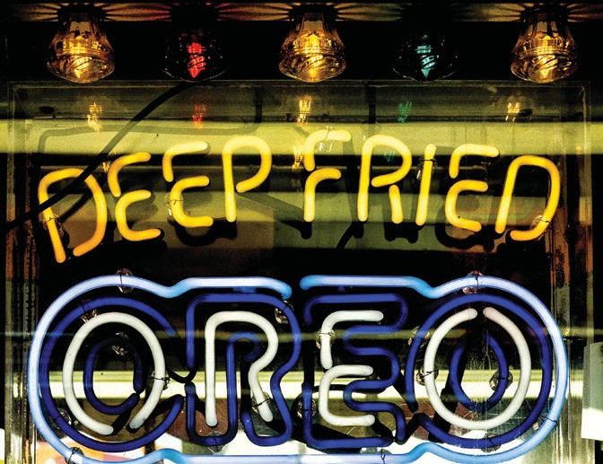

Royal Creamery and Coffee: Pizza Cones (cheese, sausage, pepperoni), Soft Serve Ice Cream, Milkshakes, Tornado Sundae (funnel cake mix topped with whipped cream and drizzled with chocolate), Deep-Fried Snacks, Hot Coffee

Tailgater Toby BBQ Cafe: Pulled BBQ Pork or Chicken Sandwich, Sliced BBQ Beef Brisket, Cheddar Bratwurst and Garlicky Kielbasas, 100% Angus Beef Hot Dog, Mac-n-Cheese Bowl (bacon mac-n-cheese topped with your choice of BBQ meat, jalapeños and crumbled potato chips), Hickory-Smoked BBQ Tacos, Potato Salad, Creamy Coleslaw, Mac-n-Cheese

The Tender Rib: Pork Ribs, Beef Brisket, NC Pulled Pork, Chicken Tenders, Fries

Yummy Food Corner and Grill: Chicken Teriyaki on a Stick, Pad Thai, Fried Rice, Yakisoba Noodle,
Stir Fry (choice of seafood, steak or chicken) with Rice, Yakisoba Noodle and Vegetable, Egg Rolls, Corn Dogs, Bubble Smoothies, Thai Iced Tea

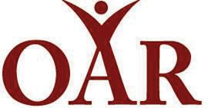
a Special Thank you to our Partners & Sponsors:
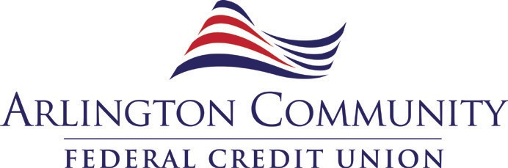

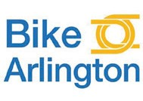

Indoor Vendors
A-Span ............................................ C11
AAPCO............................................. J11 Aburi Botanicals .............................. C06
AFAC ....................................... C15-C16
Amazing Skylights........................... J07
Ameritech Construction ...................H16 Andrew Romer ................................ F01
Animal Welfare League of Arlington.D07 Anna Elsa Design ........................... M12
AoPS Academy ................................D05
Arlington Aging & Disability Services........................................ K08
Arlington Commissioner of the Revenue........................................ K04
Arlington Committee of 100 ............ J10 Arlington County
Sheriff's Office ............... L07-L08-L09
Arlington County Treasurer .............. K05 Arlington Free Clinic ........................ K10
Arlington GOP .................................. C13
Arlington Historical Society..............D12 Arlington Independent Media... B01-B02 Arlington Neighborhood Villages ...... K06 Arlington Outdoor Education
Association ................................... C12
Arlington Public Schools.......... K02-K03

Arlington Senior Adult Council ......... K07 Arlington Sister City Association ......D10 Arlington YMCA ........................ J02-J03
Arlington Young Democrats ......E20-E21 Arlingtones ...................................... B03
Arlingtonians for a Clean
Environment .................. L01-L02-L03 Armine’s Designs ............................ C14
Aurora Bath & Jewels...................... F02
Bamboo Pillows...............................G01
Barefoot Dreamer Designs ............. M06
Barker Adoption Foundation ............H13
Basis Independent McLean ............. B04 BathFitter ........................................ B10
Beldon Home Solutions ..................H18 BeyondWood ................................... E05
Bibi salon & Spa .............................. B11
BIGE VONA..............................M01-M02
Boso Foods..................................... M13
Boy Scout's of America NCAC ......... J04 Brian’s jerky and Peanut Company .. E09 Burke & Herbert Bank ..................... C17
Capital Remodeling .........................D17
Chen Den Sand Blast.......................D06
Childrens Craft Show.......................D18 Church of Jesus Christ of
Latter Day Saints .......................... K01
Citizens for the Classic .................... C20

Closet America ................................ E10
Colibri Crafts ................................... C21
Comcast...........................A01-A02-A03
Community Resources of America... K11 Congregation Etz Hayim .................. E14 Cook Bros................................ G20-G21
Dazzling Divas Spa.......................... E15
DC DanceSport Academy ................ B06 Dead Bat Designs........................... M15
Discovery Toys ................................ F09
Earth Rhythms Jewelry ................... F07 ECDC Enterprise Development Group............................................D19
Facets ............................................. F11
First Church of Christ Scientist ........ C18 Flordelis ..........................................G06
Fresh & Fancy ................................. E08 G’s Glory Handbags ................. C09-C10
Gideons International....................... C04 Giggle in Pink ..................................H03
Glassworks by Nonie....................... E04
Goochie Glasses ..............................D09
Gray Clay Pottery.............................G05
Halo Dips.........................................G09
HandiLeighCrafted.......................... M09 Heartfelt ..........................................H04
Henna Gallery by Shweta ................D11 Henna Tattoo .................................. M03

Holistic Wellness .............................D14
Homefix Custom Remodeling .. K12-K13 Honey and Bee Products ......... C07-C08 Ismega Designs............................... F13
J. Scannell Fashions........................H08 James Haedie Building Products .....G17 John Hopkins University .................. F21 Kitchen Saver .................................. J01
Layer3 TV ........................................H11
LeafFilter of Northern Virginia, Inc....H17 Legion of Mary .........................F18-F19
Libertarian Part of NOVA .................. C05 Light Lady .......................................H01
Lily’s Miniatures ..............................G04
Loony Loony Lisa's Menagerie ........D13 M & M Inspirations .......................... F03
Maré Naturals ................................. F05
Marshall Legacy Institute................. J08
Mary Kay Costmetics....................... F06
MeiMei Fine Teas.............................G03
Mid-Atlantic Waterproofing..............G18 MMA & Sports Rehab ...................... B09
Mom & Daughter Jewelry................ F10 National Federation of the Blind.......G11 Native Winds ........................... B18-B19
Night Owl Jewelry .......................... M05
Nmandi Batik Art ..................... G07-G08
NuHome Exteriors ...........................D21
Nutrition Master Foods ................... M08 OAR.................................................G10
OCTO Puzzle.................................... F12
Original Jean Creations ................... F14 P&P Collection................................. E18
Paige Promotions LLC ..................... B05 Pampered Chef................................D04
Passanante’s Home Food Services ..H10 Peculi-art......................................... E12
Pella Windows & Doors ................... B07

Pendants By Ashlyn ......................... F08
Pentagon Mixed Martial Arts............ B08 Plushies of Fluff...............................D20
Prince William Home
Improvement ......................... J12-J13
Princess Zoey’s socks ..................... F04
Puzzled Charms ..............................D03
Red Carpet Remodeling...................H21
Renewal by Andersen...................... E16 Responsible Energy Partners...........H19 Rikki Tikki Company....................... M14 Scentsy ...........................................G13
Sears Home Services ...................... K09
SilverWhimsies Jewelry ................. M07 SP Unlimited................................... M10
Steampunk Jewelry ........................D08
Stephen Lally Pottery....................... E13 Stix & Stones................................... C01
Susan Terri Designs.........................G02 TCS Building....................................G16
Thompson Creek Windows.............. J09

Total Remodeling Systems .............. B12 Transurban ...................................... B15
Trinity Gifts ...................................... F16
Trinkets and Treasures .................... E07 Tutti Beauty ..............................E17-F17
Upper Glass.....................................H02
Usborne Books ................................ F15
Vacation Village .......................D01-D02
VCA South Paw........................D15-D16 VDOT...............................................H12
Verizon ..................................... J05-J06
Veroka Distributors......................... M16 Virginia Cooperative
Extension ....................... L04-L05-L06
Vortex Training................................. E11
Watkins Products ............................ E02
Weichert Realtors ............................G19
Whylslam DC................................... C19
Wild Women Pins.............................H09
Window Nation........................ B13-B14 Zip Car ............................................H15

COMPETITIVE EXHIBITS

B19

B18

M16 B17
K13 | J13
K12 | J12
K11 | J11
K10 | J10
K9 | J9

H21 | G21
H20 | G20
H19 | G19
H18 | G18
H17 | G17

F21 | E21
F20 | E20
F19 | E19
F18 | E18
F17 | E17

D21 | C21
D20 | C20
D19 | C19
D18 | C18
D17 | C17

L9 M15 B16

L8 B15

L7
M14

M13

B14

B13

L6
M12

M11
ENTRANCE TO VENDORS / EXIT TO MIDWAY & FOOD VENDORS
K8 | J8
K7 | J7
K6 | J6
K5 | J5
K4 | J4
K3 | J3
K2 | J2
K1 | J1

H16 | G16
H15 | G15
H14 | G14
H13 | G13
H12 | G12
H11 | G11
H10 | G10
H9 | G9

F16 | E16
F15 | E15
F14 | E14
F13 | E13
F12 | E12
F11 | E11
F10 | E10
F9 | E9

D16 | C16
D15 | C15
D14 | C14
D13 | C13
D12 | C12
D11 | C11
D10 | C10
D9 | C9

L5 B12

L4 B11

B10
M10

M9

L3 B9

L2 B8

L1
M8

M7

B7

B6

INDOOR STAGE
B5

ARLINGTON B4
M4
M3
M6

M5
H8 | G8
H7 | G7
H6 | G6
H5 | G5
H4 | G4
H3 | G3
H2 | G2
H1 | G1

F8 | E8
F7 | E7
F6 | E6
F5 | E5
F4 | E4
F3 | E3
F2 | E2
F1 | E1

D8 | C8
D7 | C7
D6 | C6
D5 | C5
D4 | C4
D3 | C3
D2 | C2
D1 | C1

COUNTY BOOTHS B3

B2

B1

INFO
M2

M1

REGISTRATION
FAIR T-SHIRTS & TERRANCE MILLER PHOTO BOOTH
ENTRANCE
A1 | A2 | A3

ROUTE 50
& Bike Path

Pedestrian

Community Garden
Competitive Exhibits

Permit Parking: Purple
Racing Piglets
Pony Rides

Rides & Games
SOUTH IRVING STREET

Indoor Vendors
Indoor Stage
Fair T-Shirts & Photobooth
SOUTH OLD GLEBE ROAD
Food Vendors

Car Free Diet

Outdoor Stage
Turf Field Programming
Yoga, Soccer, Demonstrations, and More!
Kids’ Court

Permit Parking: Green
Harlem Wizards Inflatable Games
Free Valet

Parking
Outdoor

Parking

Permit Parking: Blue
Disability Parking: Plates/Placard Required
ACFD Programming Monster Mural

Picnic
Area

Shuttle Stop

SECOND STREET SOUTH

Thomas Jefferson Community Center

Parking No public parking, except in disabiltiy lot with proper documentation.

3501 2nd Street South, Arlington, VA
Indoor Programming
Outdoor Programming Indoor Entrance
Shuttles from Arlington Career Center, Ballston Metro,
I-66 Parking Garage, and Pentagon City Metro available.
Please refer to the fair schedule for exact activity times.

