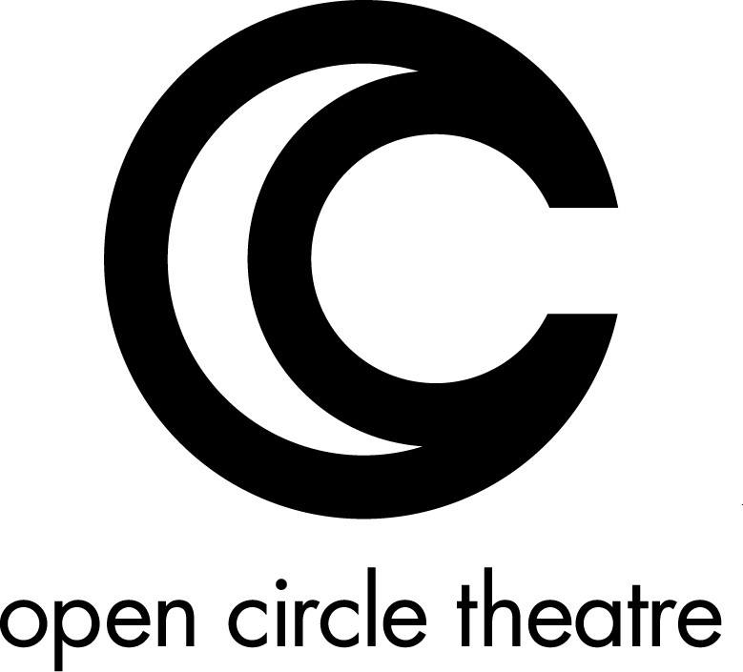
The Open Circle Theatre logo – an O surrounding a C

Open Circle Theatre Announces
The Who’s Tommy

Contact: Doretha “Doe” Dixon – 240 683-8934 – OCTpress1@gmail.com

SILVER SPRING, MD -- Open Circle Theatre (OCT) announces the cast list for their
upcoming production of The Who’s Tommy, directed by Artistic Director Suzanne
Richard with Music and Lyrics by Pete Townshend, Book by Pete Townshend and Des
McAnuff. After a five-year hiatus, OCT bursts back onto the scene with a challenging
piece based on the beloved rock opera of the 70’s. Tommy uses driving rock rhythms to
explore the story of a young boy traumatized by a violent act as he struggles through
different stages of his recovery. Featuring Music Direction by Jake Null (2016 Helen
Hayes Award Winner, for Avenue Q,), Choreography by Dance Exchange (Cassie
Meador, Executive Artistic Director, and Matthew Cumbie, Associate Artistic Director),
and Neil (Michael) Sprouse as Lead ASL Master, The Who’s Tommy runs October 27
through November 20, 2016 at the Silver Spring Black Box Theatre.

“Jake, Neil and I have assembled a highly talented and diverse cast of actors for this
iconic musical theatre piece. We’re happy to have on board some of the best
performers of the current DC theatre scene!”
Suzanne Richard, Artistic Director

The Who’s Tommy stars the previously announced Russell Harvard (Broadway’s
Spring Awakening, I Was Most Alive With You, Tribes, and television’s Fargo) as older
Tommy.

Of special note: every performance will be totally accessible. American Sign Language is incorporated throughout the show, captioning will be available and audio description will be provided at every performance.

Please visit our website and blog at www.opencircletheatre.org for more information and
press from past years.

###

