

**A RLINGTON KIWANIS PANCAKE BREAKFAST**

### **Blueberry, Chocolate Chip, and Original!**

### **Moon Bounce, Raffles & More**

***A Fun-Filled Morning Sponsored by the Arlington Kiwanis Club***

To Benefit The ELIMINATE Project - A Campaign of Kiwanis International To ELIMINATE Maternal & Neonatal Tetanus -

A Disease that Kills 160 Babies Each Day Around the World

**Saturday, April 29, 2017**

**8 AM - 12 Noon**

Clarendon United Methodist Church 606 North Irving St. • Arlington, VA

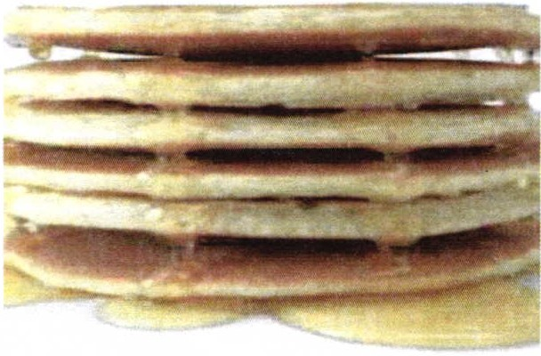 

**Breakfast: Pancakes - Sausage - Coffee - Apple Sauce - Orange Juice**

**Price: $8 Adults - $4 Children (5-10 yrs) - Free for Children under 5 (With Paying Adult)**

1st Chance to Order Your Kiwanis Blueberries

Great Raffle Prizes 

**For information visit our website**

[**www.arlingtonvakiwanis.com**](http://www.arlingtonvakiwanis.com/)

**email: gjcdo@yahoo.com**

**ELIMINATE**

maternal /neonatal tetanus

With The Eliminate Project, Kiwanis International and UNICEF have joined forces to eliminate maternal and neonatal tetanus, a deadly disease that steals the lives of nearly 60,000 innocent babies and a significant number of women each year. To eliminate MNT from the Earth, more than 100 million mothers and their future babies must be immunized.