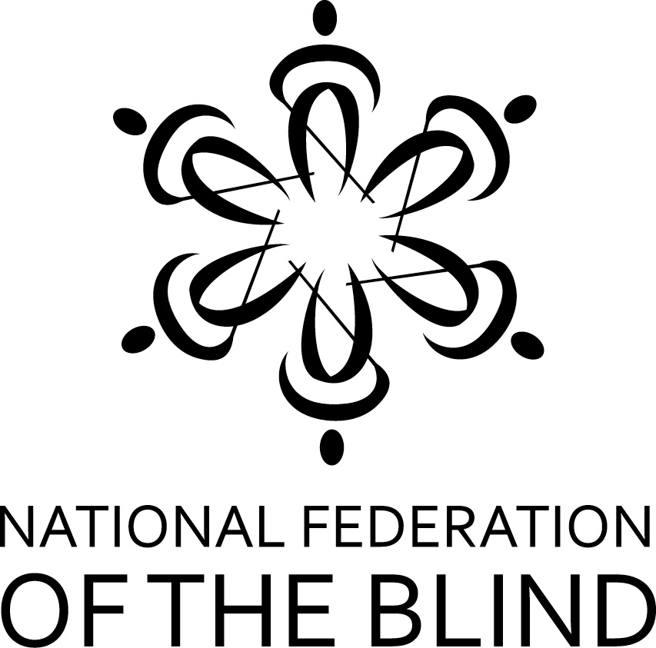

THE NEW Nationwide BRAL Contest IS HERE!

The National Federation of the Blind of Illinois, in partnership with the National Association to Promote the Use of Braille (NAPUB), now offers its first annual nation-wide Braille Readers Are Leaders contest open to kids in all states, grades K-12. Contestants compete to read the most Braille pages, going against other kids in similar grades across all participating states. The contest runs for six weeks, encouraging kids to be proud of their Braille reading ability and to work to improve their skills -- while possibly winning prizes in the process.

A thumbnail sketch of the contest:
- For each student who enters, a certifying official (parent, teacher, etc.) must fill out and submit a registration form. This can be done as early as November 15 2017 and as late as February 1 2018.
- Kids enter in one of five grade categories: K-1, 2-3, 4-5, 6-8, & 9-12.
- Participants record Braille pages read between December 15 2017 and February 1 2018 on a reading log.
- The certifying official must submit the completed reading log form by February 10 2018.
- Prizes in each grade category are: first, $25; second, $15; third, $10.
- Every contestant, whether a winner or not, will receive a “goodie bag” of Braille-related items at the end of the contest.
- To get the complete contest rules, registration form, and the reading log form, visit the website, http://www.nfbofillinois.org/nationwide-bral-contest.
- Both the registration form and the reading log form can be submitted by email as attachments to Deborah Stein at dkent5817@att.net. Please put Nationwide BRAL in the subject line.

In addition to awards in the five grade categories, the Kelly Doty Award is given to a student who has met unusual challenges in order to learn and read Braille. Such challenges include, but are not limited to, having other disabilities in addition to blindness or being an English language learner.

If you have questions, contact the contest administrator:Deborah Stein, dkent5817@att.net(please put Nationwide BRAL in the subject line), phone 773-203-1394

