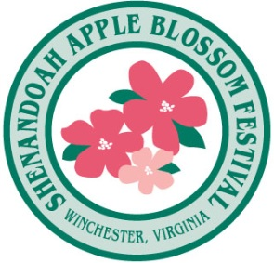
CO-CELEBRITY SPONSOR

Who: Shenandoah Apple Blossom Festival
Events: Sports Breakfast, Grand Marshal Reception and Grand Feature Parade
When: Saturday, May 1, 2021
Where: Winchester, VA

SABF: to secure and cover all expenses related to Sports celebrities (appearance fees, first class airfare for celebrity and guest, Hotel and meals
Level: CO-Sponsor with other sponsors

BENEFITS:
TICKETS & INVITATIONS
- Sponsor to receive $75.00 ticket allotment to event of choice, time sensitive.
- Sponsor to receive invitation to Theme Announcement Party (Fall) (Value $150.00)
- Sponsor to receive invitation to Official Sponsors’ Reception (April) (Value $300.00)

PRINT
- Sponsors LOGO included in newspaper tabloid insert distributed to 200,000 households regionally
- Sponsors name included in official festival program, event story, sponsors listing

SIGNAGE Festival to provide Sports Breakfast power point

WEBSITE
- Sponsor logo included in Festival website event page; (275,000 unique visits)
- Sponsor to receive 200 x 200-pixel web ad on the Sponsor page and hot link

FACEBOOK and EMAIL BLAST
- Festival will cross promote the event through Email Blasts reaching over 8,000 persons

Facebook postings to over 34,000 friends, https://www.facebook.com/#!/OfficialSABF

OTHER
- Use of the SABF Logo for promotional purposes (with approval)
- Sponsor included in public address announcements at the event
- Sponsor can distribute coupons at the event and the SABF store which is opened for 45 days

SPONSORSHIP INVESTMENT:
- $1,000.00 (discounted from $2,500.00)

Contact: Dario Savarese, Marketing Director; (540)722-8700, dario@fullcirclem.com

