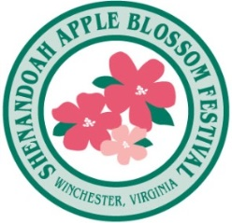
Sheetz 80’s Dance Party
What: 80’s Dance Party
When: Friday, April 30th, 2021; 8pm-12am
Where: Fredrick County Fairgrounds
Event Description: Dancing, 80’s tribute band, food, drinks, a sellout event!
MEDIA: Campaign starts March 19th through May 6th, 2021
Level: Event Sponsor

SCHEDULE OF BENEFITS:

TICKETS & INVITATIONS
- Sponsor to receive four (4) tickets to event
- Sponsor to receive invitation to Theme Announcement Party (value $150.00)
- Sponsor to receive invitation to exclusive Official Sponsors’ Reception (value $300.00)

PRINT
- Sponsors name included in newspaper tabloid insert distributed to 200,000 households regionally
- Sponsors name included in official festival program, event story, sponsors listing

FACEBOOK – INSTAGRAM – EMAIL NEWSLETTER
- Festival will cross promote the event through Email Blasts reaching over 8,000 persons
- Facebook/Instagram postings to over 34,000 friends

SIGNAGE Sponsor logo included on power point on stage and or sign with sponsor logo.

WEBSITE Sponsor logo included on event webpage, (275,000 unique visits)

EXHIBIT SPACE One (1) – Table exhibit for use by sponsor or charity organization

OTHER
- Use of the SABF Logo for promotional purposes (with approval)
- Sponsor included in public address announcements at the event

SPONSORSHIP INVESTMENT:
- $1,000.00, (discounted from $1,500.00)
- Sponsor has first right of refusal for following year up to June 30th

Contact: Dario Savarese, Marketing Director; (540)722-8700, dario@fullcirclem.com

