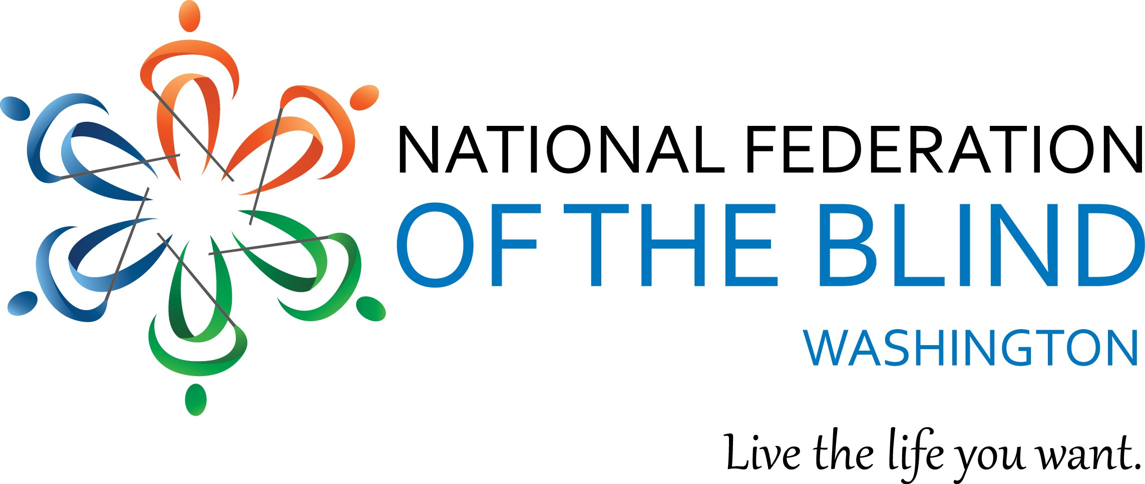
Instructions for Scholarship Application

The National Federation of the Blind of Washington is pleased to announce that we are accepting applications for our 2026 state Scholarship Program. We will award 3 $3000 scholarships to 3 outstanding blind scholars in our state. The scholarships will be awarded at the banquet of our National Federation of the Blind of Washington annual convention, which will be held at the Doubletree by Hilton Hotels Seattle Airport in Seatac, WA from February 26- March 1 2026.

In addition to a scholarship, each winner will receive financial assistance to attend the NFB of Washington annual convention, providing an excellent opportunity for networking with active blind persons in many different professions and occupations. The scholarships are awarded at the banquet on Saturday night of the convention. It is required that Scholarship Winners attend the entire convention weekend.

Official Rules

All applicants must be:
- Legally blind in both eyes
- Residents of the state of Washington
- Pursuing a full-time undergraduate or graduate course of study. If employed, part-time study will be accepted.
- Available to participate in the entire NFB of Washington state convention
- 18 years of age by the first day of convention

IMPORTANT NOTE: If an applicant is enrolled in high school, they must still abide by the age requirement listed above. Additionally, if these students know what school they are attending, and have received confirmation of their acceptance, they will receive their scholarship check at state convention banquet. Students who don’t know what college they will be attending or have not decided which college to attend will be awarded their scholarship check once we have received confirmation of their acceptance and intention to attend a college.

Each scholarship packet must include:
- Completed scholarship application form
- A personal essay, describing the applicant’s abilities, academic achievements, community leadership, future goals and philosophy of blindness. Please let your personality shine. We want to get to know you.
- High school and/or up-to-date college transcripts
- 3 letters of recommendation, specific to this scholarship application
- Proof of college enrollment

IMPORTANT SIDE NOTE:
All documents submitted MUST BE in an accessible format. It is recommended that you test the documents you intend to submit for consideration. Acceptable formats include: Microsoft Word documents, Plain text documents and PDF files. If you plan to submit a document in a format not mentioned here, you will need to ensure the accessibility for use with screen reading software. If you are not sure, please feel free to contact one of the Scholarship Committee Co-Chairs. Contact information will be listed below.

Submission Procedure/Guidelines
- All applicants must contact one of the scholarship committee co-chairpersons for a telephone interview. Please contact Nikki Palm at 360-703-8641 or Bennett Prows at 425-814-4187.
- All completed scholarship packets must be received by Friday, January 2, 2026. Application packets received after this date will not be considered. Additionally, incomplete or inaccessible packets will be disqualified.

Send completed scholarship application packets to:
NFB of Washington Scholarship co-chairpersons
- Nikki Palm: nikkirae83@gmail.com
- Bennett Prows: BJProws@comcast.net
NFBW Scholarship Application Form
Please feel free to make additional copies of this letter and application form and distribute them to any interested blind students.
Name (First, Last): _______________________________________
Date of Birth: ___________
Home Address (Please include Street Number, City, State & Zip):
________________________________________________________
Phone: ________________________
Email: _________________________
Your Current Grade Point Average: ______
Your Current class standing: ___________
High School attending/Attended: ___________________________________
Dates Attended: _____________________
College/Institution to be attended in the next enrollment period: ________________________________________________________
Phone (Please include area code): ______________________
Major: ____________________
Career Goal: _____________________________________________

