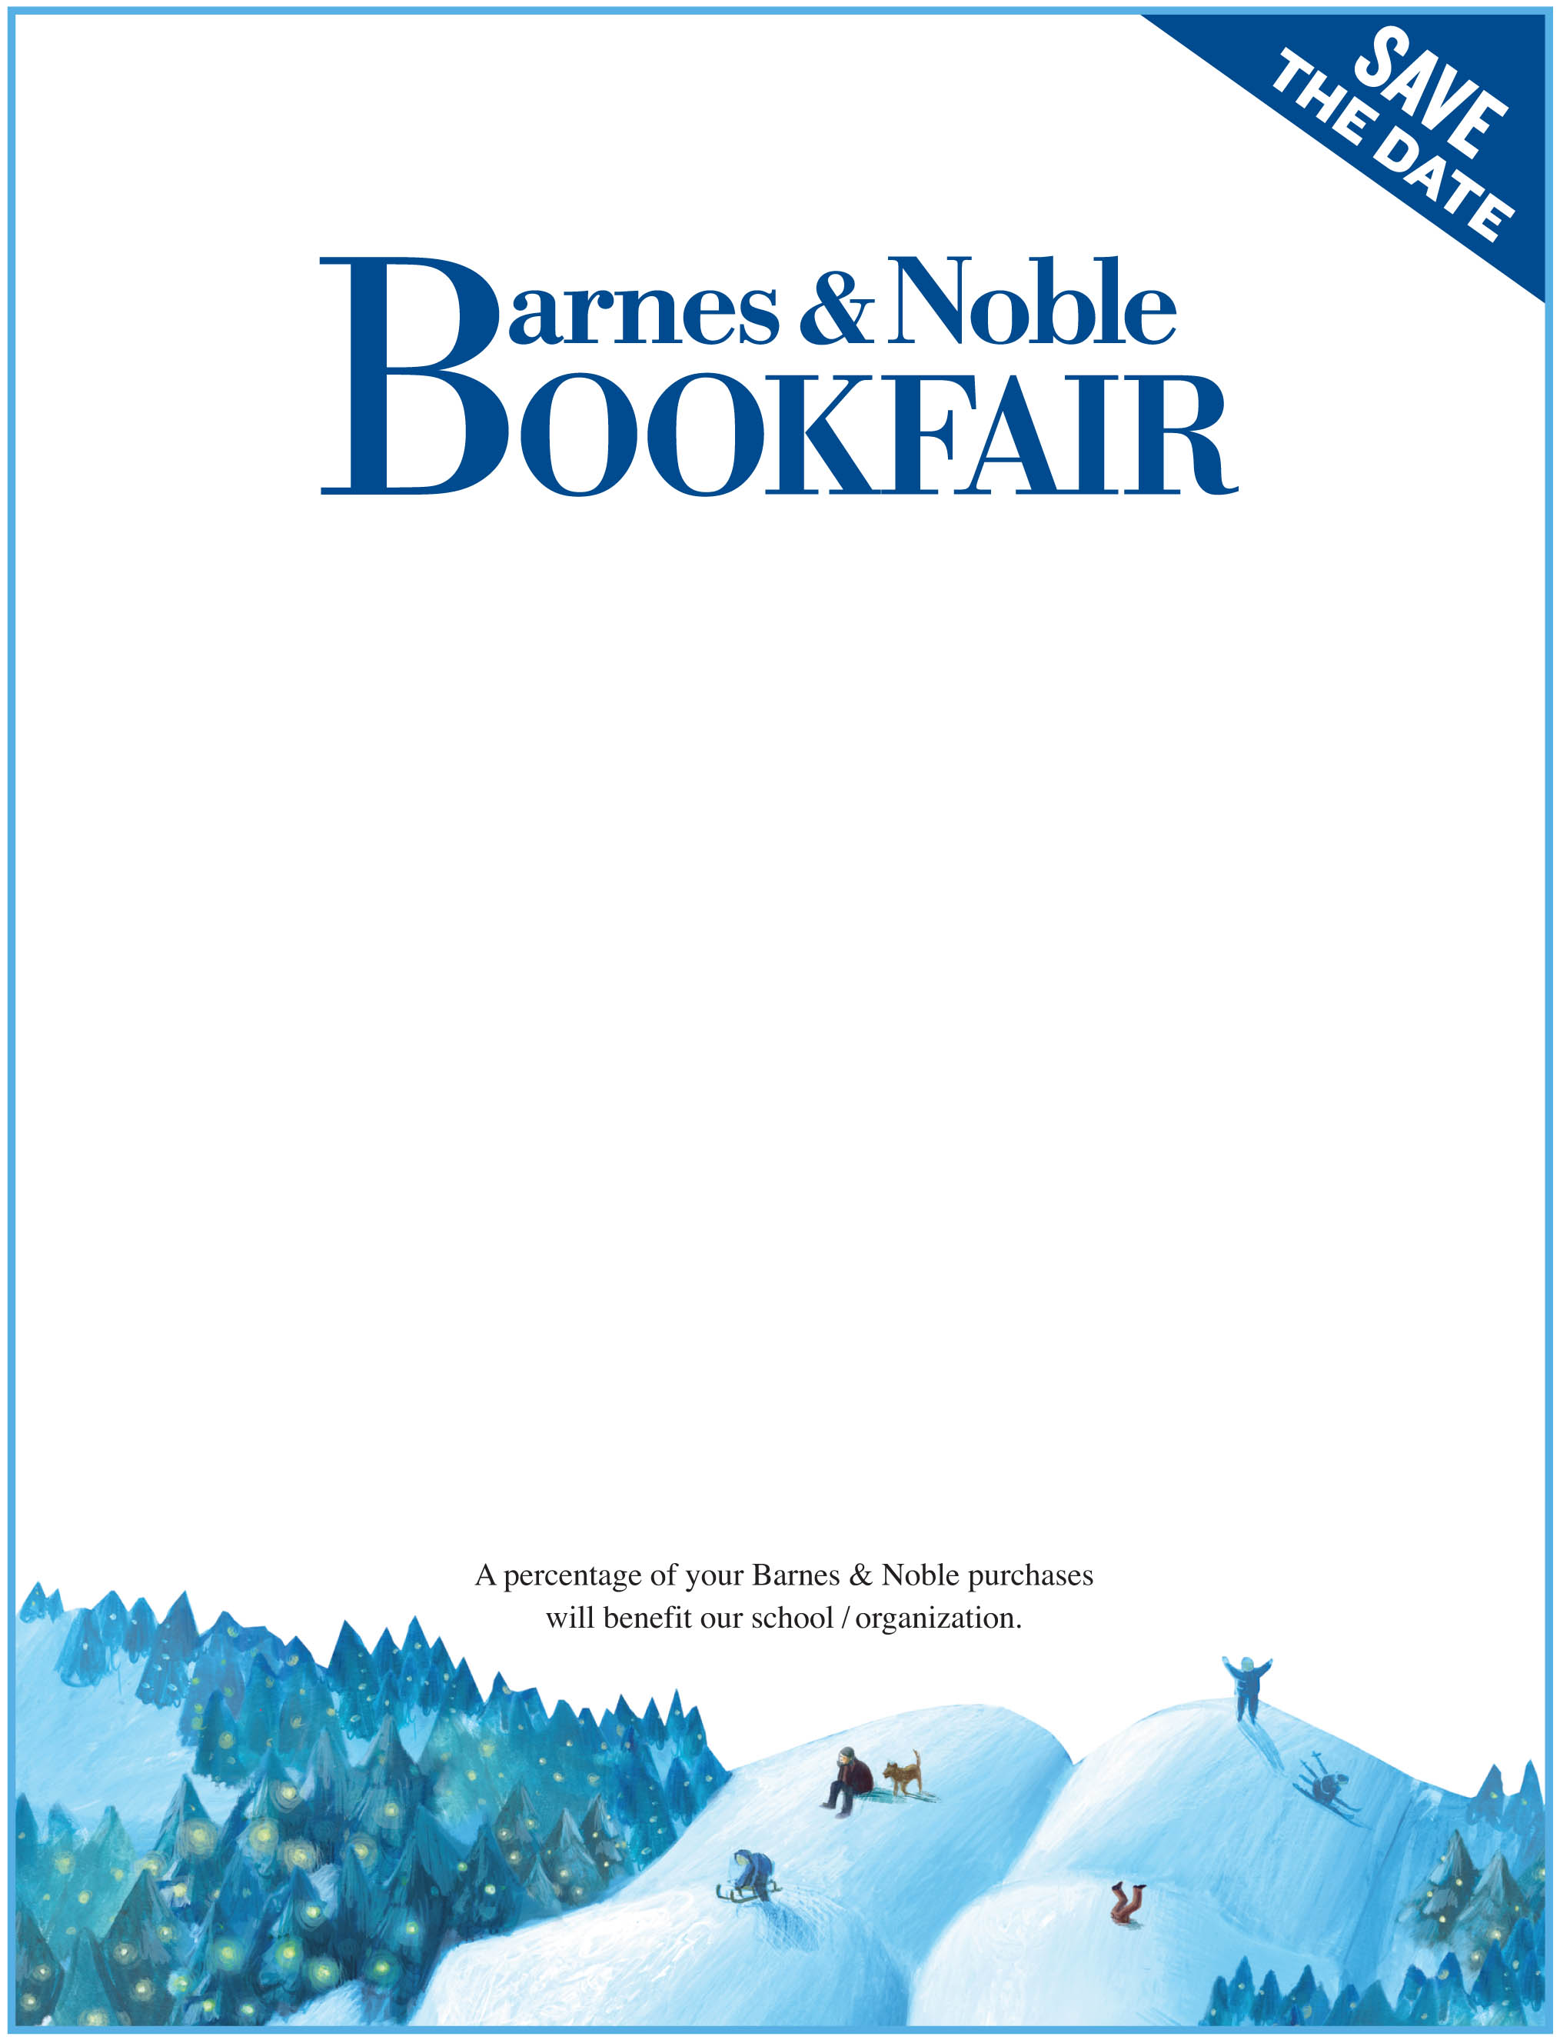

January 2nd – 4th

Stay tuned for more information on our event!
Author Signings
Live Music

Storytimes
And much more…

Hosted by: Barnes and Noble
Pacific Place Mall, Downtown Seattle
1 Block North of the Convention Center
at the corner of 7th & Pine

600 Pine Street, Seattle WA 98101
206.264.0156

Support the National Federation of the Blind by shopping at ANY Barnes & Noble store nationwide. Remit this Bookfair Voucher when you make purchases on these dates, and a percentage of your purchase will be donated back to the National Federation of the Blind.

Bookfair ID
446245
National Federation of the Blind

