A Memorial Meeting for Darson LaPan’s friends will be held @ Seattle Intergroup 5507 6th Avenue South (at Lucile Street) in Seattle, 98108 on September 17, 2011 4:00PM followed by scattering the ashes at Myrtle Edwards Park. This gathering is open to all.
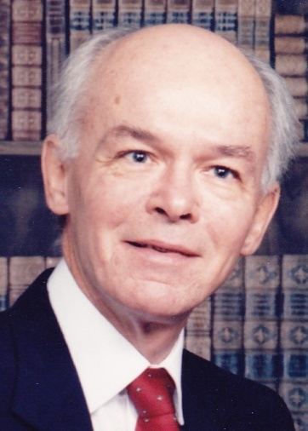
Opening Remarks by Hans Lipp
Darsons Story read by David French
Sharing memories of Darson
A reading from TOUCHSTONES: A Book of Daily Meditations for Men, August 23d (Darson’s Birthday) Darson’s favorite . Read by Jim Limerick
We close this gathering by standing in a circle holding hands.
A moment of silence
“Live and let live” Darson LaPan
Refreshments AUGUST 23, 1939 - February 21, 2011

Myrtle Edwards Park

The Agnostic Preamble
This group of A.A. attempts to maintain a tradition of free expression, and conduct a meeting where alcoholics may feel free to express any doubts or disbeliefs they may have, and to share their own personal form of spiritual experience, their search for it, or their rejection of it. We do not endorse or oppose any form of religion or atheism. Our only wish is to assure suffering alcoholics that they can find sobriety in A.A. without having to accept anyone else's beliefs or having to deny their own.

