A Memorial Meeting
for
Darson LaPan’s friends
will be held @ Seattle Intergroup 5507 6th Avenue
South (at Lucile Street) in Seattle, 98108
On Saturday, September 17, 2011
4:00 P.M.
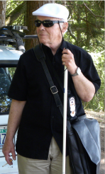

AUGUST 23, 1939 - February 21, 2011

DOS: February 12, 1986 - February 21, 2011

