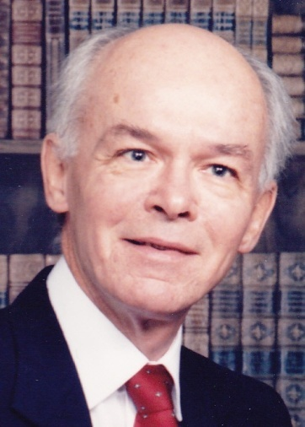
DARSON LAPAN

AUGUST 23, 1939 - February 21, 2011

DOS: February 12, 1986 - February 21, 2011

Darson LaPan died of bilateral pneumonia on February 21st, 2011 in Medford, Oregon. He was 71. He was diagnosed with stage IV Squamous cell carcinomas, a common type of Lung Cancer and planned to start Chemotherapy. He died at Rogue Valley Hospital
Darson was born on August 23, 1939 in Greely, Colorado When he was 6 years old he had brain surgery in Portland, OR to remove a tumor. It was thought he would never walk again. He was able to walk but lost his vision due to the damage to his optical nerves.
He entered the Oregon School for the Blind and in the 6th Grade he was mainstreamed into public school. After High school Darson spent 7 years to get his BA degree. He was one of 30 Blind people to get a scholar ship to study Russian at Georgetown University. Darson was the first editor of "The Horn" a neighborhood newspaper specific to the Powderhorn Park neighborhood of Minneapolis, Minnesota. Despite being blind Darson managed newspaper's stories, layout, and distribution in the late 1970s and early 80s. Darson ha d a great voice and he had jobs in radio, theater and other entertainment venues.
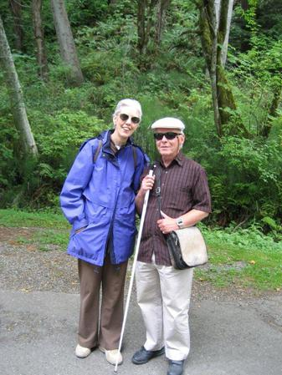
He was always open about being gay and agnostic.
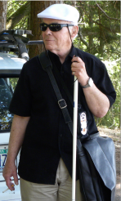
After living and working in Minneapolis he moved to Seattle. His life took a turn when he joined Alcoholics Anonymous. Instead of hanging out in bars he joined the many Seattleites hanging out in coffeehouses. Darson was active in the recovery community in Seattle, Bainbridge, Portland, Gresham, Sequim and Ashland and helped many Alcoholics achieve sobriety. He would recite “How it works” a lengthy reading at meetings, from memory.
He worked for several non profit groups (Loring Nicolette Bethlehem Community Centres Incorporated, Northwest Harvest, Bloedel Reserve, Seattle Neighborhood Group) first as a volunteer then as a full time paid employee.
Darson, even though his vision was limited, loved live theater. He always managed to get season tickets and attend many plays a season. Neither Alcoholics Anonymous nor facing death did not change his agnosticism; but he was very spiritual. He had believed in an “inner resource” which he identified as a power greater than himself.
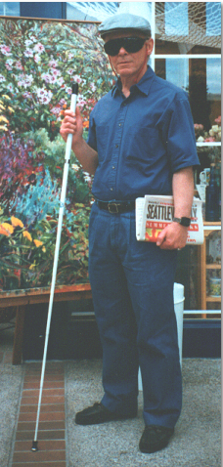
Darson was well known for moving. His dream was living in Boston or back in Minneapolis. Since he came to the Northwest he moved from Ballard to Sunset House on 1st Av. then to another HUD building north of 1st Ave.; then to Ashland. From Ashland he moved to Portland’s East side then to the west side. From there he came to Bainbridge and then he was off to Sequim. He left Sequim to move to Ballard, from there to Gresham, then over to Portland and then back to Bainbridge. He decided to leave Bainbridge and move to West Seattle and finally just before his death he arrived back in Ashland. Each place was the perfect place to live and always was the last time he was going to move. But after a year he would start talking about missing one thing or another and start looking for a new place to live.
Darson was a good friend, sponsor and confidant to many. He was extremely organized. He was a proud and opinionated man. He loved reading, smoking and playing with his cat. He had the latest electronic adaptive equipment to help him with his blindness. He struggled with his vision. His father disowned him when he found out he was gay. His mother passed away last year and gave the bulk of her belongings to her caretaker.
Now the struggle is over.
We love you Darson.
A reading from TOUCHSTONES: A Book of Daily Meditations for Men, August 23d (Darson’s Birthday) Darson’s favorite
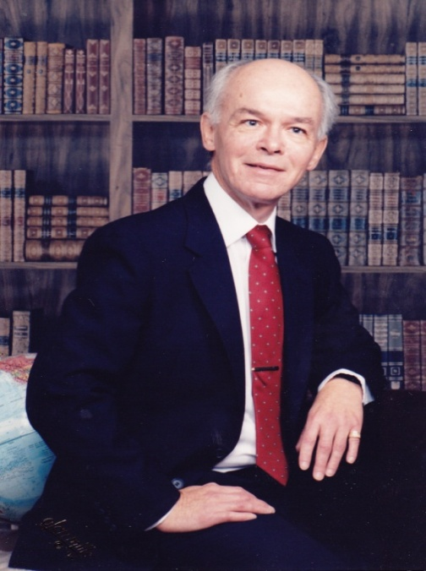
Just because a man lacks the use of his eyes doesn't mean he lacks vision.
—Stevie Wonder
it has been easy for many of us to meet our limitations with self-pity. Maybe we think being a real man means always being strong, capable, good looking, and in charge. If we have a handicap, like blindness or a learning disability, we may have thought we were less masculine or less worthy.
All of us have handicaps. Some are greater than others, and some are more visible than others. These handicaps confront us with our powerlessness. We do not find our finest human qualities until we have met our limitations and accepted them. A new side of our strength develops when we accept our powerlessness and yield to it rather than trying to take charge of it. We develop greater vision when we stop feeling sorry for ourselves about our handicap and surrender to its truth. We then see our kinship with all men and women who struggle with their limitations.
Today, I will set aside self-pity and remember to be grateful for the lessons my limitations have taught me.
From Touchstones: A Book of Daily Meditations for Men ©1986, 1991 by Hazelden Foundation.

