For Immediate Release From Seattle Neighborhood Greenways

Event links: http://www.facebook.com/events/361597903883577/
http://neighborhoodgreenwayssea.wordpress.com/take-action/city-wide-meetups/

Contact: Alexa Heidrich, 503-327-4715, centralseattlegreenways@gmail.com, amheidrich@gmail.com

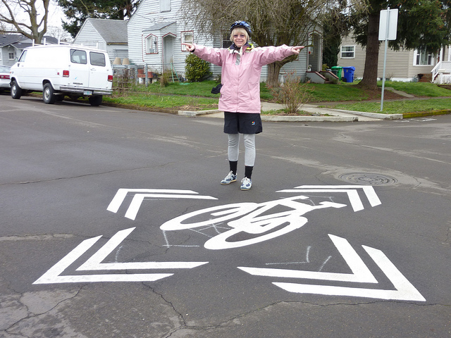
Traffic Mike presents “Designing Streets for Everyone”
Neighborhoods throughout Seattle are reclaiming their local streets for family-friendly walking and biking routes using Neighborhood Greenways – safe, low-cost and low-stress walking and biking corridors connecting people with the places they want to go. By adding traffic calming, safe crossings at busy streets, and extra trees and greenery, a network of low-traffic streets can be transformed into useful, park-like routes around the neighborhood.
On May 3rd Central Seattle Greenways is hosting a talk by Michael Hendrix, “Traffic Mike,” who will talk about tools engineers and planners use to analyze current road conditions, how they propose upgrades to problematic intersections, and the costs associated with improving the overall safety of neighborhood streets. He’ll also address how engineers work to utilize existing road infrastructure to improve the safety of streets and intersections. Mill will provide examples of other city’s failures and successes, and add to our vocabulary as we advocate to the City to implement greenways in our neighborhoods.
Mike Hendrix has been working on designing neighborhood greenways and other bike facilities for over 10 years. He is a registered Professional Engineer in both Washington State and Arizona and a certified Professional Traffic Operations Engineer. He has been on committees for pedestrian safety including school zones and crosswalks for the Institute of Transportation Engineers. He has also conducted research on bike facilities, some of which will be included in the NACTO Urban Bikeway Design Guide's new chapter on Neighborhood Greenways.
Please join us at the Capitol Hill Library for this opportunity to learn more about how streets are engineered, and how we can advocate for safer streets in the language of the Seattle Department of Transportation.

What: Designing Streets for Everyone
Who: For everyone interested in safe streets
When: May 3rd
Where: Capitol Hill Library
425 Harvard Avenue East Seattle, WA 98102

###
Formed in August 2011, Seattle Greenway Organizers is a rapidly growing coalition representing neighborhoods across Seattle to plan and advocate for safe and comfortable streets connecting us to the places we use, whether we walk, drive, ride a bike, push a stroller, or move by wheelchair. Greenway organizers continue to meet frequently within their own neighborhoods around Seattle to plan community connections, and come together monthly as a citywide advocacy coalition. We invite all Seattle neighborhoods to join this city-wide effort.
http://groups.google.com/group/seattle-greenways-organizers
http://www.facebook.com/SEAGreenways
http://www.facebook.com/CentralSeattleGreenways
http://www.facebook.com/events/361597903883577/

