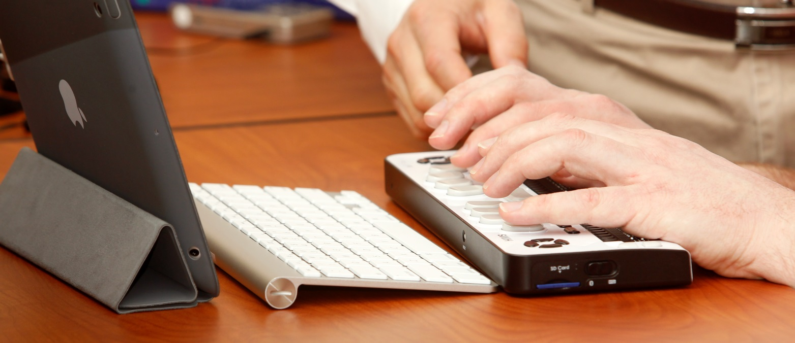

Assistive Technology and Low Vision

Open House

When: Tuesday October 8, 2013 from 11 am – 7 pm

Where: Department of Services for the Blind (DSB)

3411 South Alaska St

Seattle WA 98118

(free parking available on site)

Ever wondered what kind of technology is out there for a person who is blind or has low vision? Well here’s your chance to find out! The Dept. of Services for the Blind is opening its doors to their Seattle Assistive Technology and Low Vision labs to provide you with a hands-on experience. Come try out a wide range of tools, devices and technology to see what’s out there. Staff will be on site to answer your questions so you can get the most out of your experience. Representatives from the WA Assistive Technology Act Program (http://watap.org/) and WA Access Fund (http://www.washingtonaccessfund.org/) will also be present to provide information about their services.

Please RSVP to: Nancy Eckert (206) 906-5512 or nancy.eckert@dsb.wa.gov

*refreshments will be served

