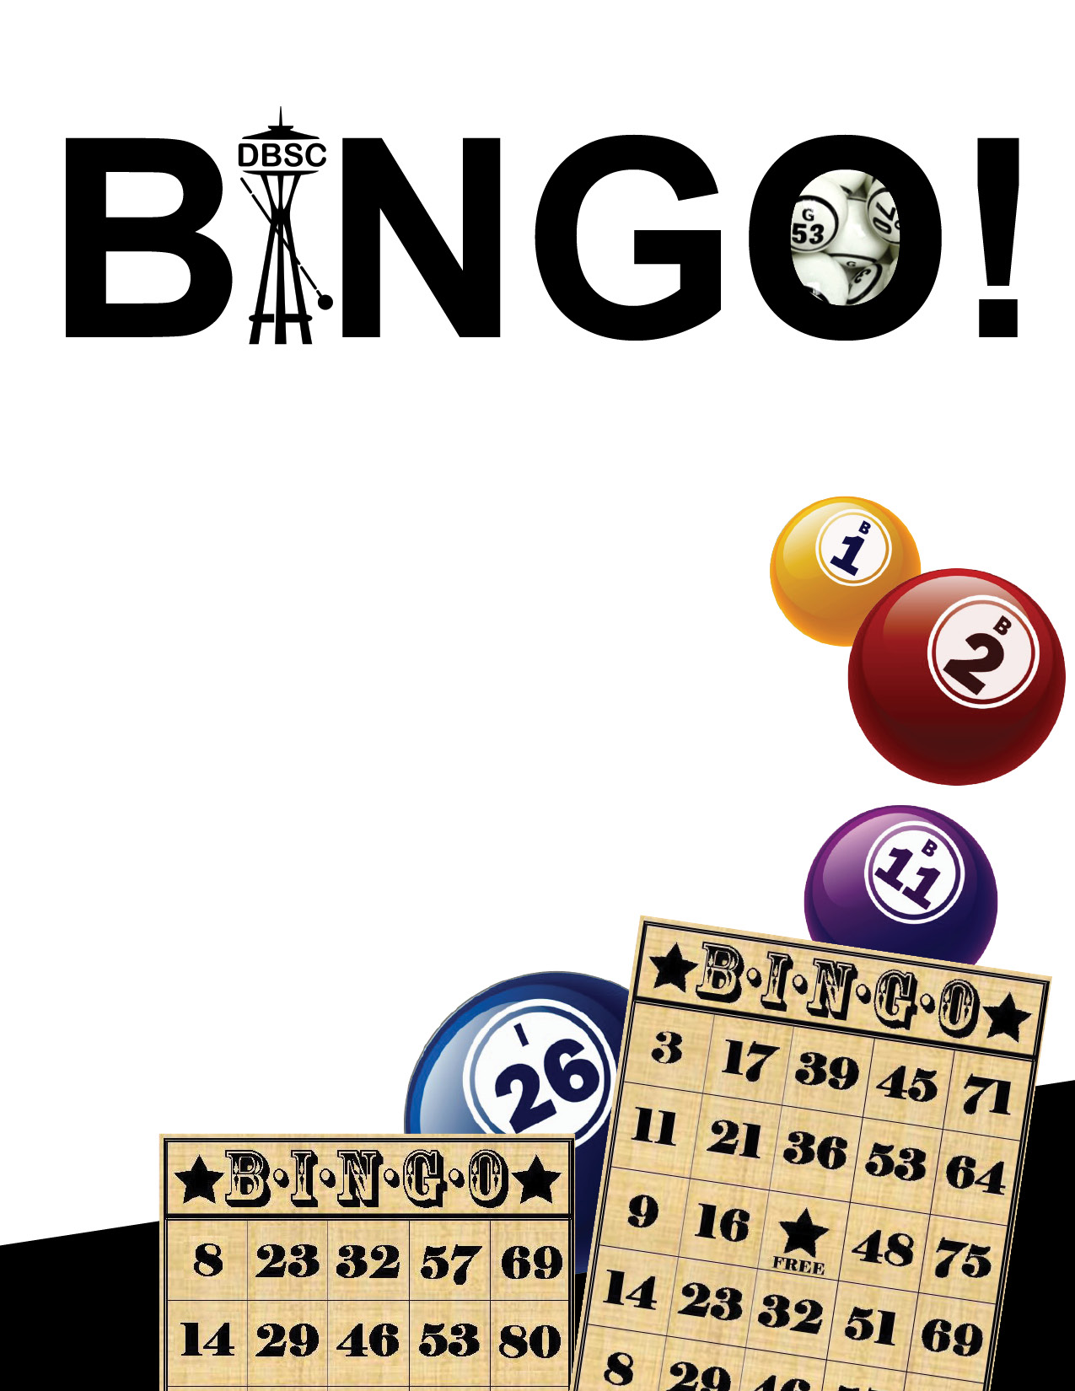
DBSC Presents…

Bingo
Saturday, January 11, 2014, 1:00-4:00 pm
HSDC Conference Room (1625 19th Ave, Seattle)
$20.00 includes:
• Three games of bingo
• Prizes
• Light refreshments
Extra bingo card for $5
Pay with debit/credit card, check, or
cash at the door
To request SSP, contact Cathy
at choog@seattledbsc.org
Request deadline:
Dec. 20, 2013

