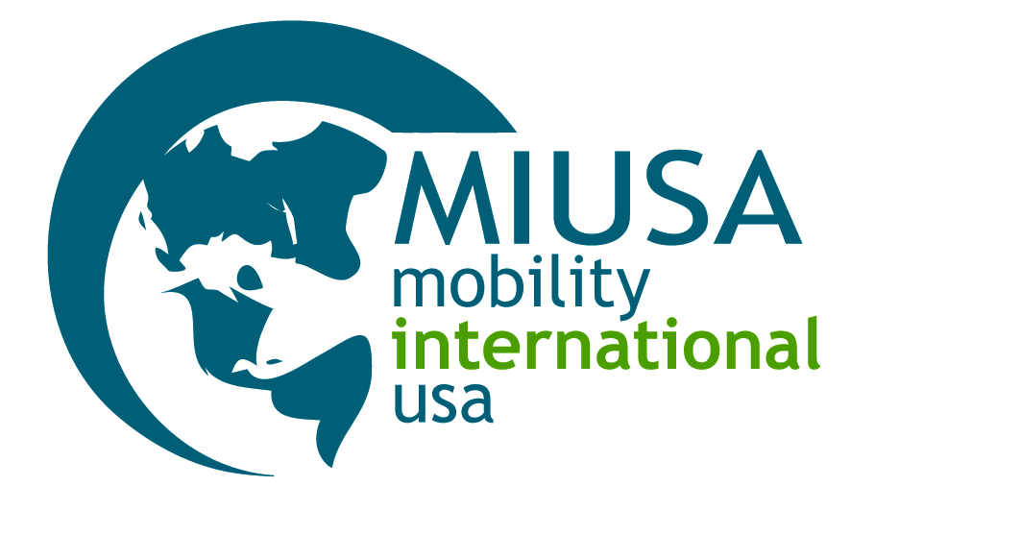

Preliminary Disability-Related Recommendations for
2014 YES Semester Students with Disabilities

Student: Celine / Malaysia
Placement Organization: AFS USA

Prepared by: Stephanie Gray, MIUSA Program Manager
Email: sgray@miusa.org
DISABILITY INFORMATION

Celine is blind.

- Diagnosis: Bilateral retinal hemorrhage and subsequent blindness related to Leukemia in childhood (2002). For information about Acute Promyelocytic Leukemia, please see the St. Jude Children’s Research Hospital fact sheet at: http://www.stjude.org/stjude/v/index.jsp?vgnextoid=9c0c061585f70110VgnVCM1000001e0215acRCRD

- Celine has advanced computer and keyboarding skills and is proficient with JAWS for Windows, a popular screen reader developed for computer users who are blind or low vision. JAWS software reads aloud what appears on the screen and gives the user a sophisticated set of tools for navigating and accessing Web pages and all screen content. JAWS is compatible with Microsoft Office Suite, Corel WordPerfect, Adobe Acrobat Reader, Internet Explorer, Firefox, and many more applications that are used on a regular basis in school settings. For more information, please see http://www.freedomscientific.com/products/fs/jaws-product-page.asp.

- Celine has advanced braille skills and uses braille in her native language and in English. For writing braille, she uses a braille typewriter and slate and stylus. Although Celine indicated that she is proficient with English braille contractions, it will be important to assess her proficiency with braille contractions prior to her departure from Malaysia (if possible) or as soon as she arrives in her U.S. host community. Note: Very few international students learn contracted (Grade 2) English braille outside the U.S. As U.S. braille textbooks are produced in contracted braille, Celine may need access to classroom materials in another format (e.g. electronic or audio) while she continues to improve her English braille skills through tutoring or self-study.

- In her school in Malaysia, Celine uses a braille typewriter and laptop with JAWS software to take notes and complete in-class assignments and homework. She occasionally uses audio materials as well as the assistance of readers, both paid readers and classmates.

- Celine has a white cane and some Orientation and Mobility (O&M) skills. She travels independently in familiar environments (e.g. inside her school) and uses a sighted guide* for community travel.*A sighted guide is a sighted person who provides assistance to a blind or low vision individual with walking in unfamiliar environments. Although a common accommodation around the world, in the U.S., students are generally expected to learn Orientation and Mobility (O&M) techniques, including white cane skills, to increase their independence and confidence with community travel (see below for tips on how O&M training can be arranged).

- AFS Malaysia characterized Celine as independent and self-confident. She has excellent English language skills and is highly motivated to participate in the YES program. She also has diverse interests, including piano performance, chess and track and field.

- In her home country, Celine attends a specialized secondary school for the blind as a residential student during the week. She lives with her natural family on weekends.

PLACEMENT RECOMMENDATIONS

Based upon a review of Celine’s written YES application materials and MIUSA’s past experience with students with similar disabilities, MIUSA’s interpretation of her placement-related needs are:

School

- With appropriate support and access to accommodations, there is every indication that Celine can thrive and be successful in a mainstream high school, especially a high performing school with an emphasis on academics and opportunities to learn and participate in extracurricular activities alongside non-disabled peers.

- If a school for the blind is considered as a placement option for Celine, it will be critically important to verify that the school has high academic standards and offers a rigorous academic curriculum on par with that offered in mainstream high schools. Although some U.S. schools for the blind offer a rigorous academic program, many do not. The majority of blind and low vision high school students in the United States (between 80-90%) now attend mainstream high schools as schools for the blind increasingly serve students with multiple disabilities whose needs can be best met in a specialized school environment. Note: Some students who attend a school for the blind in the U.S. have an opportunity to take some of their classes at a mainstream high school where there is a greater number and variety of academically-challenging courses and where they have an opportunity to be mainstreamed alongside same-aged peers without disabilities. For some students, this third option provides a valuable opportunity to learn new skills for independent living and experience full inclusion simultaneously.

- She will need the support and involvement of K-12 Teacher(s) of the Blind and Visually Impaired (TBVIs) to be successful in school.

- She will need accommodations in school, such as:

  - Access to textbooks and other classroom materials in electronic, audio, digital, and/or braille formats.

  - Access to adaptive equipment and software, such as a laptop with screen-reading software, if she is unable to bring her laptop with her to the U.S., and a refreshable braille display for schoolwork, email and Internet use, if possible.

  - Tutoring in Contracted (Grade 2) English braille and Nemeth code, the Braille code used for math and science notation, if needed and desired.

  - Access to a braille note taker, such as a Braille Lite, for note taking, and/or digital recorder.

  - Extra time on assignments and tests.

  - Orientation and Mobility (O&M) skills training. Note: Orientation and Mobility (O&M) training is included in the range of special education services provided to students with disabilities as part of their Individualized Education Plans (IEPs). The type of O&M training provided is determined on the basis of an evaluation by an O&M specialist, typically someone within the school district or in a neighboring school district. O&M specialists are also employed by some community organizations, such as the Lighthouse for the Blind or local Associations for the Blind. See MIUSA’s Blind or Low Vision Visitors to the United States tipsheet for more information on identifying services, including O&M specialists.

  - Peer assistance to travel from class to class while Celine increases her skills and confidence with independent travel.

- A learning media assessment and/or assistive technology assessment will be important in assessing Celine’s needs in a classroom setting.

- An Orientation and Mobility (O&M) skills assessment will be important in assessing Celine’s skills and safety vis-à-vis independent mobility at school and in the community.

Host Family

- Celine may be most successful in a supportive home environment in which her host parent(s) can provide her with time and personal attention, especially as she learns new and increased skills for independent living.

- One or more host parent(s) with relevant disability-related experience (e.g., familiarity with assistive technology, Orientation and Mobility techniques, adaptive sports, etc.) may be very helpful, but not essential to her success.

ACTION STEPS

MIUSA recommends the following action steps:

- Identify and contact the professional(s) in Celine’s U.S. high school or school district who coordinates accommodations for students with disabilities, particularly blind and low vision students, e.g., the Director of Special Education.

- Meet with this professional(s) to discuss the process of arranging accommodations that may be necessary and useful to Celine during the spring semester.

Questions to ask include:

- Are the results of a visual acuity exam conducted by a U.S. medical professional required in order to arrange vision-related accommodations and/or services in the school district?

- Is an Individualized Education Plan (IEP) required or advisable in order to arrange vision-related accommodations and/or services in the school district?

  - What is the process of arranging a learning media assessment and/or assistive technology assessment to evaluate a student’s needs in a classroom setting?

  - Does the staff of the high school or school district at large include one or more Teachers of the Blind and Visually Impaired (TBVIs)?

  - What is the process of arranging ongoing consultation for Celine with a TBVI to discuss and arrange accommodations in a classroom setting?

  - What is the process of arranging an Orientation and Mobility (O&M) skills assessment and O&M training?

  - What is the process of arranging tutoring in Contracted (Grade 2) English braille and Nemeth code?

- Arrange for access to a calculator, cell phone and alarm clock with speech (also known as VoiceOver) technology to reduce Celine’s reliance on her host family and to support the development of her independent living skills.

- Arrange for Celine to have access to free audio format reading materials through Bookshare (www.bookshare.org), the National Library Service for the Blind and Physically Handicapped (www.loc.gov/nls/), and/or Learning Ally (https://www.learningally.org/), a membership service that provides access to thousands of books and textbooks to individuals with disabilities as well as the support of parent support specialists.

- Identify adaptive sports and recreation programs in Celine’s host community, especially aquatics and track and field programs. Note: In some communities, adaptive sports and recreation programs are offered by the Parks and Recreation Department and/or by non-profit organizations.

- Arrange for Celine to visit her new high school, preferably in the company of U.S. classmates, outside of the regular school day so that she can become familiar with the school environment, map travel routes to and within the school, and identify and problem-solve potential access barriers.

- Identify disability advocacy organizations, particularly organizations that serve blind and low vision individuals, in Celine’s host state and community that offer information, referral to local resources, volunteer opportunities, and/or ideas for enhancement activities for FLEX/YES clusters, etc.

