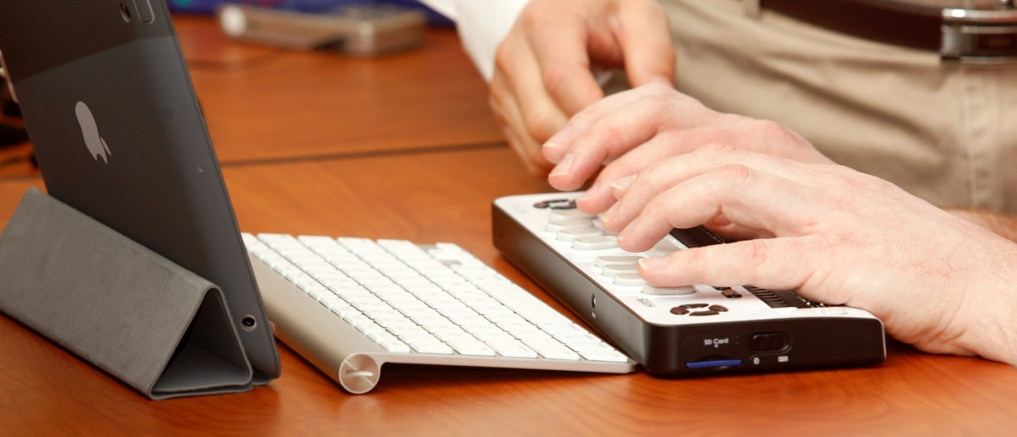

Assistive Technology Open House for Families

When: April 26, 2014 from 10 am - 2 pm

Where: Dept. of Services f/t Blind, 3411 South Alaska St, Seattle WA 98118

Ever wondered what kind of technology is out there for a child who is blind or has low vision? Well here’s your chance to find out! The Seattle Dept. of Services for the Blind is opening its doors to their Assistive Technology and Low Vision labs to provide you and your family with a hands-on experience. Come try out a wide range of tools, devices and technology to see what’s out there. Staff will be on site to answer your questions so you can get the most out of your experience. Representatives from the WA Assistive Technology Act Program (http://watap.org/) and WA Access Fund (http://www.washingtonaccessfund.org/) will also be present to provide information about their services. We will be offering three interactive presentations along with the general lab experience. Feel free to drop it for a specific presentation or anytime during the open house hours.

- 11 am- 11:30: Accessible games on the iPad and iPhone- presented by DSB AT staff
- Noon- 12:30: See Like Me (Low Vision simulation experience)- presented by DSB LV staff
- 1 pm – 1:30: AT in Daily Living- presented by WATAP and the Access Fund

Please RSVP by Monday April 21st to:
Janet George at (206) 906-5530 or janet.george@dsb.wa.gov

*refreshments will be provided

