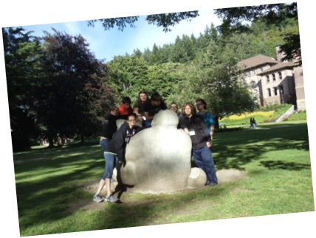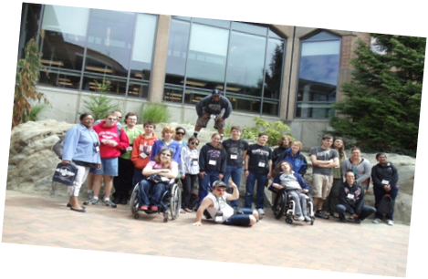

We are looking for future community leaders!!

Come join us for the 13th Youth Leadership Forum for High School Students with Disabilities, an exciting, fun, educational, five-night, six-day
Leadership Program!!

The Youth Leadership Forum is a project of the Washington State Governor’s Committee on Disability Issues and Employment

WHO: Approximately 35-45 high school students with disabilities from around the state will be selected to attend the Forum through a competitive process.

WHEN: July 27 – August 1, 2014

WHERE: Western Washington University
Bellingham, Washington

COST: Students/Parents will not be charged expenses to attend this Forum

DUE DATE: June 13, 2014

Please fill out this application, save and then email it to Debbie Himes; dhimes@esd.wa.gov.

- Students must complete all information requested in this application. (If you need help, please ask your parents or teachers or you can call Debbie Himes, at (360) 725-9511).

- This application can be filled out by tabbing through to each gray section of the document.

- If you would like a paper application, please call the above number.

- Please see Page 8 for additional application instructions.

Youth Leadership Forum Application
Due Date – June 13, 2014

This application can be filled out by tabbing to each gray area.

- Student’s Name:
- Male Female Date of Birth:
- Mailing Address:
City, State & Zip Code:
Email Address:
- Home Phone Number: ( )
Cell Number: ( )
- Name of High School:
Phone #: ( )
- Are you receiving Transition Services from the Division of Vocational Rehabilitation (DVR/DSB) Department of Services for the Blind? If so, please provide your (very important):

DVR ID Number:
DVR/DSB Counselor’s Name:
DVR/DSB Counselor’s Phone:
- Grade Level on July 1, 2014 (must be a junior, senior or graduate):

- High School Graduation Date:
YLF Application, Page 2
Student’s Name:

- School and Community Involvement:
Please list any extra-curricular involvement with your school and community. (This may include offices you have held, club memberships, after school activities or work experiences.)

School-related extracurricular activities:
*Activity:
Grade Level: Dates:

*Activity:
Grade Level: Dates:

*Activity:
Grade Level: Dates:

Community-based extracurricular activities:
*Activity:
Grade Level: Dates:

*Activity:
Grade Level: Dates:

*Activity:
Grade Level: Dates:
YLF Application, Page 3
Student’s Name:

- References:

- High School Representative (teacher, principal, counselor, coach).

Name:
Title:
Organization:
Phone: ( )
Email:

- Community Representative (employer, coach, friend of family).

Name:
Title:
Organization:
Phone: ( )
Email:

- Survey of Personal Interest

Your answers to the following topics will be used to assess your interest and readiness to participate in the Youth Leadership Forum. Please type your responses to the topics in the separate pages(s). Your total responses for all four of these topics should not exceed (4) pages.

YLF Application, Page 4
(Question 1)
Survey of Personal Interest
Student’s Name:

- Experiences as a person with a disability –What are two important experiences (good or bad) you have had as a young person with a disability? (Please be specific about your examples as they relate to your disability.)

YLF Application, Page 5
(Question 2)
Survey of Personal Interest
Student’s Name:

(b) In terms of leadership, please tell us about two people who have positively influenced your life and why. (Family members, teachers, counselors, friends, public officials or celebrities are appropriate examples.)

YLF Application, Page 6
(Question 3)
Survey of Personal Interest
Student’s Name:

- Why do you feel you are qualified to be a delegate to this Youth Leadership Forum and please tell us why you want to participate in this Forum.

YLF Application, Page 7
(Question 4)
Survey of Personal Interest
Student’s Name:

- Describe your future plans after high school graduation.

YLF Application, Page 8
Student’s Name:

I have completed the Youth Leadership Forum Application and understand that I will be contacted regarding my attendance by June 18, 2014.

12.
Signature of Student Date

13.
Signature of Parent/Guardian Date
Phone # of Parent: ( )

(If signatures are electronic, please provide the phone number of a parent if you are under the age of 18.)

(Students 18 or older and on your own, don’t need to have the signature of a parent/guardian.)

T-Shirt Size (need to place the order early)
X-Small
Small
Medium
Large
X-Large
XX-Large
XXX-Large

YLF Application, Page 9
Student’s Name:

(Keep for Your Records, DO NOT RETURN)

Please use the checklist below to make certain your application packet is complete. Incomplete applications will not be considered.

Check List Completed
1. Application form (5 pages)
2. Signed application (Student & Parent/Guardian)
3. Survey of Personal Interest (response to 4 topics)
4. Photocopy application for your records

14. Please Email/US Mail or FAX the application to the address below.
Governor’s Committee on Disability Issues & Employment
Debbie Himes
PO Box 9046
Olympia, Washington 98507-9046

Email: dhimes@esd.wa.gov

(360) 725-9511
(360) 725-9510 FAX

If you have any questions, please contact Debbie Himes at the above number/email.

Applications must be emailed/postmarked by
June 13, 2014 for consideration!!

Thank you for completing this application!

