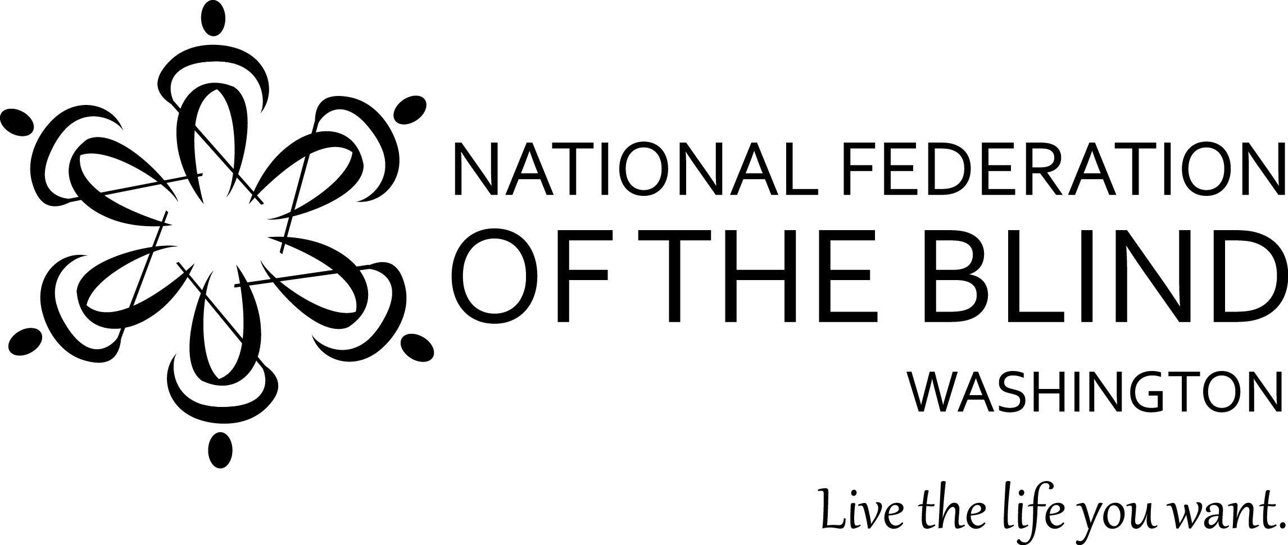
Instructions for Scholarship Application

May 14, 2014

The National Federation of the Blind of Washington is pleased to announce that we are accepting applications for our 2014 Scholarship Program. We will award 2 scholarships totaling $5,000 to 2 outstanding blind scholars in our state. The scholarships will be awarded at the banquet of our state NFB convention, which will be held at the Hilton Hotel in Vancouver, Washington during the weekend of October 3rd-5th, 2014.

All applicants must be:

- Legally blind in both eyes
- Residents of the state of Washington
- Pursuing a full-time undergraduate or graduate course of study
- Available to participate in the entire NFB of Washington state convention

In addition to a scholarship, each winner will receive assistance to attend the 2014 NFB of Washington annual convention at the Hilton Hotel in Vancouver, Washington the weekend of October 3rd-5th, providing an excellent opportunity for networking with active blind persons in many different professions and occupations. The scholarships are awarded at the convention banquet on Saturday night, October 4th. Attendance at the convention is mandatory.

Each scholarship application must include:

- Completed scholarship application form
- An essay describing the applicant’s abilities, academic achievements, community leadership, future goals and philosophy of blindness
- High school and/or up-to-date college transcripts
- 3 letters of recommendation

All applicants must also contact Marci Carpenter, State Scholarship Chairperson, for a telephone interview. She may be reached at 206-604-5507.

All completed scholarship packets must be received by Friday, September 5th, 2014.

APPLICATION PACKETS RECEIVED AFTER SEPTEMBER 5TH WILL NOT BE CONSIDERED. INCOMPLETE APPLICATIONS WILL BE DISQUALIFIED.

Send completed scholarship application packets to:

Marci Carpenter
NFB of Washington
Scholarship Chairperson
mjc59@comcast.net

or mail to:

Marci Carpenter
3200 California Ave SW #35
Seattle, WA 98116

If you have any additional questions please contact Marci Carpenter at 206-604-5507 or mjc59@comcast.net.

Please feel free to make additional copies of this letter and the application form, and distribute them to any interested blind students.

Name:____________________________________________
Date of Birth: _
Home Address: Street: ___________________________________
City:______________________ State______ Zip___________
Home Phone: _____________ Cell Phone:_____________ Email:_________________________
Your Current Grade Point Average:
Your Current class standing: ___________________ (Freshman - Senior, graduate student)
High School Attended: __________________________________________
Address: _____________________________________________________________________
City: _________________________________ State:________ Zip: ___________
Dates Attended:_____________________
College/Institution to be attended in Fall Semester, 2014:_______________________________________
Address:_______________________________________________________
City:__________________ State:______ Zip:__________
Phone:______________________
Major:____________________________________________________
Career Goal:________________________________________________________

