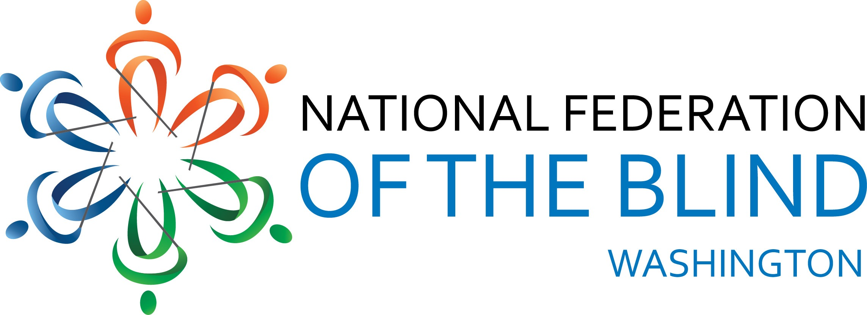
AGENDA
2015 Convention
National Federation of the Blind
of Washington
Marci Carpenter, President
October 30-November 1, 2015
Red Lion Hotel Seattle Airport
18220 International Blvd
Seattle, WA 98188

The National Federation of the Blind of Washington knows that blindness is not the characteristic that defines you or your future. Every day we raise the expectations of blind people, because low expectations create obstacles between blind people and our dreams. You can live the life you want; blindness is not what holds you back.

Important Information and Announcements

Unless otherwise noted, all meetings and exhibits will take place in the Seattle Room. Other meetings will take place in the Tacoma Room. Both rooms, along with the hotel restaurant, bar and Tully’s coffee stand, are located in a building next to the main hotel.

The guide dog relief area is a raised grassy area in the parking lot on the south side of the hotel. The hotel has established it as a pet relief area so it has a garbage can and baggies.
The Hospitality Suite will open late Friday afternoon. The Greater Seattle chapter will welcome you with snacks and beverages. The suite will be open at times when we are not in session. This is also the location for the Student Pizza Lunch and Organizing meeting on Saturday. Current or prospective college students as well as high school and middle school students are encouraged to come to the lunch.

There will be an exhibit space in the Seattle room on Friday from 1:00pm-5:00 pm. A large, tactile map of Washington, and other images produced by 3dPhotoworks, will also be on display during the convention. There will also be a demonstration of the KNFB READER App.

THE KNFB READER APP IS NOW AVAILABLE!!!!
Now you can have the convenience of an OCR scanner in the palm of your hand. The KNFB Reader app is a revolutionary tool that you can use, with the touch of a single button, to read virtually any type of printed text, including mail, receipts, class handouts, memos, and many other documents. Accuracy is facilitated by a field-of-view report, automatic page detection, and tilt control.
Proprietary document analysis technology determines the words and reads them aloud to the user with high quality text-to-speech. Read the words you want to read; live the life you want.
Visit the Apple App Store to purchase the KNFB Reader app and start enjoying it today!
For the latest news and information about the KNFB Reader, follow us on Twitter @KNFBReader or like us on Facebook.

CONVENTION AGENDA

Friday, October 30

1:00 pm-5:00 pm Exhibits

4:30 pm-6:00 pm Washington Association of Guide Dog Users meeting-Tacoma room

7:00 pm NFB of Washington Board of Directors meeting

8:00 pm-8:30 pm Resolutions Committee meeting-Tacoma room

8:15 pm-10:30 pm Entertainment and Games, including cash bar

Saturday, October 31

8:00 am Convention Registration

9:00 am Opening Announcements

9:05 am Welcome
The Honorable Mia Gregerson,
Mayor, City of SeaTac, Washington

9:15 am NFB National Report
Everette Bacon, President, National Federation of the Blind of Utah
Board member, National Federation of the Blind

10:00 am Blind People At Work in a Spa
Tasha Budnik, Downtown BANYA, Everett, Washington
10:10 am News from the National Association of Blind Students
Sean Whalen, President, NABS

10:30 am Break

10:45 am What’s Happening at the Washington State School for
The Blind?
Dean Stenehjem, Superintendent, WSSB

11:00 am Programs and Celebrations of the Washington Talking Book and Braille Library
Danielle Miller, Program Manager, Washington Talking Book and Braille Library

11:15 am Youth Programs at the Washington Department of
Services for the Blind
Janet George, Program Coordinator, DSB

11:30 am Informed Choice in Rehabilitation Services
Daniel Frye, Director, New Jersey Commission for the Blind

11:45 am Reports and Resolutions

Noon Adjourn

12:10 pm Student Lunch and Organizing meeting, Washington Association of Blind Students
Cindy Bennett, Coordinator
Hospitality Suite, room , Red Lion Hotel

12:10 pm Parent Lunch, Washington Association of Parents of Blind Children
Jennifer Gandarias, President
Tacoma Room

2:00 pm Sports and Recreation Help Us lives The Lives We Want
Boys in the Field
Luc Gandarias and Humoody Smith
Programs of the United States Association of Blind
Athletes, Christopher Anise, Spokane, Washington

2:30 pm The Workforce Innovation and
Opportunity Act: Impacts on Rehabilitation Services
Luoma Durand, Director, Washington State Department of Services for the Blind
Michael McKillopp, Deputy Director, Washington State Department of Services for the Blind

2:50 pm Celebrating The History of the NFB of Washington
Denise Mackenstadt, NFBW Historian, Sequin, Washington

3:10 pm Blind People At Work in Sports Stadiums
Tanna Dieken, Seattle, Washington

3:20 pm Landmark Decision in Access to Information in the Schools
Noel Nightingale, President, Greater Seattle Chapter, NFB of Washington

3:30 pm Break

3:45 pm Technology To Help Us Live The Lives We Want
Andrea Travis, Washington Access Fund

4:00 pm Presidential Report
Marci Carpenter, President, NFB of Washington

4:15 pm Chapter Building and Perspectives of a Life in the Federation
Carl Smith, National Federation of the Blind of Utah

4:45 pm Reports and Resolutions

5:00 pm Adjourn

6:00 pm Reception and Cash Bar

7:00 pm Convention Banquet
Gary Mackenstadt, Master of Ceremonies
Presentation of Scholarships
Banquet Address, Everett Bacon, National Representative

Sunday, November 1

9:00 am Business Meeting
Report from the Nominating Committee
Resolutions
Chapter Reports
Wrap-Up

11:00 am Adjourn

Exhibitors
Washington Access Fund
Washington Talking Book and Braille :ibrary
Next Level Assistive Technology
Department of Services for the Blind / Business Enterprise Program
Vision Matters
Lighthouse for the Blind

