The Washington State Community of People with Disabilities
WHO: People with disabilities & Organizations representing people with disabilities.
WHAT: Meet with Legislators.
WHY: Discuss issues that are critical to people with disabilities.
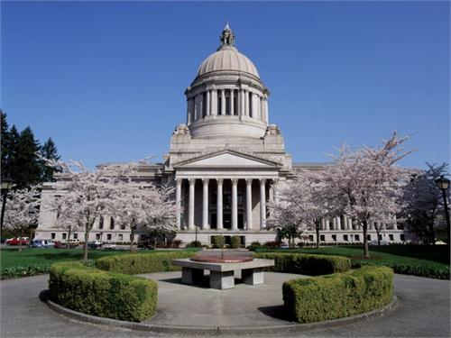

Invites you to attend
the 35th Annual
Disabilities Legislative
Reception

Wednesday, January 20, 2016
5:30 - 7:30 pm
Columbia Room of the Legislative Building
(State Capitol)

Hosted by:
Washington State Developmental Disabilities Council (DDC),
Governor’s Committee on Disability Issues and Employment (GCDE), Washington State Rehabilitation Council (WSRC),
Self Advocates in Leadership (SAIL), and
Washington State Independent Living Council (WASILC).

Questions about the reception? Contact:
Betsy McAlister dbmcharger@frontier.com

To request travel stipends contact Katie Story by December 31, 2015, 206-542-6644 ext. 149 or katie@parkviewservices.org
For reasonable accommodations & interpreters contact Debbie Himes by December 31, 2015, 360-902-9362 or dhimes@esd.wa.gov
Directions: http://leg.wa.gov/legislature/pages/parking.aspx

