35th Annual Disabilities Legislative Reception

Where people with disabilities and the organizations that represent them meet with Legislators to discuss issues critical to people with disabilities.

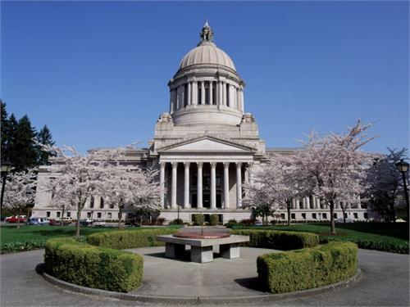
January 20, 2016
5:30- 7:30 p.m. The Columbia Room

Dear Legislator:
We cordially invite you to attend the Annual Disabilities Legislative Reception to be held in the Columbia Room of the Legislative Building on Wednesday, January 20, 2016 from 5:30 to 7:30 p.m.
This is an informal event attended by over 330 people and representatives of 60 organizations concerned with issues faced by people with disabilities and their families. This year we will be focusing on legislative budget and policy issues, and the celebration of the 25th anniversary of The Americans with Disabilities Act (ADA).
If you can’t attend, please send a member of your staff.
We thank you for your work on behalf of people with disabilities and their families. We look forward to seeing you at the reception to discuss issues of importance to people with disabilities.

Hosted by:
Washington State Developmental Disabilities Council (DDC),
Governor’s Committee on Disability Issues and Employment (GCDE), Washington State Rehabilitation Council (WSRC),
Self Advocates in Leadership (SAIL), and
Washington State Independent Living Council (WASILC).

Questions: donna.patrick@ddc.wa.gov
or 360-586-3566

