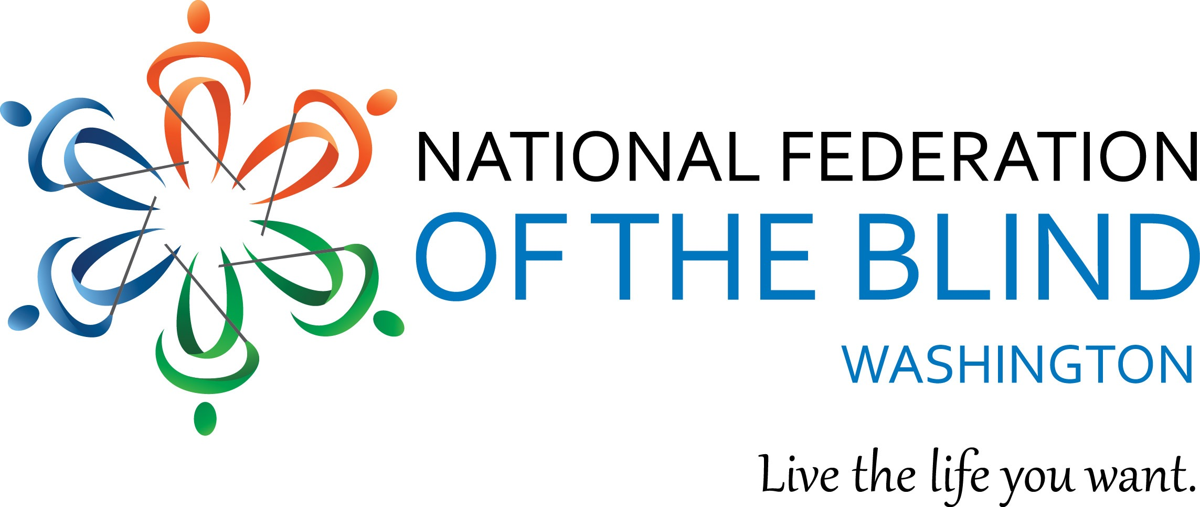
Register Now
for the
National Federation of the Blind of Washington
2016 convention
October 14-16, 2016
Best Western Plus Tacoma Dome hotel
2611 East E St., Tacoma, Washington
98421
(253) 272-7737

Follow this link; https://nfbw.wufoo.com/forms/x1a3tb0p0xsw3fw/ to register for the convention.

Join us for a fun and engaging weekend! There will be exhibits, awarding of scholarships, important discussion of blindness-related education and employment issues, a dynamic banquet address by NFB National Representative Ever Lee Hairston https://nfb.org/ever-lee-hairston-bio, a student meeting with NFB National Association of Blind Students President Kathryn Webster, breakout sessions and meetups around special interests, and an Independence Walk in celebration of White Cane Day on Saturday, September 15.
Convention hotel room rates are $99.00 + tax

You don’t want to miss this convention!

