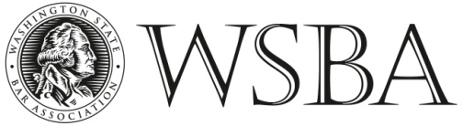

POSITION DESCRIPTION

TITLE: Diversity and Public Service Programs Administrative Assistant (Work Study)

COMPENSATION: $15 - $17 per hour, 15-19 hours per week

REPORTS TO: Diversity and Public Service Programs Manager

HAS REPORTING: None, N/A

SUMMARY: This position coordinates and maintains daily administrative activities, website maintenance, data collection and analysis and additional projects assigned by the Diversity and Public Service Programs Manager. The Washington State Bar Association’s (WSBA) Diversity and Public Service Programs promotes inclusion and equity, public service and pro bono opportunities in the legal profession pursuant to the WSBA Diversity Plan and RPC 6.1. Beginning and end dates for the work study position varies depending on the student’s schedule.
RESPONSIBILITIES: The DPAA’s primary focus for 2017 will be coordinating the statewide diversity stakeholders meeting. The DPAA will be responsible for working with the diversity and public service team, minority bar associations, law schools, legal organizations and WSBA members. The DPAA will provide administrative support and research for meetings, events, programs and initiatives. The DPAA will help establish and manage D & I and Public Service presence on social media as well as the WSBA website.

REQUIREMENTS: MUST exercise strict level of confidentiality
Strong administrative and organizational skills
Ability to research using various search methodologies
Effective written, spoken, and interpersonal communication skills
Ability to analyze information and make appropriate recommendations
Ability to prioritize and manage various tasks with competing deadlines
Ability to work independently as well as part of a team
Proficient experience with Microsoft Office and the internet
PREFERRED
QUALIFICATIONS: Self starter
Attention to detail
Experience working with diverse communities

Interested applicants should send a cover letter and resume to Felix Neals, WSBA Senior HR Specialist at felixn@wsba.org. This position will remain open until filled. This is a work study position. Candidate must be approved for work study funds through their respective school.

