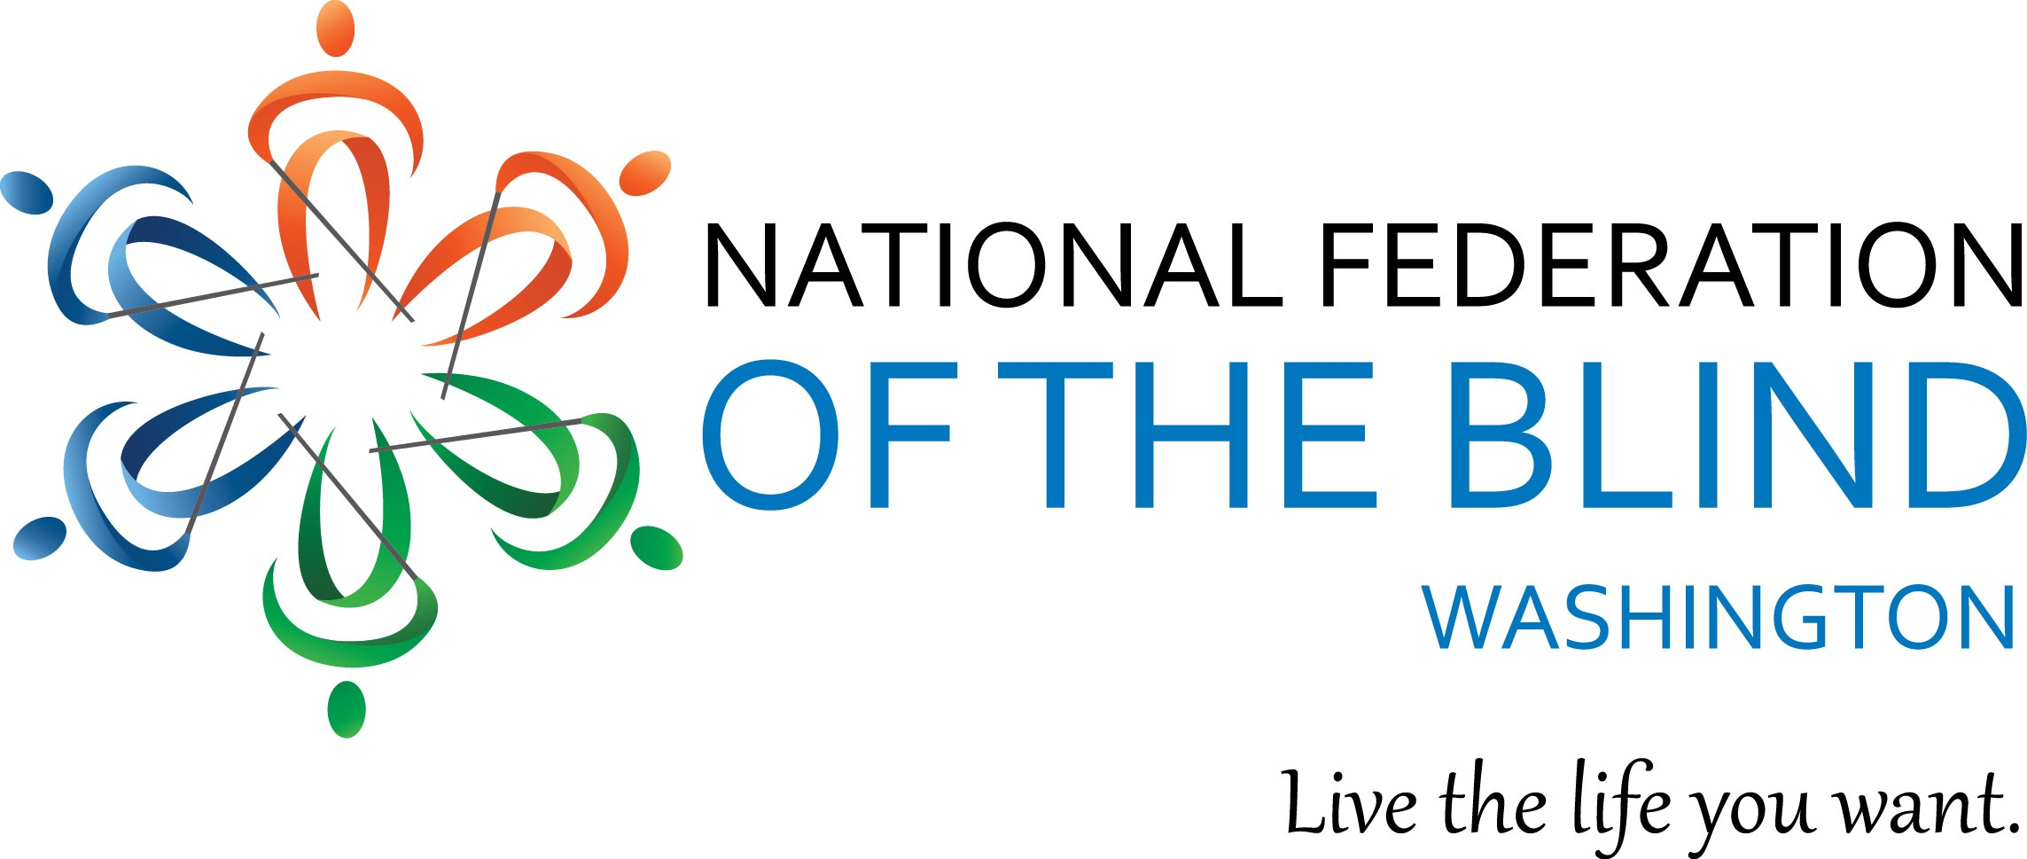
Instructions for Scholarship Application

The National Federation of the Blind of Washington is pleased to announce that we are accepting applications for our 2017 Scholarship Program. We will award 2 scholarships totaling $5,000 to 2 outstanding blind students in our state. The scholarships will be awarded at the banquet of our state National Federation of the Blind convention, which will be held November 3-5 at the Hotel RL, located at 2300 East Evergreen Dr. SW, Olympia, WA 98502.

All applicants must be:

- Legally blind in both eyes
- Residents of the state of Washington
- Pursuing a full-time undergraduate or graduate course of study or a part-time student who also works full-time
- Available to participate in the entire 2017 NFB of Washington state convention

In addition to a scholarship, each winner will receive assistance to attend the 2017 NFB of Washington annual convention, providing an excellent opportunity for networking with active blind persons in many different professions and occupations. The scholarships are awarded at the banquet on Saturday night of the convention. Attendance at the convention is mandatory.

Each scholarship application must include:

- Completed scholarship application form
- An essay describing the applicant’s abilities, academic achievements, community leadership, future goals and philosophy of blindness
- High school and/or up-to-date college transcripts
- 2 letters of recommendation

All applicants must also contact Cindy Bennett, one of this year’s Scholarship Committee co-chairs, for a telephone interview. Cindy can be reached at clb5590@gmail.com or (828) 989-5383.

All completed scholarship packets must be received by Friday, September 22, 2017.

APPLICATION PACKETS RECEIVED AFTER SEPTEMBER 22 WILL NOT BE CONSIDERED. INCOMPLETE APPLICATIONS WILL BE DISQUALIFIED.

Send completed scholarship application packets to:

Cindy Bennett
NFB of Washington
Scholarship co-chair
Clb5590@gmail.com

Or mail to:
National Federation of the Blind of Washington
PO Box 2516
Seattle, WA 98111

If you have questions please contact Cindy Bennett.

Please feel free to make additional copies of this letter and the application form, and distribute them to any interested blind students.

NFBW Scholarship Application Form

Name: ____________________________________________
Date of Birth: _
Home Address: Street: ___________________________________
City:______________________ State______ Zip___________
Home Phone: _____________ Cell Phone:_____________ Email:_________________________
Your Current Grade Point Average:
Class standing as of fall, 2017: ___________________ (Freshman - Senior, graduate student)

Education History
(copy and paste these fields to enter more than one high school or college attended.)

High School Attended: __________________________________________
Address: ____________________________________________________________________
City: _________________________________ State:________ Zip: ___________
Dates Attended:_____________________

Undergraduate College: __________________________________________
Address: ____________________________________________________________________
City: _________________________________ State:________ Zip: ___________
Dates Attended:_____________________

(N/A for undergrad applicants)
Graduate School Attended: __________________________________________
Address: ____________________________________________________________________
City: _________________________________ State:________ Zip: ___________
Dates Attended:_____________________

College to be attended in Fall, 2017:_______________________________________
Address:_______________________________________________________
City:__________________ State:______ Zip:__________
Major:____________________________________________________

Career Goal:________________________________________________________

