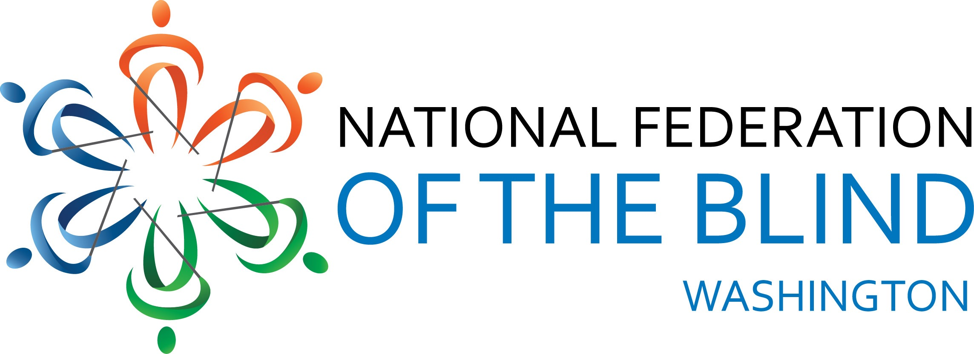
AGENDA
2017 Convention
National Federation of the Blind
of Washington
Marci Carpenter, President
November 3-5, 2017
Hotel RL Olympia
2300 Evergreen Park DR SW
Olympia, WA 98502

The National Federation of the Blind of Washington knows that blindness is not the characteristic that defines you or your future. Every day we raise the expectations of blind people, because low expectations create obstacles between blind people and our dreams. You can live the life you want; blindness is not what holds you back.

Important Information and Announcements

Unless otherwise noted, all meetings will take place in the spruce Ballroom. Exhibits will be in the Pine Room. All meeting rooms are located on the ground floor, the hotel restaurant and the lounge are located on the main lobby level.

The dog guide relief area is the grassy area behind the hotel. Please make sure to clean up after your dog guide.

Groups not scheduled for a convention session may meet at other times. Announcements will be made during convention.

The Hospitality Suite will open Friday evening and immediately after the banquet on Saturday evening. The affiliate will welcome you with snacks and beverages. Individuals 21 and over must present valid ID to be served beer and wine in the hospitality suite.

The hotel restaurant provides a free, full breakfast to NFBW guests. The restaurant is also open for dinner and lunch.

CONVENTION AGENDA

Friday, November 3

1:00 pm-5:00 pm Exhibits
Pine Room

2:15 pm-3:30 pm Convention First Timers Session Meet NNFBW leaders and mentors, learn how the convention works and participate in a fun activity.
Cedar/Hemlock Room

4:00 pm-5:30 pm Registration; Ballroom Foyer

7:00 pm-8:00pm NFB of Washington Board of Directors meeting
Cedar/Hemlock Room

8:00 pm-9:00 pm Resolutions Committee meeting
Cedar/Hemlock Room

9:00 pm-10:30 pm “Take the Stage” karaoke and performances at the Hotel RL stage
(No alcohol will be sold here)

9:00 pm-11:30pm Hospitality Suite opens with beer, wine and snacks
Location TBA

Saturday, November 4

8:00 am Convention Registration; Ballroom Foyer

9:00 am Welcome and Opening Announcements
Cheryl Selby, Mayor, City of Olympia.

9:15 am NFB National Report
Julie Deden, NFB National Representative and Director. Colorado Center for the Blind

9:45 am NFBW State Report
Marci Carpenter, President, NFB of Washington

10:05 am Putting an end to sub minimum wages- Seattle and the state
Marci Carpenter, President, National federation of the Blind of Washington; Shaun Bickley, Mayor’s Commission for People with Disabilities, City of Seattle.

10:30 am Break

10:40 am My First NFB Convention: Lynn Domingo.

10:50 am Training Centers; Freedom of Choice
Julie Deden, Director, Colorado Center for the Blind, Julie Brannon, Director, Orientation and Training Center, Washington State Department of Services for the Blind

11:25 am My First NFB Convention: Nellson Tualevao.

11:35 am Traveling as a Blind Person
Michael Forzano, Software Development Engineer, Amazon; Cindy Bennett, PhD Student, University of Washington; Buna Dahal, Owner, Dynamic Buna.

11:50 am Reports and Resolutions

Noon – 2:00 pm Lunch

2:00 pm Education and Literacy for Blind Students; Options in Washington State
Scott McCallum, Superintendent, Washington State School for the Blind; Michael Dickneite, Vision and Deaf/Hard of Hearing Supervisor, Seattle Public Schools; Danielle Miller, Manager, Washington Talking Book and Braille Library.

2:25pm: What You Need to Get a Job: Blindness Skills and Job Readiness.
Cory Klatik, Technical Program Manager, Microsoft; LouOma Durand, Executive Director, Washington State Department of Services for the Blind; Tim Paulding, Orientation and Mobility Instructor, Inland Lighthouse for the Blind.

3:05 pm Break

3:15 pm Mini Sessions-concurrent sessions. Attend as many as you like.

* Dog Guide Users
Facilitated By: Corey Grandstaff.
Hemlock Room

* Tech Techniques (show and Tell)
Facilitated By: Cory Klatik.
Pine Room

* Increasing Diversity in our Community.
Facilitated By: Jamal Mazrui
Cedar Room

3:45 pm Mini Sessions-concurrent sessions. Attend as many as you like.

* Mind, Body, Spirit.
Facilitated By: Danielle Frampton
Hemlock Room

* Demonstrations of KNFB Reader and NFB Newsline
Facilitated By: Mike Mello
Pine Room

4:15 pm Reconvene and Debrief

4:30 pm My First NFB Convention: Matthew Hines.

4:40 pm Elections

5:00 pm Adjourn

6:00 pm Reception and Cash Bar

7:00 pm Convention Banquet
Gary Mackenstadt, Master of Ceremonies
Banquet Address, Julie Deden, National Representative
Presentation of Scholarships, Bennet Prows and Cindy Bennett

9:30-12:00am Hospitality suite.
TBA

Sunday, November 5

9:30 am Announcements

9:35 am, Legislative Issues Affecting Blind People in Washington State, Matthew Hines, Legislative Coordinator, National Federation of the Blind of Washington

10:20 am Communication and Chapter Building, Chapter Reports, Andrea Travis, Secretary, National federation of the Blind of Washington

11:20 am Convention Wrap-up.

11:30 am Adjourn

