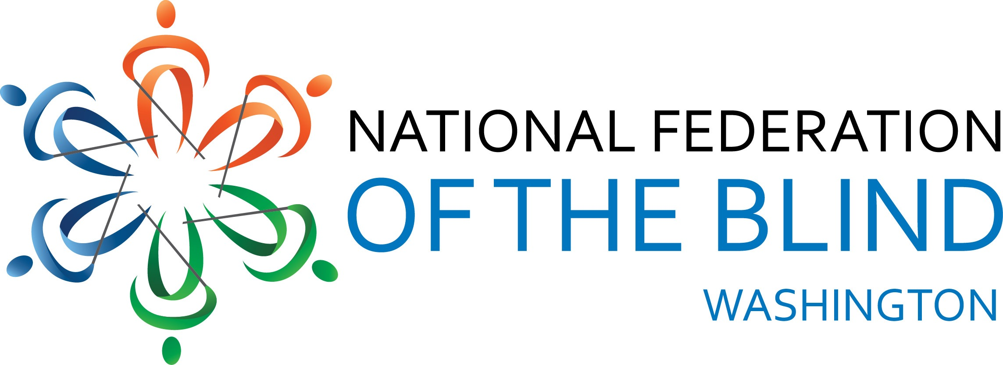
National Federation of the Blind of WashingtonAGENDA
2018 Convention
National Federation of the Blind
of Washington
Marci Carpenter, President
October 26-28, 2018
Hotel RL Olympia
2300 Evergreen Park DR SW
Olympia, WA 98502

The National Federation of the Blind of Washington knows that blindness is not the characteristic that defines you or your future. Every day we raise the expectations of blind people, because low expectations create obstacles between blind people and our dreams. You can live the life you want; blindness is not what holds you back. Together with love, hope and determination we transform the dreams of blind Washingtonians into reality.

Important Information and Announcements

Unless otherwise noted, all meetings will take place in the Pine Ballroom. Exhibits will be in the Spruce Room. All meeting rooms are located on the ground floor, the hotel restaurant and the lounge are located on the main lobby level.

The Washington Parents of Blind Children will meet at lunch time on Saturday. See Jenifer Gandarias for details.

The At Large chapter will meet at dinner on Friday. Meet Kris Colcock and Jenelle Landgraf outside the hotel restaurant at 5:10 pm.

The dog guide relief area is the grassy area behind the hotel. Please make sure to clean up after your dog guide.

Groups not scheduled for a convention session may meet at other times. Announcements will be made during convention.

The hotel restaurant provides a free, full breakfast to NFBW guests. The restaurant is also open for dinner and lunch.

Convention registration is open through Monday, October 22, 2018. Due to hotel catering constraints anyone registering after that date will not be guaranteed a banquet meal. You can register online at nfbwconvention.com.

CONVENTION AGENDA

Friday, October 26
1:00pm-5:00 pm Exhibits
Spruce Room

3:30 pm-5:00pm Rookie Roundup: Meet NNFBW leaders and mentors, learn how the convention works and participate in a fun activity.
Hemlock/Cedar Room

4:00 pm-5:00 pm Registration; Ballroom Foyer

7:30 pm-8:30pm NFB of Washington Board of Directors meeting

8:30 pm-9:30 pm Resolutions Committee meeting

9:30 pm-11:00 pm “Take the Stage” karaoke and performances at the Hotel RL stage
(Hotel lounge open until 12:00am)

Saturday, October 27

8:00 am Convention Registration; Ballroom Foyer

9:00 am Welcome and Opening Announcements

9:15 am NFB National Report
Mark Riccobono, President National Federation of the Blind

9:55 am NFBW State Report
Marci Carpenter, President, NFB of Washington

10:10 am Ending sub-minimum wages in Seattle and the state

10:25 am Break

10:30 am My First NFB Convention: Amandeep Kaur

10:35 am The Changing Landscape of Services to Blind Adults in Washington; A discussion of Order of Selection and Independent Living/Older Blind Services
Lou Oma Durand, Director, Department of services for the Blind, Corey Grandstaff, moderator

11:05 am How my NFBW scholarship has helped me live the life I want, Janell Landgraff

11:10 am Scholarship Winner Introductions

11:20am Washington Talking Book and Braille Library Update, Danielle Miller, Director, Washington Talking Book and braille Library

11:30 am School for the Blind updates,
Pam Parker, director of Outreach Services and DeEtte Snyder, State Coordinator, Birth-3 Services

11:50 am Reports and Resolutions

Noon – 2:00 pm Lunch

Breakout Sessions: Choose one to attend during each time slot.
2:00 pm-2:45pm
Technology for travel and Leisure
Hemlock Room

Financial Management
Northwest Access Fund
Cedar Room

2:50pm - 3:35pm
Technology at home and Work
Hemlock room

Yoga, Janell Landgraf
Cedar room

3:50pm My work as a Blind O&M Instructor
Tim Paulding, Travel Instructor, Inland Lighthouse for the blind

4:00pm Ringing the Bell in Washington; Braille Enrichment for Literacy and Learning (BELL) report
Corey Grandstaff, BELL Site Coordinator
Cole Fish, BELL participant
Les Fitzpatrick, BELL volunteer

4:20 pm My Experience at the Colorado Center for the Blind
Luc Gandarias, Sophomore, South Whidbey High School

4:30 pm Adjourn

6:00 pm Reception and Cash Bar

7:00 pm Convention Banquet
Gary Mackenstadt, Master of Ceremonies
Banquet Address, Mark Riccobono, President, National Federation of the Blind
Presentation of Scholarships, Bennet Prows and Tim Paulding
(Hotel lounge open until 12:00am

Sunday, October 28
9:00 am Announcements

9:05am Chapter Reports.

9:35am Legislative Update
Matthew Hines, Legislative Coordinator

9:50am Break

9:55am: Elections

10:25am Closing Remarks from President Mark Riccobono.

10:35am Building Membership in the NFB of Washington

11:20 am Convention Wrap-up.

11:30 am Adjourn

INCLUSIVITY, DIVERSITY, AND SOCIAL CONDUCT
As an attendee at our convention, you not only represent yourself but also represent our organization. We want you to enjoy our time together and to make new friends and renew old acquaintances. Although we encourage members to socialize and have fun, the convention also provides a valuable opportunity to come together to continue the work of our organization, to learn about the important initiatives that we are involved with on local, state and national levels, and to plan our work for the future.

The National Federation of the Blind seeks to provide a convention environment in which diverse participants, including members, speakers, exhibitors, and volunteers, may learn, network, and enjoy the company of friends and colleagues in an environment of mutual respect. We recognize a shared responsibility to create and uphold that atmosphere for the benefit of all. Some behaviors are therefore specifically prohibited:

- harassment or intimidation based on race, religion, ethnicity, language, gender, sexual orientation, gender identity/expression, disability, physical appearance, or other group identity

- sexual harassment or intimidation, including unwelcome sexual attention, stalking (physical or virtual), or unsolicited physical contact

- public drunkenness and associated behaviors (e.g., belligerence, yelling, hostility, destruction of property)

Participants are expected to observe these rules and behaviors in all convention venues, including online arenas, social media, and convention social events. Participants who are asked to stop a behavior that the recipient considers hostile or harassing are expected to comply immediately.

For assistance or to report an incident, please call or text Buna Dahal at 303-910-6413 or President Carpenter at 206-604-5507. All reports will be fully investigated according to the steps outlined in our Code of Conduct. Based on the information found in the investigation, appropriate action will be taken and may involve organization leaders and legal counsel. Based on the circumstances, hotel security and/or law enforcement may become involved, when appropriate.

We are committed to diversity, equity, and the free expression of ideas. These principles have been delineated in our Code of Conduct adopted by our Board of Directors in 2017. This document my be found at nfbw.org and clicking on the “Code of Conduct” link.

