Free2Fly 5K — FAQs
Sunday, September 27 · Seward Park, Seattle · Check-in 8:00 AM · Race starts 9:00 AM

Event Details
When and where is the Free2Fly 5K?
Sunday, September 27, at Seward Park, Seattle.
If you are getting dropped off by rideshare or paratransit we recommend using the address listed below for the Audubon Center so the driver can use the roundabout.
Seward Park Audubon Center
5902 Lake Washington Blvd S
Seattle, WA 98118

What is the schedule for raceday?
Check-in opens at 8:00 AM at Picnic Shelter #1. Please try to arrive at this time.
Pre-race announcements will begin at the start line at 8:45am just north of the Seward Park Clay Studio.
The 5K starts at 9:00 AM
Post-race festivities will conclude at 11am
Is this course timed?
These bibs do not contain timing chips. If you would like to know your time to complete this 5k, please bring your own gadget to track the time, whether that’s a watch, phone, or metronome.
What is the race course like?
Course description: The course is a flat out-and-back along the north, paved curve of Seward Park’s Shore Loop Road. We will start and finish just north of the Seward Park Clay Studio. Participants will follow the Shore Loop Road clockwise then turn around at the 1.55 mile mark to return to the start/finish line. Please stay to the right when moving in either direction unless you intend to pass another participant.
A screenshot of the course map can be found here:
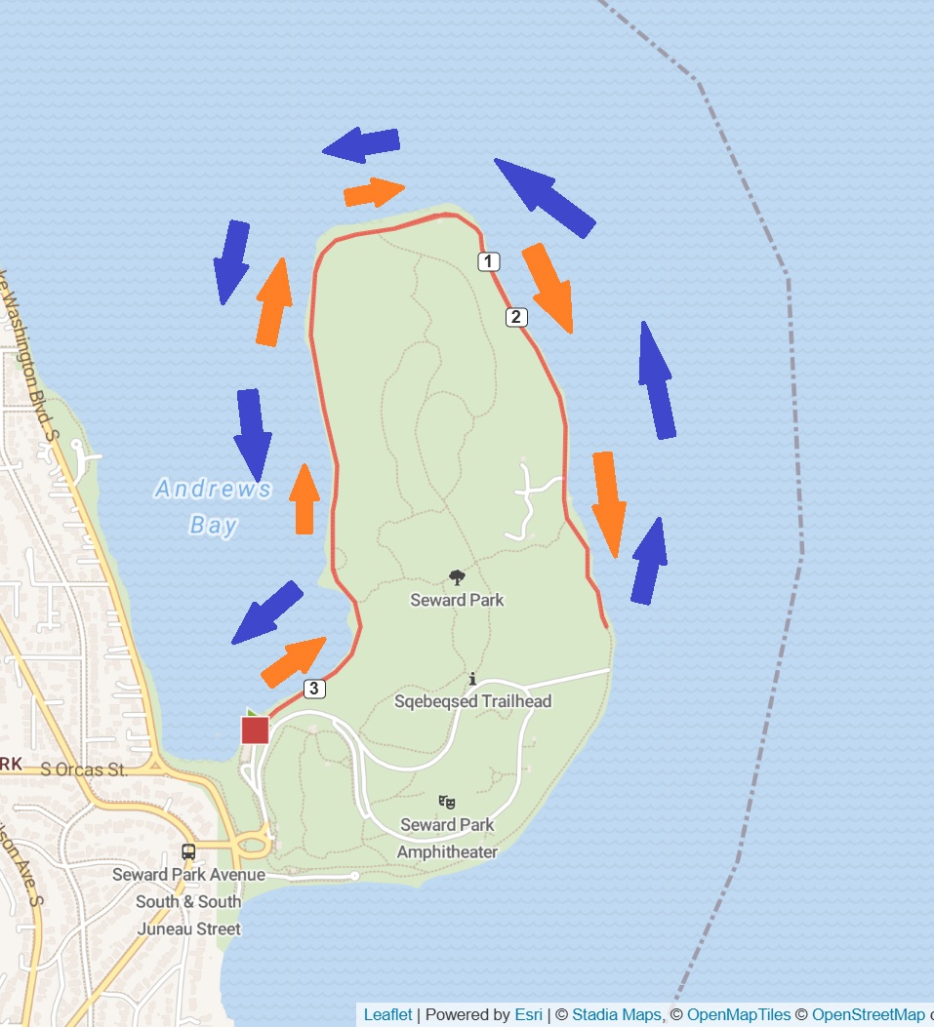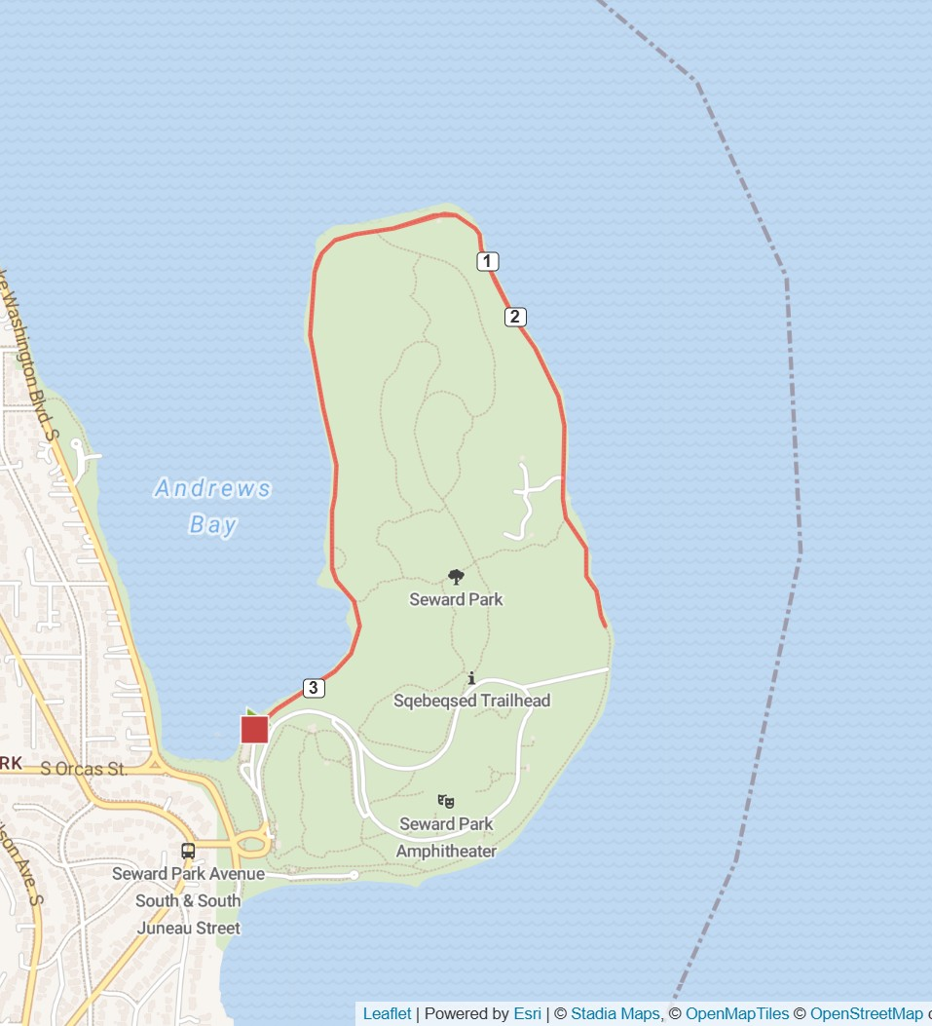
What on-course support will be provided?
We will have volunteers at mile 1, miles 2, and mile 3 to provide audio mile mile markers for visually impaired participants. There will be refreshments and snacks at the end.
What happens after the race?
We have tactile surprises instead of finisher medals at the finish line plus a post-race celebration with food and information booths from community partners. Huge thank you to Top Pot for donating doughnuts and coffee and to the Brooks Disability Employee Network for donating snacks and beverages!
Do I need to bring my own water?
While we encourage participants to rely on reusable water bottles, we will have water bottles available for free at the end of the race.
Can I leave my gear somewhere during the race?
We encourage you to leave valuables in a safe location. If you have a cane, bag, and/or jacket to leave while you participant in the 5k, you can leave it with our volunteers who will stay at Picnic Shelter #1. Please attach a luggage tag with your name on it or be able to explain what your bag looks like to our team so they can help you retrieve it.
If you drive yourself, please leave your personal items in the car and retrieve them after the race so as to not overwhelm the small gear check area.
What attire should I wear?
Please check the forecast the day before the event for the latest info. Seward Park can get windy, so we recommend a jacket to wear after the race when your body starts to cool down.

Are there restrooms?
There are public restrooms near the Audubon Center.

Registration
How do I register?
Registration is done through the form here: https://www.wearefree2fly.com/free-2-fly-5k
Is there a registration fee?
There is no registration fee. However, we recommend making a donation to support the event and Free 2 Fly, a 501(c)(3) nonprofit. Our suggested donation is $20: https://www.wearefree2fly.com/donate
I'm a sighted runner/walker who'd like to join. Do I have to guide a visually impaired individual?
No. On the form, you can indicate whether you'd like to be a guide or simply participate on your own.
How can I be sure my registration went through?
Once you submit the form, you'll receive an automated confirmation email. Please double-check that the information in that email is correct.
I registered, but what if I find out a few days beforehand that I can't make it?
We understand that things change. Send us an email at wearefree2fly.rc@gmail.com to let us know that you can no longer attend at least 48 hours before the event so we can adjust pairings as needed.
I'd like to share this event with my friends, family, colleagues, or community — how can I do that?
Please share the registration link (https://www.wearefree2fly.com/free-2-fly-5k) or the QR code below, which takes people to the same page.


Accessibility & Support
I'm visually impaired. Can I participate?
Absolutely. Please indicate this when you register, and let us know how we can best support you. We can provide a sighted guide or you can bring your own, just let us know via your registration form. For sighted guides that we provide, we will provide tethers as well. If you bring your own guide you are also welcome to borrow a tether for the race.
During the race, we will have volunteers at mile 1, miles 2, and mile 3 to provide audio mile mile markers for visually impaired participants.
I'm DeafBlind. Can I participate?
Absolutely. Please indicate this when you register, and let us know how we can best support you.
I use a wheelchair or another mobility device — can I participate?
Absolutely. Please use the accessibility information section on the form to let us know how we can best support you. This course is flat and there are ramps to access the parking lot.
I have a guide dog. Can I bring them along the race course during the 5k, or can I leave them with a volunteer while I participate?
You are welcome to bring your guide dog along the course if they are ready for a 5k distance. If you need to leave your dog with a volunteer while you participate in the 5k, please indicate this in the registration form.
I’m visually impaired. Is there a tactile map I can preview before the race?
Yes! On race day, we will have tactile maps that you can feel before the race starts. Please arrive around 8am to ensure you have enough time to check in and review the tactile course.

Donations
How can I make a general donation?
Through the donations page, where you can choose a preset amount ($10/$20/$30/$40) or enter a custom amount, and select one-time, weekly, monthly, quarterly, or annual giving. There's also an option to cover the 3% processing fee so your full donation reaches Free2Fly, a 501(c)(3).
Can I donate through my employer's or organization's giving program?
Yes. Please use the donations page. If our organization is not on your company’s giving site, let us know and we'll reach out to be added.

Other
Who can I contact with questions?
Email wearefree2fly.rc@gmail.com, or reach out via Instagram/social at @free2fly.rc.

