
Federal Transit Administration
Office of Civil Rights

Civil Rights Training
December 2 - 4, 2009
Washington, DC

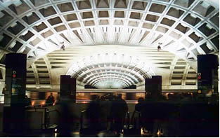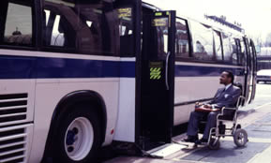

The Federal Transit Administration’s Office of Civil Rights invites its grant recipients and other interested stakeholders in all FTA Regions to attend a three-day training on FTA’s civil rights requirements and guidance. The training will review federal laws, regulations, executive orders, and guidance covering the Americans with Disabilities Act, Title VI of the Civil Rights Act of 1964, and the U.S. Department of Transportation’s Disadvantaged Business Enterprise (DBE) Program. This training will also discuss recently implemented and proposed updates to existing FTA civil rights directives and guidelines.

This training will help practitioners better understand the importance of civil rights considerations in transportation and transit planning, project development, investment, and operations. Participants will be able to apply the content learned during this course to their daily work activities and local environment.

Participants will also have the opportunity to provide the FTA with feedback on challenges and opportunities that they have experienced in implementing Federal civil rights directives and to share examples of effective or promising practices that could be adopted by state, regional, and local agencies or community-based organizations.

Scholarships for travel expenses are available!

This training will be held at the Westin Arlington Gateway located at 801 North Glebe Road, Arlington, VA 22203. Hotel rooms are available on a first-come first-serve basis. To reserve a room at the group discount rate of $207/night, call 1-888-627-7076 or 703-717-6200 and mention the FTA Workshop. The room registration cut-off date is November 13, 2009.
Reservation Deadline: Workshop reservations must be made by November 13, 2009 while all scholarship requests must be made by November 6, 2009.
FTA Civil Rights Training
Preliminary Agenda

Wednesday — December 2, 2009

Morning Americans with Disabilities Act of 1990 (ADA)
Overview and Updates
Afternoon ADA Fixed Route Self Assessment
Complementary Paratransit Self-Assessment
ADA Trivia!

Thursday — December 3, 2009

Morning Title VI of the Civil Rights Act of 1964 Overview
Overview of New Title VI Circular
Title VI Video “Divided Highways”
Afternoon Environmental Justice
Exercise: City of Metropolis
DOJ Video “Language Barriers”
Limited English Proficiency (LEP)

Friday — December 4, 2009

Morning Disadvantaged Business Enterprise Program (DBE) Overview
DBE Goal Methodology
Afternoon DBE Fraud
DBE Certification

