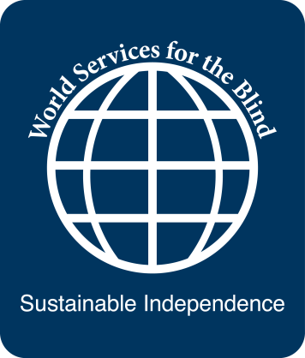 Microsoft Certified IT Professional (MCITP)

Program Length: 5 months (7 with internship)
Enrollment Dates: September 6, 2012
Program Description: The Microsoft Certified IT Professional program is designed to prepare a person to work as a computer systems problem-solver at a business that has a computer network, such as educational institutions, hospitals, government agencies, or banks. The entry level position is usually at a help desk with advancement into information technology management.

Pre-Requisites:
• High school diploma or GED
• A+, Network+ and Windows 7certified
• Good comprehension of technical written material using assistive technology, if applicable
• Keyboarding speed of 30 wpm
• High proficiency on appropriate assistive technology
• 12th-grade proficiency in business math
• Wonderlic score of 25
• Strong logical reasoning ability
• Ability to learn and retain information
• Ability to work in a high-tech environment
• Willingness to relocate for employment
• Good independent living and travel skills
• Positive attitude
• Excellent interpersonal skills
• Excellent communication skills

For referrals or more information contact:

Recruitment and Admissions Office
Lions World Services for the Blind
(501) 664-7100 or (800) 248-0734
training@lwsb.org www.lwsb.org

