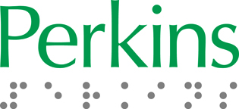
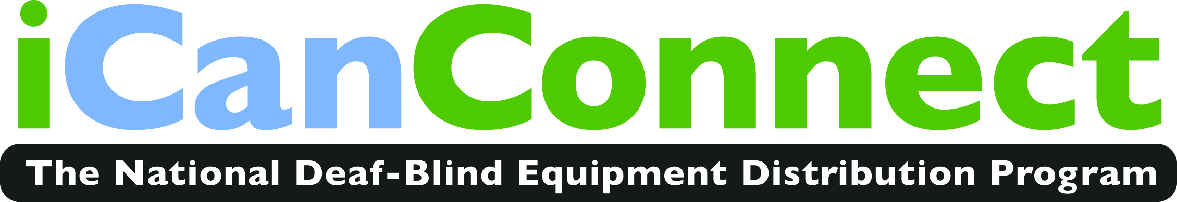
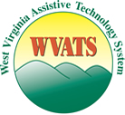

West Virginia Assistive Technology Systems (WVATS) and West Virginia SenseAbilities are pleased to announce the establishment of iCanConnect West Virginia, a program established by the Federal Communications Commission (FCC) to distribute a wide array of assistive technology to people with combined hearing and vision loss who require special equipment to make a phone call, send an email or access the Internet.
Working in conjunction with the FCC, the Perkins School for the Blind, the Helen Keller National Center for Deaf-Blind Youth and Adults (HKNC), WVATS will connect people in West Virginia who are deafblind with the proper agencies to obtain equipment and training on how to utilize it. iCanConnect was mandated by the 21st Century Communications and Video Accessibility Act (CVAA) and provides a wide range of hardware, software and applications to suit the varying communications technology needs of people who have hearing loss plus visual impairment.
Who can benefit from iCanConnect West Virginia? Here are just a few examples.
- A recent college graduate who is deaf-blind and wants to use Monster.com to search for a job
- A young girl with combined hearing and vision loss who wants to use Skype to connect via sign language with her grandmother
- A man who has lost sight and hearing as a result of aging and wants to use email and Facebook to reconnect with friends and family

Who is eligible?

Any individual who meets the definition of deaf-blindness in the HKNC Act and has an income that does not exceed 400% of the federal poverty level can qualify to receive telephone, advanced communications and information services equipment.
Communication is essential for staying healthy, holding a job, managing a household and participating in the community. If you know someone who might benefit from the iCanConnect program West Virginia, please contact West Virginia Assistive Technology Systems at 304-293-4692 and West Virginia SenseAbilities (Annette Carey or Ruth Ann King) at 304-558-2696.

You can also visit the new website, www.iCanConnect.org or call 1-800-825-4595.

