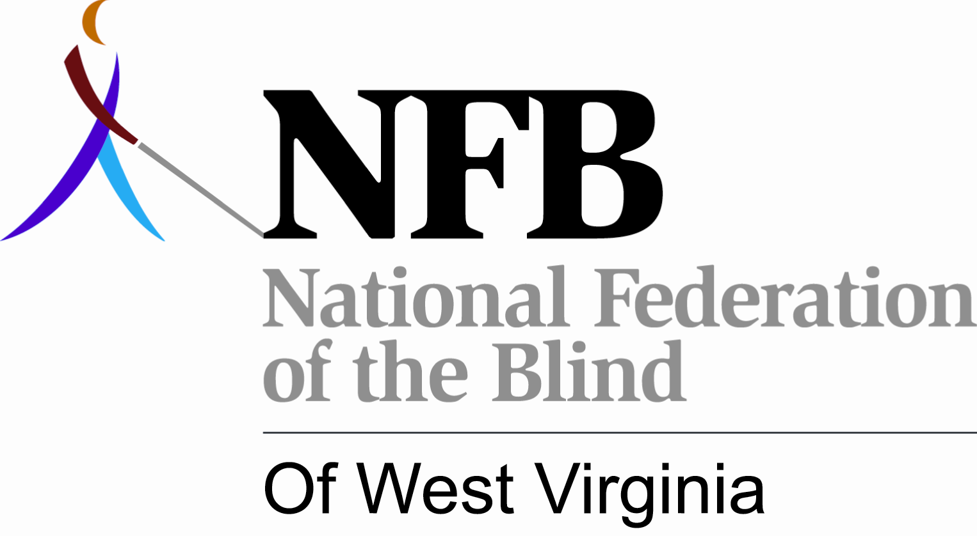

BUSINESS OWNERS -ADVERTISING MANAGERS -PROFESSIONALS -CIVIC ORGANIZATIONS

The National Federation of the Blind of West Virginia (NFBWV), the oldest and largest organization of blind persons in the state

invites you to be an official sponsor of its 2014 state convention.

The event takes place the weekend of September 11-14, 2014 at the Best Western Bridgeport Inn, Bridgeport, WV.

The convention is the largest annual gathering of blind persons in West Virginia. In addition to conducting the official business of the organization, the convention is an opportunity to learn about government policies and programs, new technologies, and other vital issues affecting the lives of blind West Virginians.

You can disseminate your message while supporting the work of the Federation by becoming an OFFICIAL CONVENTION SPONSOR. Official sponsorship guarantees your business or organization a listing in the convention agenda, announcements from the podium during convention sessions, recognition on the NFBWV web site, and display advertising in the hotel lobby throughout the convention weekend. Sponsors will receive exposure and recognition commensurate with their respective levels of support.

Convention sponsorship is offered at four levels:

PLATINUM: $300 and Up
GOLD: $200.00 to $299.99
SILVER: $100.00 to $199.99
BRONZE: $50.00 to $99.99

Contact: Charlene Smyth, NFBWV President, 401 E Olive St; Apt. 1-A, Bridgeport, WV 26330 cs.nfbwv@frontier.com or 304-841-1111

