BRAND DOCUMENTS FOR

THE NATIONAL FEDERATION OF THE BLIND

Summary of Branding and Messaging Documents Consolidated

Updated November, 2016

SECTION 1: NATIONAL FEDERATION OF THE BLIND BRAND ARCHITECTURE

WHAT IS BRANDING?

Branding is the process of determining what you want your reputation to be, and then doing everything you can to create that reputation.

When done well, branding determines how you look, how you sound and how you act. It is a filter for making decisions—often difficult decisions—about who you are as an organization, and perhaps more importantly, who you aren’t.

A strong brand becomes a familiar entity. The name and logo of the organization represent a clear set of values, ideas, personality, and actions. Being clear about your brand helps others who believe what you believe find and join with you.

Brand also acts as a guide for those who represent your organization―whether in a volunteer, professional, or board capacity. Because your organization has defined the qualities for which it wants to be known, those who join, support or represent the National Federation of the Blind will know how they can best represent you―and how they can bring the brand to life.

It’s a new day for the National Federation of the Blind. Here’s what it looks like.

The following document outlines the brand architecture for the National federation of the Blind, as developed through a process involving Federation leaders and members from across the country working with Mission Minded, a nonprofit branding consulting firm.

KEY FINDINGS

Key Findings are the result of all the research and discovery work undertaken by Mission Minded. Discovery includes a review of all critical internal and external documents provided by the NFB, relevant websites, clarifying conversations with key leaders in the organization, interviews with non-members, quantitative research conducted on your behalf, and an understanding of the organization in the context of its competitors. These insights, in collaboration with the input provided by organizational leaders throughout the process, form the basis for the brand recommendations included in this document.

KEY FINDINGS – Executive Summaries

Positive Aspects of the Brand

- Civil rights organization dedicated to fighting for equal rights
- Collective action-many voices are better than one; speak for those who can’t
- Provide countless resources and support for the blind
- Tireless, determined; a fearless leader

Negative Aspects of the Brand

- Militant and demanding
- Rigid in its definition of blindness and how blind people should act
- Exclusive; does not represent all blind people
- Stodgy and old-fashioned; not representative of younger generations

Positive Perceptions of the Brand

- Largest membership of blind organizations (50,000 strong)
- Longevity; over 75 years of advocacy
- Political clout; well known in local, state, and national governments; contributions to disability rights
- Passionate, skilled leaders

Negative Perceptions of the Brand

- A large, wealthy organization that doesn’t need me
- A bully that doesn’t play nicely in the sandbox
- If I don’t adhere to all the NFB’s principles, I won’t fit in
- Top-down, rather than democratic, organization

Shifting Perceptions of the Brand

Where we are

- Fearless, determined at all costs
- Committed to our philosophy, at times dogmatic
- Dated, not quite keeping up with the times
- A club only those who believe what we believe may join
- Revolutionary

Where we need to be

- Fearless, committed to equality, and fair practices
- Focused on collective action on behalf of all blind people, yet relevant to the individual
- Inclusive, welcoming

AUDIENCES
Target audiences are the people the NFB must engage in order to accomplish its goals. The NFB does not have the resources to reach every conceivable supporter of its work; therefore, it is critical to take a disciplined approach to identifying the demographic and psychographic characteristics of the audiences most critical to the organization’s success.

Current members are the lifeblood of the organization; the “we” of the NFB. The brand architecture and eventual messaging must ring true to current members and help to reignite their passion for the organization and its mission. The challenge we are focused on here is to expand the influence and membership of the NFB by reaching individuals who choose not to affiliate with or support the organization today, for a range of reasons.

The following audiences, signified by composite fictional characters, represent those who are most likely to be persuaded by messaging about the NFB.

AUDIENCES

Launching Luis – Generation Y (18 to 36) Blind Adult

Luis is a blind, Hispanic, 23-year-old man. He is a recent college graduate and his family is very proud of him. He has an acceptable, though not exciting, job and can pay the rent on his rather grungy first apartment. He still lets his mom take care of him to some degree and she makes sure his refrigerator is stocked and brings him dinners so he won’t go hungry.

He has a new iPhone 5c and 427 friends on Facebook. He likes technology, social media and Netflix. He likes to hang out with his buddies, but he is really not much of a joiner. He doesn’t get out as much as he thinks he probably should. In fact, he is a little disappointed in himself for not doing more with his life. He thought he would have a better job and a nicer apartment by this point in his life. Maybe even a steady girlfriend. In truth, his blindness skills aren’t all that great and he lacks self-confidence to take bigger risks.

He hasn’t given that much thought to blindness organizations or the NFB. Since he’s not really a joiner he made a decision somewhere along the line that it wasn’t for him. In reality, he could be a lot more successful and satisfied with his life if he took advantage of what the NFB has to offer him.

When I interact with the NFB I feel hopeful and dare to dream about my future because I have a reliable network I can turn to for support, expertise and encouragement.

Somewhat Satisfied Cheryl – Blind Adult, 37+

Cheryl is a 38-year-old mother of two. She is divorced from her first husband and is happily re-married living a busy life that revolves around her family. They enjoy family outings and look forward to their annual vacation with her sister and their kids to Branson, MO. She has many blind friends and they like to go league bowling together on Wednesday nights.

She job-trained at Lions World in Little Rock and has a reliable, if not very fulfilling, job at the IRS. In her heart, she knows that this is not her dream job and she wishes she had challenged herself to become a teacher. At times she is a little ashamed that she settled for this path.

Cheryl and her friends are aware of the NFB and appreciate its Newsline service and some of the other support technology they offer. She is glad they challenge companies like Amazon to make their products accessible for her, but she would never dream of going to a protest. Or would she?

Truthfully, she would like to expand her circle a bit, but friends and colleagues have told her unless she follows all the “rules” of the NFB, they won’t welcome her. Her Lions World alums scoff at the NFB and prefer to attend the occasional ACB convention where they feel safe, not challenged. She is curious about the NFB and has perused their website but is not exactly sure how she might fit in or get involved. The website certainly didn’t invite her engagement or make her feel welcomed. She is nervous the NFB members might look down at her for her “lesser” education and safe job. If the NFB reached out to her in the right way, she might be willing to see what they are really all about.

When I interact with the NFB, I feel more deeply fulfilled and inspired to dream bigger because I have friends who care about me, a community that supports me and skills I could not have learned from anyplace else.

Pampered Patsy – Blind Youth

Pampered Patsy is 16 years old and a junior at East High School. Patsy and her mom are very close and love watching movies, shopping and eating frozen yogurt together. Secretly, she’d like to stop wearing some of the dowdy clothes her mom picks out for her at JC Penney and do some shopping at Forever 21, but she’d never hurt her mom’s feelings.

She was mainstreamed into public school at an early age and has a teacher’s aide with her all day long. Her aide is great at helping her manage her classes, opening her locker and navigating the lunch line, but this isolates her at school. She sometimes feels a bit lonely because she doesn’t really have any of her own teenaged friends.

While she has a cane, she doesn’t really use it that much. It just seems easier to walk with her family and she doesn’t want to hold them up. She has learned Braille but since most of the books she’d like to read are also audiobooks, she listens instead. She works hard at school and gets good grades. Most days she feels good about herself.

Like most high school juniors, she is worried about what is next for her. She would like to be an elementary teacher because she feels more comfortable around kids. But, she is not sure how she would pull that off. She knows there are blind teachers, but she hasn’t met any at her school. And it is hard for her to imagine going to college on her own. Would she be able to manage without her family close by? She concludes that an online university is a better choice for someone like her.

She has heard of the NFB and is neutral about it. Her aide mentioned the summer programs they offer at the Colorado Center for the Blind, which sound interesting, if a little scary. Getting involved with the NFB could provide her with inspiration, role models, resources and financial aid for college. If her mother knew about all the NFB could offer her daughter and gave it her stamp of approval, Patsy would definitely explore it.

When I become part of the NFB, I feel free to expect the most of myself because I am supported by a community of people who believe in me, care about me and inspire me to dream bigger than I would without them.

Getting By Greg – Transitional Blind (anyone in-denial, seniors, veterans, those facing vision loss, the newly blind)

Getting By Greg is a 35-year-old man who works as a claims adjuster at a local insurance agency. He is married with a young son and loves to take his son to baseball games. He stays fit playing basketball with his buddies, goes to church and is saving responsibly for retirement and his son’s education.

Greg is legally blind with 20/400 vision, however, he would never admit this to his friends. They just think he has really poor vision. He has enough vision to get by although he can’t drive. He uses a screen magnifier on his office computer, which works okay for now. He has started using Newsline just because it makes it a bit easier to keep up with the news. He suspects they have other products that might be helpful but he won’t shop for them and admit he might need them.

Using the term “blind” to describe himself would be admitting failure, and he is not ready to do that. He would rather suffer temporary and sub-par fixes rather than admit he is blind. Inside, he is worried about what the future holds for him. What if his vision keeps getting worse? Will his wife and friends stand by him? Can he continue to work and provide for his family?

The NFB has helped many people in Greg’s shoes, and could help him by providing tools and resources to improve his quality of life; role models to empower him; advocates to ensure job security and a sense of community by being around others who have successfully navigated this terrain.

He might be willing to support the NFB “to help others,” if not himself.

When I interact with the NFB I feel hopeful about my chances for a satisfying and rewarding future because I know the NFB will be there to support, train and encourage me.

Mission Minded Melissa – Individual Donor

Melissa is around 40, but you’ll never know for sure. She is a college graduate and education director for the Chicago Science Museum. She is an early adopter of new technology, works out and eats at Chipotle. She drives to Target in her red Prius. She cares about social justice and believes her contributions of time or treasure will make a difference.

Her neighbor growing up, Pam, was blind and she saw how challenging it was for her at times. They see each other every few years at an occasional family gathering and she admires all that Pam has achieved. She knows that the NFB scholarship Pam received enabled her to go to college and earn her degree.

Life hasn’t always been easy for Melissa and she shares a kinship with those who have had to overcome big challenges. When she makes a charitable contribution, she wants to know it will really make a difference in someone’s life. She is familiar with the NFB and sometimes donates a portion of her charitable giving to them. She has seen first-hand the transformative difference the NFB can make. She knows the NFB is not a place where her peers typically give and she likes that. She sees herself as independent, in-the-know and giving to the NFB is consistent with her values.

When I support the NFB I feel special because I know something many others don’t: that curing blindness isn’t the goal. I want my donation to support programs and an organization that helps blind people achieve their dreams.

Senator Uncle Sam – Policy Maker

Senator Uncle Sam is 63 and has been serving his country since he was in his 20’s. He started off as an idealistic state representative fighting for freedom, equality and civil rights for his constituents. At this point in his career he is a bit jaded and seems more interested in self-preservation and fundraising for his next campaign. While he still upholds his ideals, he is less likely to go out on a limb for them.

While in his younger years he met frequently with disability rights groups to craft legislation, now he has other priorities. The blind are a relatively small fish in his pond and he doesn’t think they are critical to his success. He sees the disabled in general as beneficiaries of federal funds, not agents of change.

He doesn’t mind meeting with the NFB, but quite frankly, he finds their aggressive style somewhat off-putting. He wishes they would be more willing to settle for compromise, even though he knows their demands are valid. If he believed the NFB respected and understood where he was coming from and the challenges he faces he would be more willing to collaborate with them on possible solutions rather than refusing to consider their ideas and demands.

I am compelled to work with the NFB because I know they are trying to help blind people realize their dreams of independence and self-sufficiency, but it takes legislative and legal work on my part to make this a reality.

Judge “David T” – Successful Blind Adult Not Affiliated with the NFB

Judge David T graduated from Columbia Law School and was a successful litigator before becoming a judge in Washington, DC. He is at the top of his profession and his achievements are his pride and joy. He loves to share his successes with others and hopes to inspire many future lawyers.

He prefers to use assistance to get around, rather than a dog or a cane. He uses a driver to get him around DC and has a housekeeper to do his shopping and take care of household tasks for him. He takes pride in his home and sense of style. He prefers to spend time with his sighted colleagues. He sees most blind people as beneath him because he has really had to work hard to get where he is. He doesn’t respect blind people who ask for handouts or rely on welfare. He hates to imagine his sighted peers might seem him as less adequate in any way.

He has known about the NFB for many years. In his younger days he went to a conference but it wasn’t quite for him. Today he uses Newsline and some of the other technology the NFB provides. He occasionally makes a donation. He knows the NFB serves a valuable role in protecting the rights of the blind and advocating for fair and equal treatment. While he wants to make sure the NFB sticks around, he is not really interested in signing up for all the responsibilities of being a member or being publicly affiliated with a disability organization.

I feel reassured to know that an organization like the NFB exists to challenge discrimination and unfair practices, and to encourage blind people to live up to their full potential. My involvement helps others feel about themselves as I do about myself.

BRAND ARCHITECTURE – DEFINITIONS

The Brand Architecture is internal language and ideas. It is the foundation upon which we craft our external-facing brand identity and messaging.

BRAND VALUES. The essence of our brand. Values are the code by which the brand lives—principles upon which we make our decisions. They are the heart and soul of the organization and do not tend to change over time.

BRAND PERSONALITY. These are the distinguishing qualities and characteristics of the NFB. Personality attributes are the culture of the organization—who you aspire to be.

BRAND VALUE PROPOSITION STATEMENT. The brand value proposition is the unique value your audiences receive from your work in exchange for what you ask from them. Not intended as a public message, it's an internal guide for what should be conveyed about the organization.

BRAND POSITIONING STATEMENT. The brand positioning statement describes how the NFB seeks to position itself relative to its competition. The statement identifies the key elements that make the organization unique and the core ideas for which you seek to be known.

BRAND PROMISE. A distillation of the other elements, the brand promise is the heart of what's most important about you. It is the thing you tell yourself so that you can go out and live the brand.

BRAND VALUES

The essence of our brand. Values are the code by which the brand lives—the principles upon which we make our decisions. They are the heart and soul of the organization and do not tend to change over time.

COURAGE. Fighting for freedom takes perseverance and unwavering determination in the face of challenges, setbacks and difficulty. For 75 years the NFB has led this fight and made significant progress on the road to complete freedom and equality for the blind. It will take our continued courage to “break down the remaining barriers on the last miles of the road to freedom” (to paraphrase Dr. Maurer).

RESPECT. Our faith in the capacity and dignity of blind individuals is at the heart of our mission. We assert the right to be treated fairly and equally. We reject society’s low expectations that come from the ingrained belief that blindness is the characteristic that exclusively defines us.

FULL PARTICIPATION. We assert that blind people have a right to live fully and equally in the world. From this flows our expectation that society will not artificially prevent blind people from full participation. The world is better off when all of its people can contribute all that they have to offer.

LOVE. The NFB provides a loving, supportive and encouraging family that shares in the challenges and triumphs of our blind brothers and sisters. This deeply held faith in one another sustains members during times of challenge and cheers on individual and collective successes. Love is the feeling that permeates our organization and pushes us to expect the best from each other.

DEMOCRACY. The NFB is the original and largest organization OF the blind. By virtue of being a democratic organization open to all blind people, we represent the issues that are important to the blind openly and fairly. National, state, and local officers are elected by the membership of the NFB to ensure a representative form of government and democratic decision-making practices. Our membership-driven structure ensures blind people may determine their own future rather than relying on others to advocate for them.

COLLECTIVE ACTION. The primary purpose of the NFB is “to serve as a vehicle for collective action by the blind.” A core belief is that the blind can and will speak for themselves. Embodied in this self-determination is the understanding that progress comes from blind people working together, sharing individual dreams and speaking with a more powerful, unified voice than any one person could on his or her own.

BRAND PERSONALITY

These are the distinguishing qualities and characteristics of the NFB. Personality attributes are the culture of the organization—who you aspire to be.

INSPIRATIONAL. This personality trait includes: Courageous, Risk-taker, Always striving, Motivational, Full of hope, Optimistic

INNOVATIVE. This personality trait includes: Imaginative, Solution-seeking, Creative, Technologically-savvy

POWERFUL. This personality trait includes: Smart, Prepared, Confident, Determined, Outspoken

INVITING. This personality trait includes: Caring, Loving, Nurturing, Authentic, Helpful, Encouraging, Warm

BRAND VALUE PROPOSITION

The brand value proposition is the unique value your audiences receive from your work in exchange for what you ask from them. Not intended as a public message, it's an internal guide for what should be conveyed about the organization.

I am filled with hope, energy, and love by participating in the National Federation of the Blind because my expectations are raised, my contributions make a difference to me and to others, and I can celebrate the realization of my dreams with my Federation family.

BRAND POSITIONING

The brand positioning statement describes how the NFB seeks to position itself relative to its competition. The statement identifies the key elements that make the organization unique and the core ideas for which you seek to be known.

The NFB is the only organization that believes in the full capacity of blind people and has the power, influence, diversity, and determination to help transform our dreams into reality.

BRAND PROMISE

A distillation of the other elements, the brand promise is the heart of what's most important about you. It is the thing you tell yourself so that you can go out and live the brand.

Together with love, hope and determination, we transform dreams into reality.

TAGLINE

The tagline distills the internal Brand Architecture into external facing language. It should be featured prominently in marketing communications and works alongside the organization’s name and updated logo. All NFB affiliates and chapters should embrace and use this tagline to help create a strong, unified, national brand.

The National Federation of the Blind. Live the life you want.

BRAND ARCHITECTURE SUMMARY

BRAND PROMISE: Together with love, hope, and determination, we transform dreams into reality.

BRAND VALUES: Courage, Respect, Full Participation, Love, Democracy, and Collective Action

BRAND PERSONALITY: Inspirational, Innovative, Powerful, Inviting

BRAND VALUE PROPOSITION: I am filled with hope, energy, and love by participating in the National Federation of the Blind because my expectations are raised, my contributions make a difference to me and to others, and I can celebrate the realization of my dreams with my Federation family.

BRAND POSITIONING: The NFB is the only organization that believes in the full capacity of blind people, and has the power, influence, diversity, and determination to help transform our dreams into reality.

TAGLINE: The National Federation of the Blind. Live the life you want.

SECTION 2: KEY MESSAGES

MESSAGES BRING BRANDS TO LIFE

Key messages should be a part of a library of talking and writing points to be used in communicating with your target audiences. Consistent, repetitive use of your key messages contribute greatly to the ability of staff, board members, and other supporters to be effective communicators on behalf of the National Federation of the Blind. The key messages must remind your target audiences of why your work is so important and why they need to support the National Federation of the Blind.

Key messages are intended to strike both emotional and rational chords. They tell stories that illustrate the difference the National Federation of the Blind makes in the lives of blind people and the communities in which they live, work and contribute. These messages will be the cornerstone of your written, online, and verbal communications for years to come.

KEY MESSAGES OVERVIEW

ONE MINUTE MESSAGE provides high-level information about the National Federation of the Blind, providing a sense of your mission and why you are needed. It uses action verbs to SHOW what you do day to day and reinforces the problem you exist to solve. It is important that the entire organization memorize and embrace the One Minute Message.

TWO MINUTE MESSAGES explain WHY the National Federation of the Blind exists. Two Minute messages show the challenges blind people face that the NFB is uniquely qualified to address. These may also point to an opportunity that you can uniquely seize. Two Minute Messages may need to state the problem so that your listeners understand what they can do to help.

FIVE MINUTE MESSAGES show what happens as a result of your work. Not a recitation of data points, Five Minute Messages use stories to bring to life the impact you have had, or will have in the future. Five Minute Messages illustrate, in a very human way, WHAT happens in the lives of blind people and those around them when the National Federation of the Blind is successful.

TEN MINUTE MESSAGES elaborate on HOW you do your work. This includes messages that invite the reader/listener to join, support or donate to the National Federation of the Blind.

ONE MINUTE MESSAGE

The National Federation of the Blind knows that blindness is not the characteristic that defines you or your future. Every day we raise the expectations of blind people, because low expectations create obstacles between blind people and our dreams. You can live the life you want; blindness is not what holds you back.

TWO MINUTE MESSAGES

- START WITH THE ONE MINUTE MESSAGE.
- ADD ONE OF THE FOLLOWING TWO MINUTE MESSAGES THAT ILLUSTRATES BENEFITS OF THE NFB:

Two Minute Messages answer the question “Why are we here?” and explain why the National Federation of the Blind exists.

Two Minute messages are stronger when they strongly state the challenges blind people face, followed by assurance that the National Federation of the Blind is uniquely qualified to address those challenges. Often, stating a problem or challenge engages the listener in a way that makes him ready to understand what he can do to help.

Note that each Two-Minute Message has a shorthand “headline” which is really just a label that helps categorize the type of content it contains. You can use this headline to help you quickly determine which message is most relevant to a particular audience. After the headline, the first line of the message re-states the problem and the rest of the message explains how it can be solved.

Note on NFB versus National Federation of the Blind: While we advocate using the full name whenever possible, in most cases the Two Minute Message will come immediately after the One Minute Message. When speaking this way, it may be cumbersome to use the full name twice in such a short time. Use your discretion. We recommend the first mention always be National Federation of the Blind, but the second mention may be NFB.

Following are five examples. Build Two Minute Messages to suit your individual needs and circumstances using these as a guideline.

Two Minute Messages address: “Why are we here? Because…”

- No other organization can speak for us.

There is no other organization comprised of, and able to authentically represent, blind people the way the National Federation of the Blind can.

As the original and largest nationwide organization of blind people, with seventy-five years of expertise and experience, the National Federation of the Blind is able to speak with authority and legitimacy about what it really means to be blind. While many other organizations purport to speak for the blind, only the NFB can authentically speak for the blind because it is the blind. Other organizations cannot fully represent what it means to be blind in 21st century America, how much we’re capable of, and the challenges we still face. That’s why a strong National Federation of the Blind is important.

- Success can’t be achieved alone.

Individual voices don’t have as much power or impact as many voices speaking together.

We need a powerful organization of the blind that has the clout, size, and determination to make real and meaningful change. Together, as the unified voice of the blind, we can speak more loudly and clearly than any one person can. In venues from your blind child’s independent education plan (IEP) meeting at school to the halls of Congress, the National Federation of the Blind is a vehicle for collective action that is able to secure fair and equal treatment for you and other people who are blind.

- Barriers to equality still exist.

There is still much work to be done to give blind people the equality and opportunities they deserve.

While strides have been made, courage and determination are needed to break down the final barriers on the road to freedom and equality for the blind. Over the last seventy-five years we’ve had many successes that have given the National Federation of the Blind the knowledge required to break down these barriers and guard against new barriers that might emerge as our society evolves.

- Low expectations, not blindness, are the problem.

Both sighted people and blind people themselves often have unnecessarily low expectations of blind people.

Blind people and our families need encouragement, support, and tools to make our dreams possible. If you are blind, losing your vision, or have a loved one who is blind, we provide you with the love, hope, and energy you need to raise your own expectations and pursue your dreams. Blind people are sometimes reluctant to admit their dreams, let alone reach for those that seem too lofty. By connecting you with successful blind people in your chosen career, parents of blind children, and others, we can help you find ways to achieve a life you may have never thought was possible. The National Federation of the Blind will be in your corner as you work to achieve your dreams. You can live the life you want; blindness is not what holds you back.

- People still don’t believe that the blind can lead independent lives.

People often wonder how it is possible for blind people to lead independent lives.

The National Federation of the Blind transforms blindness from a source of mystery and dread to a mere physical nuisance that can be easily handled with the proper training, techniques, and tools. By connecting the blind with Braille education, mobility training, new technology, and more, the National Federation of the Blind makes independent living a reality for you and thousands of blind men, women, and children. We show the blind and the sighted alike that blindness is not the barrier to a productive, successful life that it is commonly believed to be.

FIVE MINUTE MESSAGES – Brand Stories

Five Minute Messages are stories that emotionally convey the importance of the work the NFB does, and why it is important that people join, support and engage with the NFB.

These stories often follow a format that introduces a protagonist; gets the protagonist up a tree; then “throws rocks,” or challenges, at the protagonist; and then shows how the NFB gets the protagonist down, or solves the problem. They may be long or short. The goal is to show why the NFB is so important and to bring the Brand Architecture to life.

- START WITH YOUR ONE MINUTE MESSAGE
- SHARE A TWO MINUTE MESSAGE
- TELL A STORY (YOUR FIVE MINUTE MESSAGE)

MIKAELA’S STORY (example)

ENTER PROTAGONIST
- Blake and Erica were like many other expectant parents; excited, well prepared and a little anxious about what it would be like to be new parents.
- Their nursery was all set up and they couldn’t wait to bring their 6 lb. 8 oz. baby daughter, Mikaela, home to meet her extended family.
- One thing was different for Mikaela: both of her parents were blind.

GET PROTAGONIST UP TREE
- After a fairly routine birth, the nurse brought Mikaela to her mom and dad for her first feeding. As with most new moms, nursing a newborn takes some practice. Erica called on her nurse to help make sure Mikaela was nursing properly when it did not go smoothly at first.
- The nurse helped them and reassured them that all would be fine.
- However, four hours later they were met by a social worker summoned by the hospital when this “friendly and helpful” nurse called social services to report that these new parents were both blind. “How could two blind parents possibly care for a newborn baby?” the hospital challenged.

THROW ROCKS AT PROTAGONIST
- The social worker grilled these new parents about how they would be able to care for their new daughter with questions, like how would they know when she was hungry or needed a new diaper? Blake and Erica explained how they would handle these common demands faced by all new parents.
- When the social worker asked how much they could see and would a sighted person be by their side 24 hours a day, seven days a week to help them, things took a dramatic turn for the worse.
- When it was time for them to be discharged, they were told their daughter would not be going home with them because the social worker couldn’t send this new baby home with “two people who were blind” referring to them as if they weren’t Mikaela’s parents at all.
- They had to leave the hospital without their newborn daughter.

HOW THE NFB SOLVED THE PROBLEM
- Blake and Erika contacted the NFB affiliate in their state, and the affiliate helped them hire an attorney and gathered other blind parents as witnesses who would challenge the social worker's theory that Blake and Erika could not care for their daughter.
- The state affiliate and the national office of the NFB publicized Blake and Erika's story, and the couple's plight received overwhelmingly sympathetic media coverage.
- Although the couple was without their infant daughter for two months, far too long, the state ultimately realized that it would lose the case in court and dropped the case against Blake and Erika.
- Mikaela was returned to her parents before the case even went to court, and without any conditions.

NOTE ON THE NFB STORY BANK: A story bank is in development to be able to share new, current stories across the organization. Details and website link to follow.

TEN MINUTE MESSAGES – Tell how the NFB accomplishes its goals; share the details of the work you do.

- The key legal accomplishments and milestones in protecting the rights of blind people (and those with disabilities) by the NFB to-date.
- The products and technology offered for blind individuals such as NFB-Newsline, KNFB Reader, screen readers and others offered in the Independence Market online. Always including the benefit, not just the features, of these products.
- How and why the NFB is innovating, e.g., the rationale behind and the reasons why the Blind Driver Challenge car is an important endeavor and not just an expensive “ego-builder.”
- Why the local Centers for the Blind exist and what they do for both the blind individuals who attend and the communities in which they exist.
- The need for legal representation and why the NFB is uniquely qualified to represent many of these cases vs. other lawyers.
- The continued need for advocates who can partner with local and national legislators to make sure the rights and interests of blind people are being furthered, not just defended.
- The specifics regarding fundraising goals and the need to continue providing the critical services provided only by the NFB.

SECTION 3: NATIONAL FEDERATION OF THE BLIND VISUAL IDENTITY, LOGO, AND ICON

VISUAL IDENTITY DEFINITIONS, DESCRIPTION, RATIONALE, AND HOW TO USE IT

With the launch of our new brand, it is important to ensure the visual identity of the brand is in alignment with the brand. Therefore, the effort was undertaken to create a new logo and visual treatment of our brand. We’d like all affiliates, chapters, divisions, and others to implement the current visual identity if they have not already done so.

DEFINITIONS

ICON: The term “icon” is used to describe the main single visual element of our logo. Formerly called Whozit, our icon has evolved into a sleek and contemporary character while keeping some of the whimsical nature of its previous form. Our new icon is facing forward and gives the impression of movement, activity, and warmth. In an artistic way this icon is intended to convey the feelings and experience of being a member of the National Federation of the Blind—energy, hope, love, determination, forward movement, opportunity, creativity, and action. The icon may represent different aspects of our organization depending on the unique perspective of each individual. Those perspectives may change over time as we continue to evolve.

SYMBOL: The term “symbol” is used to refer to the circular community of icons that appears in our logo and will always be used next to our full name. The symbol evokes feelings of unity and love, while depicting the diversity of our core membership and its ability to come together and support one another. (It can represent many things to different people, all of which represent us.)

CONFIGURATION: The term “configuration” is used to refer to the possible layout styles of our logo. There are currently two configurations of the logo—one for rectangular and one for square printing.

In the rectangular configuration the symbol is on the left side, with the text aligned next to it on the right. Our name is on top and the tagline sits below it. In the square configuration, the symbol is on the top, with the text centered below it. Both the symbol and the text are identical in both configurations. The only difference is that the size of the text, in relation to the size of the symbol, is slightly smaller.

DESCRIPTION

The logo of the National Federation of the Blind consists of three elements: a symbol and two text elements—our name and tagline.

THE SYMBOL: The symbol consists of six icons arranged in a circle, with the bottom of each icon pointing into the center of the circle and their tops pointing out of the circle. The icons with tops pointing towards 12:00 and 2:00 are orange, the icons with tops pointing towards 4:00 and 6:00 are green, and the icons with tops pointing towards 8:00 and 10:00 are blue. We also have full black versions of our logo—use these when you are printing on a black and white printer.

THE TEXT: The two text elements are our name, National Federation of the Blind, and our tagline, Live the Life You Want. The words "NATIONAL FEDERATION" are in all capital, black letters. The words start just below and to the right of the top of the orange icon positioned at 2:00. The words "OF THE BLIND" are in all capital, blue letters that are approximately twice as tall as the "NATIONAL FEDERATION.” These are just below "NATIONAL FEDERATION,” starting just above and to the right of the green icon's top. The entire "NATIONAL FEDERATION OF THE BLIND" text is in a sans serif font called Corbel. Below "OF THE BLIND" is the tagline, "Live the life you want." This text is right justified, black, and smaller than "NATIONAL FEDERATION,” and in a slightly italic font called Gabriola. These fonts should not be changed.

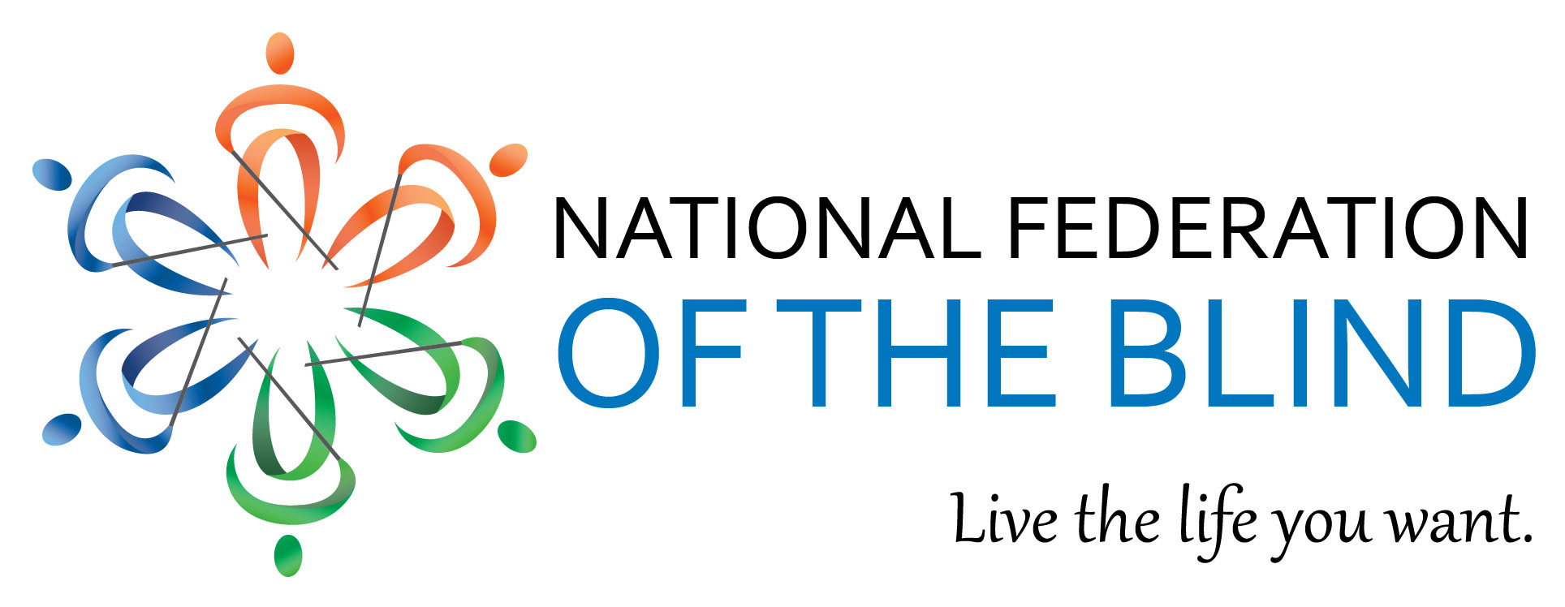
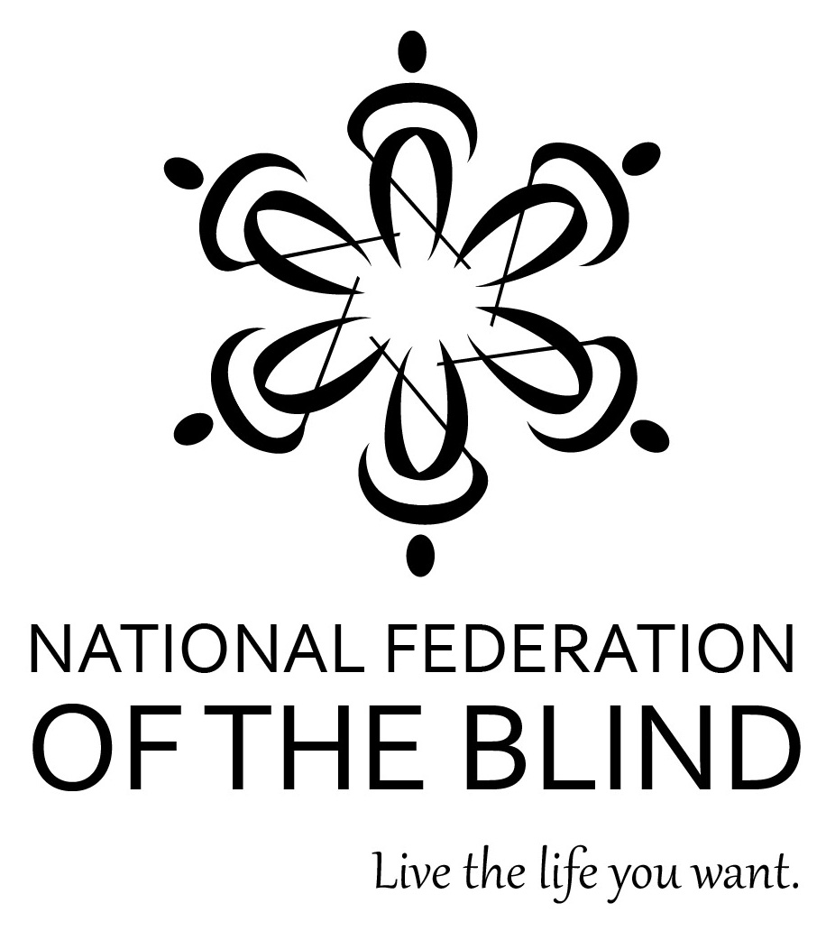
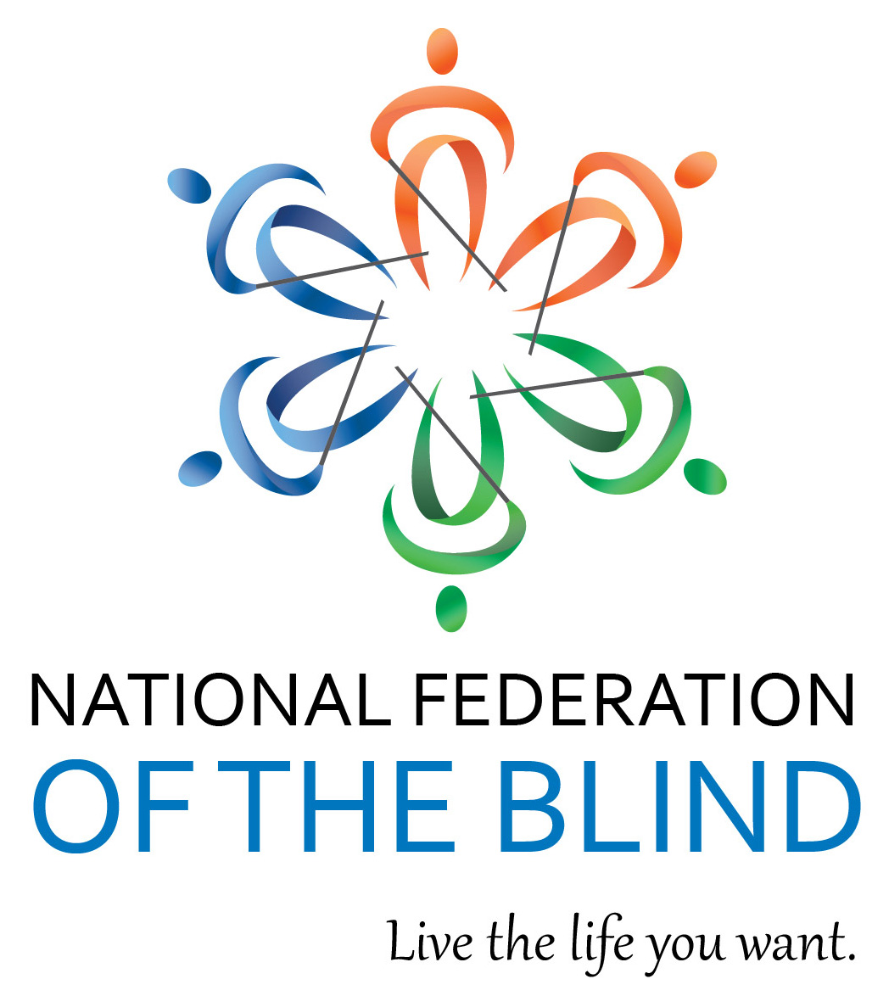

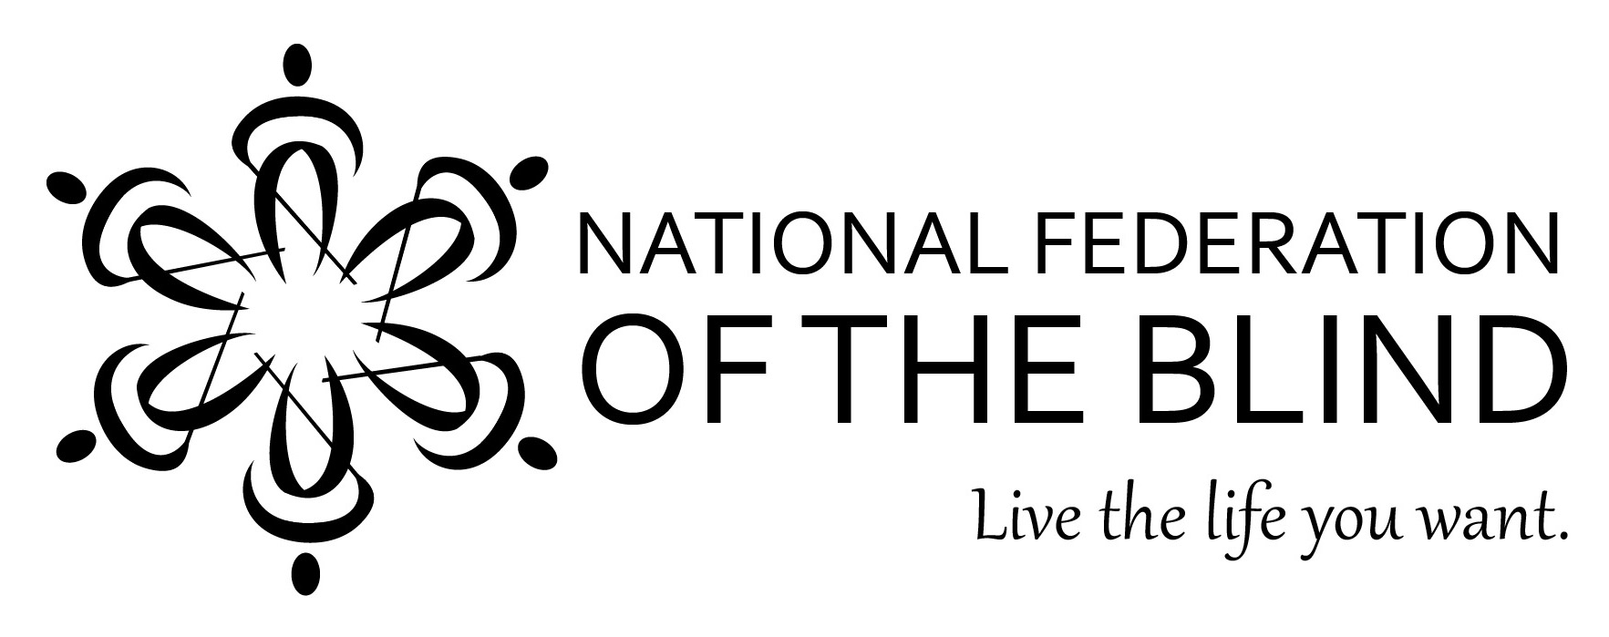

RATIONALE

The icon(s) are an updated contemporary version of our previous “Whozit” icon. This one is a little sleeker, faces forward, and is intended to convey action. By conveying creativity, movement, freedom, and warmth, the icon more strongly expresses the brand of the organization.

In our symbol, the icons are displayed in a circle and have a feeling of movement representing key values of the organization’s brand—collective action, full participation, love, and democracy.

The icon facing forward demonstrates respect and is more inviting than an icon facing to the side. The icons convey the personality of the organization—inspirational, innovative, powerful, and inviting. Finally, it is important to use more than just one icon as our symbol because we are not alone, we are a group, a team, a family, working together.

The colors (blue, orange, green) represent optimism, love, unity, hope, confidence, growth, and energy—all of which are important to our brand. The variation of colors also reminds us that we are a diverse organization and each of us has something to contribute.

The font of the text is sans serif, which is more modern and innovative than the heavy serif of our previous logo. It is also much more readable for our low-vision members. The logo places more emphasis on the words “of the blind” in order to call attention to that important and powerful aspect of our organization. The tagline font is italic to imply the energy and action we want people to take in order to “Live the life you want.” The text in the logo represents power and action.

HOW TO USE OUR NEW LOGO

The full logo consists of our symbol, our name, and our tagline (Live the life you want). When space is at a premium the tagline can be left off of the full logo.

Our symbol should never be used without our name attached to it.

Our icon can be used on its own in any of our three color choices or shades of black. As with our previous icon, we can add small embellishments for special occasions/purposes as long as the main form remains intact.

Do not use different colors than the ones approved. Our PANTONE color codes are: Blues - 294 and 3005; Green - 357; Orange - 173. Our logo also appears best if there is at least ½” white space around the logo on all sides.

High-resolution images must be used for printed materials. Lower resolution images can be used online for website and social media purposes.

Please contact Suzanne Shaffer at sshaffer@nfb.org or (410) 659-9314 with questions and to obtain logo artwork.

Communications team contact information:

Email: communicationsteam@nfb.org
Communication Request Form: http://www.nfb.org/communications-request
Contact information for Chris Danielsen: (410) 659-9314, extension 2330

