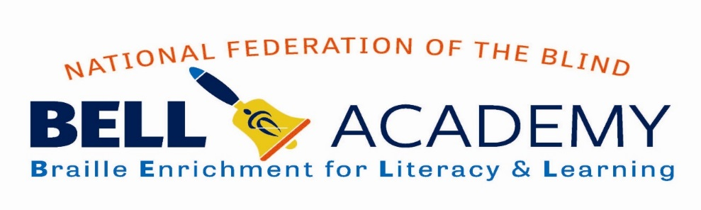
Help the National Federation of the Blind of West Virginia teach our blind kids to read braille!!
Support our BELL Academy
July 23-27, 2018
Elizabeth United Methodist Church
108 Oakwood Road, Charleston, WV 25314
For More Information: (304)993-5103
BELL FAQ

What is BELL?
BELL is Braille Enrichment for Literacy and Learning

What does BELL accomplish?
The NFB Braille Enrichment for Literacy and Learning (BELL) Academy prepares blind and low vision children, ages four through twelve, to grow into confident and independent blind people who will live the lives they want.

What do the Children attending the BELL Academy do?
The program provides Braille and non-visual skills instruction through fun, hands-on learning in a day program. In addition to Braille crafts, games, and other engaging projects, children learn vital independent living skills, interact with blind adults who serve as mentors, and enjoy field trips to sites related to the NFB BELL Academy curriculum.

Why do blind children in WV need this extra program?
BELL provides an opportunity for blind children to become more experienced in Braille and build interest in using it later in life.

Why is the BELL academy conducted by blind adults?
Many blind children have never met a successful, independent blind person. Learning from competent knowledgeable blind adults demonstrates to the children that they can also grow up to be independent and successful blind people.

Who else helps fund BELL?
Funding began with the contribution of dozens of blind individuals here in WV, our friends and neighbors and others across the state. City National Bank is helping as a major business partner and we will have support from a state-wide recreational organization. We do not receive any government or public funding for BELL, so your dollars are very important and greatly appreciated.

